Homeostatic relevance promotes access to visual awareness

Piotr Litwin^{1, 2}, Paweł Motyka³, Surya Gayet⁴

¹ Faculty of Psychology, University of Warsaw, Stawki 5/7, 00-183, Warsaw, Poland
² Consciousness Lab, Institute of Psychology, Jagiellonian University, Ingardena 6, 30-060, Kraków, Poland
³ Institute of Psychology, Polish Academy of Sciences, Jaracza 1, 00-378, Warsaw, Poland
⁴ Experimental Psychology & Helmholtz Institute, Utrecht University, Heidelberglaan 1, 3584 CS, Utrecht, The Netherlands

Author Note
We have no conflict of interest to disclose. This project was supported by a National Science Centre (Poland) research grant awarded to Piotr Litwin (grant number: 2018/29/N/HS6/01535). Full database, analysis pipeline, and research materials that could not be presented in the manuscript format (i.e., disgust-inducing clips) are available at https://github.com/piolitwin/bcfs-feardisgust. All hypotheses as well as the data analysis plan had been preregistered at OSF in a time-stamped document (https://osf.io/dyw64/) before the data collection started. Correspondence concerning this article should be addressed to Piotr Litwin, Faculty of Psychology, University of Warsaw, Stawki 5/7, 00-183, Warsaw, Poland. E-mail: piotr.litwin@psych.uw.edu.pl
Abstract
Fear and disgust have been associated with opposite influences on visual processing, even though both constitute negative homeostatic emotions that motivate avoidance behavior and entail increased arousal. In the current study, we hypothesized that (1) homeostatic relevance modulates perception at early stages of visual processing, (2) through widespread physiological responses, and that (3) the direction of these modulations depends on whether an emotion calls for immediate regulatory behavior (fear) or not (disgust). Specifically, we expected that increased arousal should facilitate detection of fear-related stimuli, and inhibit detection of disgust-related stimuli. These hypotheses were tested in two pre-registered experiments run in September-October 2022 (total N = 120, ethnically-homogenous Polish sample). Using a novel, response bias-free version of the breaking continuous flash suppression paradigm, we examined localization and discrimination of fear- and disgust-conditioned stimuli at individually determined perceptual thresholds. Our first hypothesis was confirmed: Fear-conditioned stimuli were detected and discriminated better than neutral stimuli, and the magnitude of conditioning-related perceptual preference was related to arousal during conditioning acquisition. In contrast with our second hypothesis, arousal-mediated perception of disgust-conditioned stimuli was also enhanced, although the effects were weaker compared to those evoked by fear conditioning. The current study strengthens previous evidence for facilitated perception of threatening objects and shows for the first time that stimuli evoking disgust also gain preferential access to awareness. The results imply that stimuli associated with homeostatically relevant negative emotions are prioritized by the human visual system and that this preference is grounded in the underlying arousal levels.
Keywords: visual perception, fear, disgust, physiological arousal, breaking continuous flash suppression
Homeostatic relevance promotes access to visual awareness
Fear is a homeostatic emotion – it promotes immediate allostatic behavior in response to impending danger (e.g., the fight-or-flight response). As such, it entails a sympathetic activation pattern characteristic to mobilization for action (Kreibig, 2010), resulting in increased heart rate, respiration rate, and electrodermal activity (Comtesse & Stemmler, 2017). Underlying physiological arousal is believed to be responsible for preferential visual processing of stimuli indicating threat (Mather & Sutherland, 2011). Fear facilitates attention to threatening objects (Öhman et al., 2001) and improves accuracy of localization of fear-signaling stimuli, as if it was amplifying their contrast (Phelps et al., 2006; Lee et al., 2014). To facilitate rapid regulatory behavior, fear-related arousal selectively enhances processing of low spatial frequency visual information – that is, ‘coarse’ features of perceived stimuli – while impeding the processing of visual details (Bocanegra & Zeelenberg, 2009; Borst & Kosslyn, 2010). Studies using the breaking continuous flash suppression (b-CFS) paradigm have shown that fear-conditioned stimuli enjoy preferential access to visual awareness compared to neutral stimuli (Gayet et al., 2016) and are more accurately localized, even in the absence of conscious awareness (Vieira et al., 2017). The magnitude of the enhancement of detection accuracy correlates positively with the relative arousal associated with the presentation of threatening stimuli during the conditioning phase (Vieira et al., 2017). Thus, an emerging coherent picture suggests that fear-related effects on visual perception are prevalent and likely related to underlying arousal.
The proposed mechanism of these fear-related effects is based on unconscious rapid recognition of relevant features through subcortical pathways (e.g., the amygdala) and subsequent feedback modulation of object-related activity in the visual cortex (Gayet et al., 2016). While it has been argued that such perceptual facilitation is informed by object-associated arousal (Lee et al., 2014), it does not follow that arousal exclusively improves perceptual processing, as it may exert a variety of influences depending on other contextual factors, such as approach/avoidance motivation, valence or adaptive action regulation (Balcetis, 2016). Elevated arousal levels accompany a wide variety of emotions (Kreibig, 2010) that may yield different perceptual effects. For example, percepts associated with monetary reward tend to break suppression faster (Lunghi & Pooresmaeili, 2023), whereas those associated with monetary loss tend to be suppressed (Wilbertz et al., 2014); arguably, both monetary gains and losses entail physiological arousal.
Core disgust makes another case that increases in arousal are not monotonically related to the access of visual information to awareness. Disgust is associated with a broader pattern of sympathetic–parasympathetic coactivation, resulting in increased heart rate and skin conductance response as well as increased heart rate variability and decreased cardiac output. This distinguishes disgust from other negative emotions, which increase cardiac output in order to mobilize for action (Kreibig, 2010; p. 403); disgust, as opposed to fear, serves long-term homeostatic control through inhibition of behavior. In other words, it ‘warns’ one that some objects should not be directly interacted with, but does not usually entail the need for rapid withdrawal. In this case, perceptual suppression may be more efficient in preventing acute internal responses associated with close yet indirect contact with an object of disgust (e.g., decreased normogastric activity causing nauseous feelings; Chapman & Anderson, 2012).
Accordingly, preliminary evidence shows that disgust may indeed involve perceptual suppression effects (Krusemark & Li, 2011). In a simple detection task, accuracy rates are lower and response times are longer for targets preceded by briefly-presented disgusting images (van Hooff et al., 2013). Similarly, disgust-eliciting stimuli produce greater attentional blinks than neutral or fear-related stimuli, especially at short temporal intervals (Perone et al., 2021). Although these findings may be interpreted as increased inability for attentional disengagement, there is also the possibility that they reflect poorer detection following presentation of repellent objects (an analogous effect – although in the opposite direction – to the fear-induced ‘contrast amplification’; cf. Gayet et al., 2016, Phelps et al., 2006). A recent study using the b-CFS paradigm has also shown that disgusted faces break into visual awareness more slowly than do neutral faces, while fearful faces do so faster (Silva et al., 2020); however, it should be noted that differential processing of distinct emotional facial expressions may boil down to differences in their low-level visual properties (Gray et al., 2013; Stein et al., 2018; Webb & Hibbard, 2020).
In the current study, we intended to investigate the hypothesis that the perceptual effects of emotionally-laden stimuli cannot be ascribed solely to arousal. Instead, we posited that arousal-related effects on perception are grounded in distinct (broader) physiological activation patterns attributable to specific emotions. The directionality of the effects could depend on whether the regulation of particular emotions requires an immediate response and, as such, should be irreducible to approach/avoidance motivation or emotional valence. Therefore, we chose to study the perceptual effects of fear and disgust, which constitute two examples of emotions matched in terms of the arousal (increased), valence (negative), and the behavioral orientation they motivate (avoidance), but of which only one (i.e., fear) normally promotes immediate regulatory behavior (i.e., fleeing). We expected that increased arousal should be positively related to increased performance in perceptual detection tasks for fear-conditioned stimuli, and negatively related to decreased performance for disgust-conditioned stimuli.
To examine our hypothesis, we used a variant of the breaking continuous flash suppression (b-CFS) paradigm (Jiang et al., 2007). In this method, a target stimulus presented to one eye is rendered invisible through the presentation of a high-contrast, rapidly changing mask to the other (often dominant) eye. Over time, perceptual dominance shifts, allowing participants to detect an initially suppressed target stimulus and to report its characteristics of interest (e.g., position). Accuracy measures or reaction times serve as behavioral proxies for the ease with which the target escapes perceptual suppression, and may be compared between conditions to indicate how certain stimulus conditions are prioritized over others in reaching conscious access (Stein, 2019). Taking recent methodological considerations into account (Lanfranco et al., 2021; Stein, 2019), we decided to use an accuracy-based b-CFS method. In a series of two two-alternative forced-choice (2AFC) experiments, stimulus presentation times in particular trials were set by 2-down 1-up adaptive staircases. Using trial durations as stimulus intensities, we aimed to determine presentation time thresholds allowing reliable target localization (~80% accuracy). Performance levels for conditioned stimuli (CS+) and neutral stimuli (CS−), indicating their relative contributions to threshold estimates, were then compared within shared staircases. We decided to use shared (heterogenic) staircases for CS+/CS− stimuli to keep variable stimulation parameters (i.e., presentation times) identical across conditions, while keeping the subjective difficulty of the task (i.e., performance level) within the same range for all participants. This methodological move also limited the number of trials in the experiment, which is a crucial countermeasure against rapid conditioning extinction effects. In each of the experiments, two separate (interleaved) staircases were run for left and right eyes to account for the fact that the magnitude of eye dominance varies considerably across participants (Dieter et al., 2017).
We expected localization performance to be enhanced for fear-conditioned stimuli and worsened for disgust-conditioned stimuli as compared to similar stimuli that are not conditioned (neutral). Additionally, we expected the magnitude of these differences in performance to be correlated with physiological arousal (skin conductance response) accompanying the presentation of unconditioned stimuli in the conditioning phase. Separate studies were run for fear and disgust, since 1) we did not intend to compare fear- and disgust-related effects (our directional hypotheses pertained to differences between conditioned and neutral stimuli), and 2) we wanted to avoid problems with mixing multiple conditioning procedures in one study.
Finally, in each study, we examined both the effects on localization and discrimination performance to determine which kind of information about a homeostatically relevant stimulus is affected and whether it depends on the specific emotion type. For example, fear-related effects should essentially pertain to the stimulus location (cf. Vieira et al., 2017), which is a crucial feature for successful regulatory action under time pressure. However, one may ask whether the visual system prioritizes the entire stimulus for further processing, including tangential visual features allowing its identification (cf. Gayet et al., 2016). On the other hand, perceptual suppression effects of disgust should mainly prevent visual recognition of the disgusting object’s identity. It follows that, in this case, one should perhaps expect worsened performance in discrimination tasks in particular. To examine possible dissociations between localization and discrimination performance, we had decided to include (unstaircased) discrimination tasks in all b-CFS trials. Dissociations between localization and discrimination performance may occur in the b-CFS paradigm (Lanfranco et al., 2022; Stein, 2019; Stein & Peelen, 2021), since additional presentation time is typically needed for discrimination accuracy to match the localization performance, and the amount of additional time required largely depends on the stimulus salience (Kobylka et al., 2017). Based on these observations, we expected CS+/CS− discrimination performance at localization thresholds to vary in the range from 50% (chance level) to 80% (expected threshold localization accuracy level). This allowed us to compare discrimination accuracy between CS+ and CS− stimuli to examine whether conditioning-related effects on discrimination mirror or diverge from effects on localization.
Materials and Methods
Participants
To determine the appropriate sample size, we used the effect size estimates reported by Vieira and colleagues (2017). For the main comparison of interest (paired t-test: CS+ vs CS−), we carried out a power analysis for the effect observed in the forced-choice localization task (d = 0.55) using the following formula (pwr package for R; Champely et al., 2018): pwr.t.test(d = 0.55, sig.level = 0.05, power = 0.9, type = "paired", alternative = “greater”), which yielded N = 30. To calculate the sample size required for arousal-related analyses, we used the correlation between fear-related localization performance enhancement and relative SCR response to CS+ stimuli (r = 0.36). Using the formula proposed by Hulley and colleagues (2013), we determined N = 63 for such a one-sided correlation to be detected at 0.9 power. On that basis, we decided to include 60 participants in both experiments. This number, although slightly lower than our more conservative estimation, still provided sufficient statistical power, even for analyses with exclusions.
Taken together, 120 participants took part in the study: Exp. 1: N = 60 (17 males); Exp. 2: N = 60 (15 males). Participants were recruited through the recruitment platform of the University of Warsaw (N = 51 – Exp. 1: N = 41; Exp. 2: N = 10) and social media (N = 69 – Exp. 1: N = 19; Exp. 2: N = 50). Participants recruited through the University platform were mostly students of diverse majors; however; group recruited through social media was more heterogeneous (e.g., in terms of age, educational background or socioeconomic status). The detailed data regarding age, gender identity, socioeconomic status, ethnicity, disability status or sexual orientation were deemed irrelevant for the study purposes and thus not collected in accordance with incumbent data protection policies. We only recruited participants who had claimed to not have a diagnosis of psychiatric, neurological (with a particular emphasis on epilepsy), or ocular conditions (amblyopia and color blindness). All participants had normal or corrected-to-normal vision and gave written informed consent before taking part in the study. They received monetary compensation (40 PLN; ~8.5 ‎€) for participation. The experiment complied with the ethical guidelines as specified in the Declaration of Helsinki, and was approved by the ethics committee of the Faculty of Psychology of the University of Warsaw.
Stimuli and Apparatus
All stimuli were presented on a black screen (brand/model: BenQ GL2450-T; size: 24’’; resolution: 1920 x 1200 px; refresh rate: 60 hz; gamma corrected). With the use of a custom-built dichoptic mirror stereoscope, each eye was presented with a separate visual scene consisting of two nested rectangular presentation frames. The external frame, subtending an area of 11.24 by 6.32°, was filled with a Brownian noise frame to promote the fusion of images. A uniform gray presentation area of 10.71 x 6.02°, with a fixation cross (0.2 x 0.2°) in the center, was encapsulated within the larger rectangle.
The masks consisted of overlapping colored, high-contrast circles (see Fig. 1A for a sample mask). Unique 40 masks were pre-generated and loaded from images before each experiment. During each trial, masks were shuffled in a unique order at 6 hz frequency which tends to provide the longest suppression durations (Drewes, Zu, & Melcher, 2018).
{Fig. 1 here}
The target stimuli were modeled on those used previously by one of the authors (Gayet et al., 2016) and comprised colored annuli (outer radius: 1.2°; inner radius: 0.7°) cut either on the left or the right side (-45° or +45° rotation from vertical; Fig. 1B). For the presentation of stimuli, we used red and blue annuli. The exact RGB values of red annuli and gray background were individually determined using the flicker photometry method (Kaiser & Comerford, 1975) to perceptually equate the luminance of the colors with the uniform gray background of the presentation area. By doing so, we ensured that the annuli were predominantly defined by their chromatic contrast with the background, which is the feature dimension that carries the experimental manipulation. Each of the participants provided 10 RGB estimates for red and gray colors relative to the reference color − saturated blue. Individual estimates were then averaged for the respective colors and fed to the main experiment as perceptually isoluminant RGB values. Black annuli, which served as a prompt for response, were predetermined and not subject to calibration based on flicker photometry.
We used two sets of unconditioned stimuli (US): white noise bursts (fear conditioning; Exp. 1) and disgusting video clips (disgust conditioning; Exp. 2). Along with electrocutaneous shocks, white noise bursts are the most reliable and widely used method in human fear conditioning (Lipp, 2006). However, noise bursts are more resilient to conditioning extinction effects (Sperl et al., 2016) and, as such, are better suited for procedures requiring larger numbers of trials (such as b-CFS). Noise bursts were delivered from a stereo speaker positioned directly in front of participants (under the display) at the volume of 95 dB (measured at the participants’ head position).
In the second experiment, we used short video excerpts as aversive US, because, in contrast to disgusting sounds (Köchel et al., 2013), film clips more reliably elicit an intense and specific disgust emotion (Bujarski et al., 2015; Gilman et al., 2017). We aimed to present core disgust materials through the videos, since mutilation-related disgust (e.g., associated with injuries or surgeries) can induce potentially confounding emotions, such as fear or empathy towards others (Shenhav & Mendes, 2014). We examined 8 video clips (~10 seconds each) with core-disgust-inducing content in a large (N = 115) online pre-study, of which we selected 4 to be used in the main experiment. For each of the clips, participants had been asked to assess the intensity of disgust on a 10-point Likert scale, name any other kind of emotion elicited, and indicate whether the intensity of the associated emotion would be bearable in experimental conditions. On this basis, we picked films that reliably induced medium-to-high disgust and did not tend to co-elicit other emotions. The following clips were chosen: 1) Bear Grylls eating a huge squirming worm; 2) a woman puking on herself and her partner on a rollercoaster; 3) an excerpt from Dr. Pimple Popper showing a gigantic skin cyst being squeezed out by a dermatologist; and 4) a man searching for a suppository in an extremely foul toilet (from the movie Trainspotting; for clips see https://github.com/piolitwin/bcfs-feardisgust). Each clip was cut into two sequential 5-second excerpts, forming a chronological storyline (Bosman et al., 2016), which yielded 8 unique US. All clips were presented with sound.
Skin conductance response (SCR) was recorded with the use of a Biopac EDA100C amplifier and AcqKnowledge 5.0 software (Biopac Systems Inc., Santa Barbara, CA). The signal was collected at 1000 Hz frequency (gain: 10 µS/V). Electrodes filled with isotonic gel were placed on the distal phalanges of the participant’s left index and ring fingers.
Tasks
Breaking Continuous Flash Suppression
The b-CFS paradigm was slightly modified to fit the purposes of the current study (Fig. 2). In each of the trials, participants were presented with a target stimulus (a clipped annulus) in one eye, and a rapidly flashing mask in the other eye. Thus, all of the trials involved interocular suppression. The target was presented either above or below the bilateral fixation cross displayed at the center of the black horizontal bar dividing the dichoptic scene into upper and lower presentation areas. Participants were instructed to maintain their fixation on the cross and to avoid ocular movements, and were not able to respond in the course of the trial. In all of the trials, participants consecutively performed two forced-choice tasks: they reported the position of a target with respect to the horizontal bar (up/down; localization task) and the side on which the annulus was cut (left/right; discrimination task). The position of the target was slightly radially jittered from the midpoint of the upper/lower presentation area at fixed eccentricity to counteract practice effects. Participants were instructed to report the annulus location (up/down arrows) and the side of the cut (left/right arrows) as accurately as possible by pressing buttons, and to provide their best guess if the target was not seen. In both tasks, black annuli were presented with additional instructions to facilitate intended responses. No feedback on the correctness of responses was provided throughout the experiment.
{Fig. 2 here}
Each trial started with a fixation cross (500 ms), and target stimuli were presented between 300 and 600 ms after the onset of the Mondrian masks. In all trials, target stimuli were linearly ramped up to 100% contrast in 2 seconds. The presentation time differed between the trials – it was determined by the 2-down/1-up adaptive staircase method, decreasing the trial duration after two consecutive correct responses, and increasing it after an incorrect one. The staircases were allowed a wide range of 110 possible durations from 1 to 6 seconds, spaced on a log scale with each step 1.0166 times longer than the previous one (rounded to presentation times possible on a 60 Hz monitor). Unequal up/down step sizes were used, with descending steps (11 durations) almost two times smaller than steps up (20 durations). Such specification yielded a 0.55 step down/step up ratio which is very close to the optimal one for 2-down 1-up staircases (Garcia-Perez, 1998). This allowed the algorithm to reliably converge towards the individual presentation time thresholds in localization tasks (expected accuracy: 80.35%; Garcia-Perez, 2001). In all experiments, we ran two interleaved staircases to independently estimate localization thresholds in dominant and non-dominant eyes.
There are important rationales behind our main methodological choices which may seem unorthodox, but have important advantages over alternative solutions. First, based on recent recommendations, we opted for non-speeded accuracy-based measures, since reaction times (RTs) cannot rule out other post-perceptual factors related to motor preparation or response criteria, even if participants report perceptual features orthogonal to the manipulation (Lanfranco, Rabagliati, & Carmel, 2021; Stein, 2019). Thus, RTs do not necessarily reflect suppression times alone. Second, we decided to use trial durations as stimulus intensities, because using contrasts for this exact purpose could result in trial-to-trial changes in the conditioned property (i.e., perceived color), possibly precluding the transfer of conditioning effects between stimuli with different appearances. Third, we opted for within-staircase performance comparisons, since separate staircases for conditioned and neutral stimuli could result in varying presentation times and detectable differences in the thresholded property across conditions. Finally, we decided to abstain from using control trials without suppression (in which target and masks are presented to the same eye), which are supposed to capture all aspects of the b-CFS trials except for the interocular suppression. Visual phenomenology and high predictability of such trials differs from b-CFS experience and demonstrably entails poor sensitivity for measuring differences between conditions (Stein, 2019). Using accuracy-based outcome variables already ensures that measurements capture early perceptual rather than post-perceptual processes. Numerous control trials would also needlessly contribute to conditioning extinction.
Fear and Disgust Conditioning
Conditioning was acquired in sensory conditions imitating the main experimental (b-CFS) task to ensure that the effects of learning transfer between experimental settings. Annulus color (red/blue) was used as a conditioned feature, with conditioned stimulus (CS+) color counterbalanced across the participants. Annuli were cut at 12 o’clock position (Fig. 1C) to maximize similarity between stimuli used in conditioning and experimental trials while preventing accidental conditioning with the irrelevant feature (i.e., left/right cut placement). Participants were asked to passively observe subsequent b-CFS trials, in which a target was ramped up to 100% contrast over 2 seconds. After 3 seconds, the mask suppressing the target disappeared, revealing the unoccluded target either above or below the fixation point in the center. The target position was counterbalanced across the conditioning trials. In the fear conditioning experiment (Fig. 3A), an unoccluded target was visible for 4 seconds and the US presentation started after 3 seconds of CS+ onset, with both stimuli co-terminating after another second (Sperl et al., 2016). In the disgust conditioning experiment (Fig. 3B), an unoccluded target was presented for 8 seconds and US presentations coincided with CS+ offset (David & Olatunji, 2011). The unconditioned stimuli followed the presentation of the target only during conditioned trials. Empty gray presentation areas were displayed during inter-trial intervals, which were jittered and lasted either 7–9 seconds (Exp. 1) or 10–14 seconds (Exp. 2).
{Fig. 3 here}
The general conditioning methodology was informed by the recent recommendations for successful and persistent fear conditioning (Lonsdorf et al., 2017). We used 24 trials in the acquisition phase, with 12 presentations of CS+ and 12 presentations of a control (unreinforced) stimulus (CS−); 8 out of 12 CS+ presentations were paired with aversive US, giving a reinforcement rate of 66.7%. In the first 16 trials, CS+ was presented 8 times, but only 4/8 trials were associated with the US (50% reinforcement rate). The first and last four CS+ presentations were always reinforced. The exact order of CS+ and CS− presentations was randomized in a way that precluded 3 subsequent presentations of CS+/CS− stimuli as well as 3 subsequent (un)reinforced presentations of CS+ stimuli in the first 16 trials.
SCR was measured only during the training and the conditioning session. We analyzed non-specific (spontaneous) electrodermal responses in the training period (which served as baseline for SCR standardization) and event-related responses to US presentations during the conditioning phase. US-related SCRs were calculated as the amplitude of electrodermal reaction in a time window encompassing 6 seconds after US onset (noise burst, Exp. 1) or US presentation time + 6 sec after US offset (disgusting clips, Exp. 2; scenes particularly disgusting for given participants could have also appeared at the end of the clips). Non-specific SCRs of at least 0.02 μS amplitude were automatically detected (and their exact magnitudes were determined) with the AcqKnowledge software. We had decided not to record trial-to-trial activity in the main experimental phase due to having observed in the pilot that once participants enter the experimental flow state, event-related SCR amplitudes are virtually absent in individual b-CFS trials.
Procedure
The experiment was carried out in a soundproof and dimmed laboratory room. Participants were asked to place their chin on a head-and-chin rest in front of the stereoscope. The monitor was positioned 60 cm in front of the chin rest, which amounted to an effective viewing distance of 68 cm (including the mirror stereoscope).
The procedure started with 48 practice b-CFS trials using blue and red annuli as targets. The training had a twofold purpose: it served 1) as a habituation phase for conditioning and 2) as a task familiarization procedure to avoid b-CFS practice effects affecting detection times during the main experimental trials (suppression tends to be stronger in early trials; Stein, 2019). Trial durations were preset to 3 different values: 2, 4, and 6 seconds, yielding 8 practice trials of each particular trial duration for each annulus color. The varying presentation times were chosen to imitate inter-trial changes in trial duration during the experiment proper, while allowing correct localization and identification in at least some of the trials. To further facilitate task comprehension, the masks started to gradually fade after 2 seconds of presentation, revealing a completely unoccluded target after 4 seconds.
The conditioning acquisition phase followed thereafter. Upon completion, participants were asked to rate US aversiveness (on a 1–10 Likert scale) and to indicate the CS+ color. SCR electrodes were not removed after the conditioning phase to strengthen the accurate expectation that aversive events may accompany CS+ stimuli in all parts of the experiment.
Participants were then presented with 136 experimental trials divided into 4 blocks, resulting in 34 trials per block. Short breaks between the blocks were encouraged to prevent participants from straining their eyes. Each block included two types of trials. In regular experimental trials (32/34), participants had to report, in two consecutive 2AFC tasks, target localization and the side of the cut. The order of task presentation was constant within blocks to minimize the risk of confusion, but was varied within-participants and counterbalanced across participants (e.g., for half of the participants the localization task came first in even blocks, and the discrimination task first in odd blocks, and vice versa for the other half of the participants). All experimental trials were followed by 1000 ms inter-trial intervals. The number of trials per staircase (eye), annulus color, target position, and cut location were counterbalanced both within and across blocks. CS+ and CS− presentations were randomized in a manner precluding 3 subsequent presentations of CS+/CS− stimulus occurring within a given block. Taken together, we used 64 experimental trials per individual staircase, which is more than sufficient for the staircase to converge near the threshold, and is low enough for the conditioning effects to be sustained with occasional conditioning reinforcement.
In reacquisition trials (2/34), the CS+ target was presented in one of the positions (above/below the fixation point) and ramped up to 100% contrast over 2 seconds. After 3 seconds, the mask disappeared, revealing an unsuppressed target for 2 seconds. For fear conditioning, a white burst started after 1 second of unoccluded CS+ presentation, with both stimuli co-terminating after another second. In the case of disgust conditioning, aversive clip onset coincided with CS+ termination. Inter-trial intervals following reacquisition trials were jittered and lasted either 7–9 seconds (Exp. 1) or 10–14 seconds (Exp. 2), depending on the conditioning type. Both types of trials did not differ in terms of other stimuli presentation parameters (fixation point presentation time, mask type, etc.) except for the lack of position jitter in the reacquisition trials. Reacquisition trials were randomly scattered among regular trials and presented once per staircase in a given block. The location (up/down) and eye (left/right) of target presentation in reacquisition trials were counterbalanced within participants across the experiment. Before each block, participants were explicitly informed that they should expect intermittent US presentation incidental to CS+ trials. Upon completion of the final block, participants were debriefed and compensated.
Data Analysis
Outlier Exclusions
In order to determine potential outliers in the data, we calculated general performance scores (fraction of correct out of 128 total responses in the experiment) for each participant. As stated in the preregistration, participants for whom suppression was either too effective (chance performance) or too weak (ceiling performance) were excluded from further analyses, because random and ceiling performance levels artifactually reduce the sensitivity for finding a difference between experimental conditions (e.g., CS+ versus CS−). Chance level performers were identified by fitting a Bayesian binomial mixture model (Siedlecka, Koculak, & Paulewicz, 2021). For the purpose of model specification, we safely assumed that population average performance could not exceed 95%, thus defining a cut-off point for exclusions related to the ceiling level performance.
Data from SCR “non-responders” (Dawson et al., 2017) were excluded from SCR-related correlations, but were used in analyses concerning performance levels for CS+ and CS- stimuli. Non-responders were defined as participants fulfilling at least one of the three following criteria: (1) less than 5 non-specific SCR events, (2) mean event-related SCR < 0.02 μS, or (3) mean standardized event-related SCR lower than 0.
Data Pre-processing
Following Vieira and colleagues (2017), individual event-related SCR amplitudes lower than 0.02 μS were scored as 0 and retained in the analyses. Before statistical analysis, we normalized all SCR data with the use of the log (SCR+1) correction (Dawson et al., 2007). Then, using both non-specific and event-related SCRs (Braithwaite & Watson, 2015), we standardized individual SCRs with a z-score transformation (Ben-Shakhar, 1985) to account for individual differences in skin conductance responsiveness. We decided to standardize US-related SCRs to baseline reactivity (NS-SCRs) due to our pilot observations that electrodermal responses to CS+/CS− stimuli are either absent or indistinguishable from responses to other rapidly changing stimuli in the b-CFS procedure.
Data Analysis
Performance scores for CS+ and CS− stimuli were used as dependent variables in further analyses. To examine differences in performance levels (aggregated across both eyes), we used one-way (given that we made directional hypotheses) Bayesian paired t-tests with informed priors. The prior was specified based on recent guidelines for Bayesian t-tests (Gronau et al., 2020). To obtain the prior distribution, we used the effect size for localization accuracy performance (d = 0.55) found in the study of Vieira et al. (2017) on perceptual processing of fear-conditioned stimuli, given close resemblance of their procedure and relatively small effect size as compared to other studies. We assumed this effect to be the median of the effect size distribution, which yielded a normally distributed prior with μ = 0.55 and σ = 0.18. The informed prior was specified accordingly for directional hypotheses CS+ > CS− (fear conditioning; Exp. 1) and CS+ < CS− (disgust conditioning; Exp. 2). The same tests and priors were used to examine performance in localization and discrimination tasks.
In order to examine whether localization and discrimination performance are differentially affected by the conditioning, we performed a within-subject ANOVA with conditioning (CS+ vs CS−), task (localization vs discrimination), and a conditioning * task interaction as predictors, and performance level (% accuracy) as the dependent variable. We decided not to perform Bayesian analysis here due to the challenging (and, in our case, lacking reasonable justification) prior specification for factorial designs (Rouder et al., 2017).
To examine our second hypothesis, we correlated mean standardized SCRs to US in the conditioning session with the magnitude of the conditioning effect, defined as the difference in localization/discrimination performance (% accuracy) between CS+ and CS- stimuli. Difference values indicating no conditioning effect (i.e, resulting from CS- > CS+ accuracy in Exp. 1 or CS+ > CS- accuracy in Exp. 2) were recoded to 0 (meaning simply “no effect”) to avoid random variability which could potentially result in spurious correlations. Non-parametric correlations were used in the case of any distributions violating the assumption of normality.
Transparency and Openness
Data were collected in September and October 2022. As required by APA Style Journal Article Reporting Standards, we report how we determined our sample size, all data exclusions, all manipulations, and all measures in the study. Analyses were run using R 4.2.0 (R Core Team, 2022) and JASP 0.16.4.0 (Love et al., 2019). Full database, analysis pipeline, and research materials that could not be presented in the manuscript format (i.e., disgust-inducing clips) are available at https://github.com/piolitwin/bcfs-feardisgust. All hypotheses as well as the data analysis plan had been preregistered at OSF in a time-stamped document (https://osf.io/dyw64/) before the data collection started, and all analyses examining directional hypotheses reported in the current paper are identical to those stated in the preregistration document. The only small difference pertains to the prior specification: due to a typo, the mean of the prior distribution was defined as 0.5 in the preregistration, instead of 0.55 as derived from the study of Vieira et al., 2017. This difference is negligible as it does not influence the interpretation of the results and our findings do not depend on the exact prior specification. We also decided to not include exploratory analyses related to eye dominance effects due to faulty specification of the preregistered linear mixed model.
Results
Exp. 1 (Fear)
Outliers
Based on the exclusion criteria described in the Methods section, we excluded one participant from analyses related to the localization task (performing at ceiling level), and 2 participants from analyses regarding the discrimination task (one participant performing at ceiling level, and one performing at chance level). One of these participants was a multivariate outlier, who likely misunderstood the discrimination task (lower than random discrimination performance despite 88% localization accuracy), and was thus also excluded from analysis pertaining to the interaction between task and conditioning effects. Additionally, 2 participants were defined as SCR non-responders and excluded from the SCR-related analyses due to experiencing less than 5 non-specific SCR events. Taken together, the following numbers of participants were included in the eventual analyses: 59 participants for the localization task (57 in SCR-related analyses), 58 participants for the discrimination task (56 in SCR-related analyses), and 59 for the interaction between task and conditioning.
Results
Interocular suppression was successfully induced in both dominant (mean threshold: 2.28s; SD = 1.24s) and recessive (mean threshold: 3.36s; SD = 1.48s) eyes. Also, we managed to match the perceptual salience of red and blue annuli at the group level, as we did not observe systematic preferences for any of the colors, neither in the localization, t(58) = 1.51, p = 0.137, nor in the discrimination task, t(57) = 1.69, p = 0.096. Aversiveness of noise bursts was appropriate for the fear conditioning procedure: M = 7.60 (on a 10-point scale); SD = 1.68, indicating that our participants found the US unambiguously unpleasant yet bearable. Successful conditioning was confirmed by the presence of electrodermal response (mean standardized SCR > 0) in all of the participants: M = 1.28 μS; SD = 0.52 μS.
In congruence with our hypothesis, one-tailed Bayesian paired t-tests showed strong evidence that CS+ (i.e., fear-conditioned) stimuli were localized more accurately (M = 82.76%; SD = 9.43%) than CS− stimuli (M = 77.62%; SD = 11.70%), t(58) = 2.62, p = 0.006, d = 0.34, BF₁₀ = 12.275, δ = 0.399 [95% CI: 0.188, 0.609] (Fig. 4). Similarly, we found strong evidence that the the cut location was discriminated more accurately in CS+ annuli (M = 78.23%; SD = 10.37%) than in CS− annuli (M = 72.82%; SD = 12.61%), t(57) = 2.89, p = 0.003, d = 0.38, BF₁₀ = 26.775, δ = 0.424 [95% CI: 0.212, 0.637]. A 2x2 repeated-measures ANOVA with Task (Localization vs Discrimination) and Conditioning (CS+ vs CS−) as within-subject factors revealed main effects of Task: F(1, 58) = 37.34, p < 0.001, η²_{p} = 0.39, indicating that localization accuracy was higher than discrimination accuracy, and Conditioning: F(1, 58) = 8.46, p = 0.005, η²_{p} = 0.13, showing that performance was generally better for CS+ than CS- stimuli. The Task × Conditioning interaction turned out to be insignificant: F(1, 58) = 0.001, p = 0.979, η²_{p} < 0.001, indicating that conditioning did not differently affect performance in both tasks.
{Fig. 4 here}
Non-parametric one-sided correlations were used to examine our second hypothesis pertaining to the relationship between the magnitude of the conditioning effects and mean standardized SCRs to US presentations in the conditioning phase. Participants who exhibited no conditioning effects (CS- performance ≥ CS+ performance) were included in the analyses with a re-coded score of 0; Kendall signed-rank correlations were used due to their robustness to non-normal distributions and implemented correction for tied ranks. Analyses revealed positive correlations between conditioning-related accuracy increase and the mean magnitude of physiological response to US. Correlations were statistically significant both in the case of the localization task: r_{τ}(55) = 0.19, p = 0.023 (Fig. 5A), and the discrimination task: r_{τ}(54) = 0.24, p = 0.007 (Fig. 5B).
{Fig. 5 here}
Exp. 2 (Disgust)
Outliers
Based on the same outlier exclusion criteria we used in Exp. 1, we excluded 4 participants from analyses related to the localization performance (2 participants performing on a ceiling level, and two participants performing on a chance level), and 4 participants from analyses related to the discrimination task (all of them performing on a chance level). 3 participants were excluded from analyses pertaining to Task x Conditioning interaction: 2 of them were multivariate outliers (random or worse performance in the discrimination task beside high localization performance), and one of the participants performed at a chance level in both tasks. Additionally, 3 participants were excluded from SCR-related analyses due to their US-related SCRs being indistinguishable from baseline skin conductance reactivity (mean standardized SCR to US < 0), suggesting that presentation of the disgusting clips did not induce additional arousal in these participants. In sum, final samples included 56 participants in the localization task (53 in SCR-related analyses), 56 participants in the discrimination task (53 in SCR-related analyses), and 57 participants in the analysis related to the interaction between task and conditioning.
Results – pre-registered analyses
Again, we managed to successfully induce interocular suppression in both dominant (mean suppression time: 2.09s; SD = 1.34s) and recessive (mean suppression time: 3.25s; SD = 1.70s) eyes. We can also assume that perceptual salience of red and blue annuli was successfully matched in the whole sample, given that we did not observe differences in accuracy between trials in which red and blue annuli were presented as targets, neither in the localization, t(55) = 0.11; p = 0.915, nor in the discrimination task, t(55) = 0.16, p = 0.870. Aversiveness of disgusting clips was lower than for noise bursts: M = 5.70 (on a 10-point scale); SD = 2.26, indicating moderate level of induced aversion (lower as compared to the fear conditioning experiment). Still, physiological response to the US was clearly distinguishable from baseline on a group level: M = 0.94 μS; SD = 0.55 μS.
Directional Bayesian paired t-tests showed that our hypotheses related to worse performance for disgust-conditioned stimuli were disconfirmed. We found strong evidence that disgust-conditioned stimuli were not localized less accurately (M = 81.33%; SD = 10.06%) than CS− stimuli (M = 79.02%; SD = 10.69%), t(55) = 1.28, p = 0.898, BF₁₀ = 0.011. Similarly for discrimination, one-tailed Bayesian paired t-test provided strong evidence that CS+ annuli were not inferiorly discriminated (M = 79.13%; SD = 11.34%) as compared to CS− annuli (M = 75.25%; SD = 11.78%), t(55) = 2.16, p = 0.983, BF₁₀ = 0.006. Having observed that not only was performance for CS+ not worse, but CS+ accuracy was actually noticeably higher in both tasks, we decided to switch from our original analysis plan to exploratory analyses aimed at finding whether there is any kind of preference towards disgust-conditioned stimuli.
Results – exploratory analyses
We repeated the analyses described above using two-tailed (instead of directional) Bayesian paired t-tests with a normally distributed prior with the mean centered at 0 (μ = 0) and the same standard deviation as the original prior (σ = 0.18). We did not find evidence that CS+ stimuli were localized more accurately (M = 81.33%; SD = 10.06%) than CS− stimuli (M = 79.02%; SD = 10.69%), t(55) = 1.28, p = 0.205, d = 0.17, BF₁₀ = 1.013, δ = 0.110 [95% CI: -0.101, 0.322] (Fig. 6). On the other hand, in the discrimination task, we observed significantly better performance for CS+ stimuli (M = 79.13%; SD = 11.34%) compared to CS− stimuli (M = 75.25%; SD = 11.78%), although Bayesian analysis showed that the evidence provided is weak at best, with alternative hypothesis being roughly two and a half times more probable than the null hypothesis, t(55) = 2.16, p = 0.035, d = 0.29, BF₁₀ = 2.54, δ = 0.184 [95% CI: -0.029, 0.397]. A 2x2 repeated-measures ANOVA with Task (Localization vs Discrimination) and Conditioning (CS+ vs CS−) as within-subject factors revealed a main effect of Task: F(1, 56) = 21.18, p < 0.001, η²_{p} = 0.274, showing higher performance in the localization task. The main effect of Conditioning did not reach the statistical threshold: F(1, 56) = 3.51, p = 0.066, η²_{p} = 0.059, indicating that the numerical advantage of CS+ over CS- did not reach significance. Task x Conditioning interaction also turned out to be insignificant: F(1, 56) = 2.42, p = 0.125, η²_{p} = 0.041, indicating that conditioning did not differently affect performance in both tasks.
{Fig. 6 here}
Due to our unexpected findings of a better CS+ performance, we decided to explore the relationship between the degree of the CS+ preference (the accuracy advantage for CS+) and mean standardized SCRs to US presentations in the conditioning phase in both tasks. Again, Kendall rank correlations (two-sided) were used due to the large number of tied ranks and all of the distributions violating normality assumptions. Analyses revealed significant positive correlation between conditioning-related accuracy increase and the mean magnitude of physiological response to US in the localization task, r_{τ}(51) = 0.27, p = 0.008 (Fig. 7A). In the discrimination task, such a correlation was absent, r_{τ}(51) = 0.06, p = 0.571 (Fig, 7B).
{Fig. 7 here}
Discussion
The study presents two experiments in which we examined whether stimuli conditioned with a negative homeostatic emotion (either fear or disgust) gain differential (either facilitated or hindered) access to perceptual awareness. We used an accuracy-based b-CFS method to obtain a direct measure of perceptual modulations that are not contaminated by changes in response bias. A classical conditioning approach was used to isolate the effects of negative homeostatic emotions from lower-level features associated with naturally threatening or disgusting objects (cf. Gayet et al., 2019). Moreover, we studied whether perceptual effects of emotionally-laden stimuli are grounded in physiological responses, and whether the direction of perceptual effects (i.e., facilitation or suppression) depends on whether homeostatic emotion typically requires immediate allostatic behavior (e.g., fleeing). Based on the present literature, we hypothesized that, at individual threshold-level presentation times, perceptual performance should be enhanced for fear-conditioned stimuli (Exp. 1), and diminished for disgust-conditioned stimuli (Exp. 2), as compared to unconditioned stimuli. Accordingly, because both fear and disgust have been reported to entail enhanced physiological arousal (Kreibig, 2010), we expected increased arousal to be positively correlated with fear-related performance enhancement (Exp. 1), and negatively correlated with disgust-related impairment of performance (Exp. 2).
The first experiment confirmed our hypotheses that fear-conditioned stimuli are facilitated in visual awareness. The effects occurred regardless of the type of information to be reported, as both localization and discrimination performance scores were comparably superior for the threatening stimuli. Successful elicitation of fearful responses was warranted by the clear presence of skin conductance responses to US, which were much higher than baseline skin reactivity in virtually all of the participants. These mean standardized SCRs to US were positively correlated with the magnitude of the conditioning-related perceptual preference, indicating that fear-induced effects were indeed grounded in underlying arousal, confirming our second main hypothesis. These results back up previous b-CFS studies showing preferential processing of threatening stimuli (Gayet et al., 2016; Gomes et al., 2017; Vieira et al., 2017; however, for conflicting b-CFS evidence see Hedger et al., 2014) as well as multiple reports based on experimental results obtained from other experimental paradigms (for reviews see De Cesarei & Codispoti, 2013; Lee et al., 2014). It should be noted that RT-based measures, used in these previous studies, cannot differentiate between differences in conscious access (faster release from suppression of CS+ stimuli), or differences in response bias (a more liberal tendency to report the presence/location of CS+ stimuli). In contrast, the current accuracy-based paradigm measures perceptual performance (at a fixed presentation duration), and thus provides unequivocal evidence for the perceptual nature of the CS+ advantage. Since the effects in question were present at the early stages of perceptual processing (i.e., they surfaced also in the localization task), the results are consistent with the hypothesis that arousal-mediated unconscious recognition accelerates further visual processing of stimuli associated with threat (cf. Gayet et al., 2016; Lee et al., 2014), although our design did not allow for this hypothesis to be tested directly.
In contrast, the second experiment yielded the results opposite to our initial hypotheses. Instead of expected perceptual suppression of disgust-conditioned stimuli, we found an increased performance, although the effects were clearly weaker and less robust as compared to fear-induced effects. Performance scores were significantly higher for CS+ stimuli only in the discrimination task. However, we are hesitant to interpret this as evidence that disgust-induced effects on perception occur at later stages of perceptual processing than fear-induced effects; our discrimination task may simply be a more sensitive measure for uncovering influences of emotionally-laden stimuli on perception (especially considering that the conditioning effects did not differ between response tasks in either of the experiments). Importantly, even though the effects of disgust conditioning were less consistent than those observed for fear conditioning, the magnitude of the CS+ advantage was again proportional to the physiological response to the US during conditioning acquisition. This provides further evidence for a direct link between the extent to which a stimulus induces arousal, and its enhanced access to visual awareness.
Our results stand in stark contrast with the notion that fear and disgust instigate distinct profiles of perceptual effects, with disgust being associated with perceptual suppression (Krusemark & Li, 2011). We find at least three (not necessarily exclusive) possible explanations for the results. The first option is that we accidentally conditioned the annuli with fear rather than disgust, at least for some of the participants. Upon leaving the lab room, individual participants spontaneously commented that ‘they were afraid that they would be presented with those disgusting clips again’. These occasional comments led us to believe that unmasked CS+ presentation in the experimental phase (announcing repeated exposure to a disgusting video content) could in some cases elicit an anxious anticipation rather than preemptive disgust. Indeed, materials including disgusting content have been shown to frequently co-elicit other emotions, such as amusement (Berrios et al., 2015; Hemenover & Schimmack, 2007) or fear (Olatunji & Tomarken, 2023). Even though we aimed to mitigate this risk by selecting the most disgust-specific clips in a pre-study, we might have not fully succeeded in doing so. A close relationship with fear would provide an explanation for the disgust-related preference (as if it was actually a fear-related preference) as well as heterogeneity of effects, possibly dependent on the type of emotion elicited, with a substantial number of participants performing worse for CS+ stimuli. Although we believe that incidental co-elicitation of fear could have played a role as a confounding variable, it is unlikely to be fully responsible for the obtained effects, given that, after conditioning acquisition, disgust ratings for disgust-conditioned CS+ tend to be much higher than respective fear ratings (Olatunji & Tomarken, 2023).
The second possibility is that there is some kind of actual perceptual preference for the disgusting objects. For example, it may be related to attentional processing – stimuli following disgusting objects could be inferiorly detected not due to some disgust-related processing disturbances, but due to attentional ‘stickiness’ making it harder to disengage with the disgusting object (van Hooff et al., 2013; Perone et al., 2021). Such ease and persistence of attentional capture could make CS+ stimuli break through awareness faster, in the manner of top-down attention shortening suppression times in b-CFS (Zhang, Jiang, & He, 2012; but see Gayet et al., 2020). In fact, directing spatial attention at a visual object has been shown to increase its subjective contrast (Ling and Carrasco, 2006). Accordingly, if the disgusting stimuli preemptively attract attention, they could increase the effective contrast (and thus competitive strength) of the CS+ stimuli. Indeed, this mechanism allows otherwise subliminal percepts to breach the threshold for conscious perception (Carrasco et al., 2004), just like increase of visual contrast of the target reduces suppression times in b-CFS (Tsuchiya & Koch, 2005).
The final option is that preferential processing of homeostatically relevant stimuli simply boils down to arousal. Exposure to highly arousing sensory stimulation has been shown to decrease visual contrast thresholds (Woods et al., 2013) and enhance detection of high contrast stimuli (Sutherland & Mather, 2012) as well as coarse visual information (Lee et al., 2014) related to fundamental aspects of visual scenes (e.g., object shapes). Similarly, fear selectively facilitates visual processing of low spatial frequency (‘coarse’) information (Bocanegra & Zeelenberg, 2009). Since participants were asked to report location and shape of presented annuli in our experiments, both perceptual tasks related to coarse aspects of visual input rather than fine details. Therefore, enhanced performance for CS+ stimuli could result from increased arousal, regardless of the exact emotion type. This interpretation sits well with our results: subjective aversion as well as physiological arousal induced by disgusting stimuli were lower compared to threatening stimuli, and disgust-related effects were proportionally weaker than fear-related effects. Yet, further studies – carefully controlling for aversion and arousal levels as well as including more comprehensive psychophysiological measurements – are needed to determine the most relevant factors driving perceptual preference for homeostatically relevant stimuli. In this context, it may also be essential to develop new disgust conditioning procedures that selectively evoke the emotion of disgust.
We believe that the current study provides convincing evidence for modulation of conscious access by homeostatically relevant stimuli. Its particular strength lies in the fact that it demonstrates such effects for distinct types of negative valence, accounts for arousal measurements to support interpretations, and controls for confounding factors in accordance with recent guidelines for b-CFS research (Stein, 2019). However, the study also has some limitations to consider, such as the possible co-elicitation of other emotions during the conditioning procedure, as discussed above. Another important limitation pertains to a possible underestimation of effect sizes, considering that standardized effect sizes were relatively small in comparison to the large mean differences in performance between CS+ and CS– conditions (i.e., difference in accuracy rates). In both experiments, a substantial proportion of the participants showed no preference for CS+ over CS- stimuli. We hypothesize that the specific colors of the CS+/CS– annuli could differently − but systematically − affect individual accuracy scores, resulting in high between-subject variability). Such color-specific effects could either be due to idiosyncratic color preferences, or to unsuccessful matching of subjective luminance in unsupervised conditions of the flicker photometry procedure. Although we did not observe systematic differences in performance between annuli of different colors at the group level, participant-specific color preferences could still strongly influence individual results. For future studies, we recommend to use perceptual features other than color, or to determine exact RGB values during a pilot study, using the flicker photometry procedure on a sample of competent subjects.
Constraints on Generality
Our sample was relatively heterogeneous in terms of age or socioeconomic status due to the use of several different social media groups for recruitment purposes. However, it virtually exclusively comprised participants of Caucasian descent, reflecting the ethnically homogenous character of Polish society. Cross-ethnic differences in SCR responsiveness during fear conditioning have previously been evidenced (Gold et al., 2022; Kredlow et al., 2017; Martinez et al., 2014); however, they strictly pertain to physiological reactivity – with the differences often being subtle (Gold et al., 2022) or subgroup-specific (Martinez et al., 2014) – rather than dynamics of fear acquisition or extinction per se. Also, age, education, or gender do not seem to predict failure to condition as evidenced by physiological responses (Kredlow et al., 2018). Fear conditioning paradigm is actually praised for its excellent translational value, evidencing similarities in fear learning not only cross-culturally, but even across species (Lonsdorf et al., 2017). The research on cross-cultural differences in disgust conditioning is much more scarce, but extant studies suggest that disgust may also be considered a universal emotion (Elwood et al., 2009).
Since our study focused on low-level visual processing, and we used semantically (culturally) neutral basic shapes, we believe that obtained results are widely generalizable and unlikely to be specific to the characteristics of the participants who took part in the current study. It is further evidenced by the fact that Exp. 1 essentially corroborates results previously obtained in (possibly more ethnically heterogeneous) samples from the Netherlands (Gayet et al., 2016) and Canada (Vieira et al., 2017).
Conclusion
The present study provides decisive evidence that stimuli associated with threat entertain preferential access to visual awareness. This adds to an existing body of evidence by using a paradigm that isolates influences of conditioning on perceptual processes from influences on post-perceptual processes (e.g., response bias). Similarly, but in contrast with our initial hypotheses, disgust-conditioned stimuli presented around visual threshold also yielded better discrimination performance, although the effects were generally smaller than for fear-conditioned stimuli. Taken together, our results suggest that stimuli associated with homeostatically relevant negative emotions are preferentially processed by the human visual system, thus gaining prioritized access to visual awareness. This facilitation of visual processing may be at least partially attributed to underlying physiological arousal during associative learning.
References
Balcetis, E. (2016). Approach and avoidance as organizing structures for motivated distance perception. Emotion Review, 8(2), 115–128. https://doi.org/10.1177/1754073915586225
Ben-Shakhar, G. (1985). Standardization within individuals: A simple method to neutralize individual differences in skin conductance. Psychophysiology, 22(3), 292–299. https://doi.org/10.1111/j.1469-8986.1985.tb01603.x
Berrios, R., Totterdell, P., & Kellett, S. (2015). Eliciting mixed emotions: a meta-analysis comparing models, types, and measures. Frontiers in psychology, 6, 428. https://doi.org/10.3389/fpsyg.2015.00428
Bocanegra, B. R., & Zeelenberg, R. (2009). Emotion Improves and Impairs Early Vision. Psychological Science, 20(6), 707–713. https://doi.org/10.1111/j.1467-9280.2009.02354.x
Borst, G., & Kosslyn, S. M. (2010). Fear selectively modulates visual mental imagery and visual perception. Quarterly Journal of Experimental Psychology, 63(5), 833–839. https://doi.org/10.1080/17470211003602420
Bosman, R. C., Borg, C., & Jong, P. J. de. (2016). Optimising Extinction of Conditioned Disgust. PLOS ONE, 11(2), e0148626. https://doi.org/10.1371/journal.pone.0148626
Braithwaite, J. J., & Watson, D. G. (2015). Issues Surrounding the Normalization and Standardisation of Skin Conductance Responses (SCRs). Accessed 20/05/2022 at https://www.lancaster.ac.uk/media/lancaster-university/content-assets/documents/psychology/ResearchNote_SCRs.pdf
Bujarski, S. J., Mischel, E., Dutton, C., Steele, J. S., & Cisler, J. (2015). Chapter 5—The Elicitation and Assessment of Emotional Responding. In K. A. Babson & M. T. Feldner (Eds.), Sleep and Affect (pp. 91–118). Academic Press. https://doi.org/10.1016/B978-0-12-417188-6.00005-0
Carrasco, M., Ling, S., Read, S. (2004). Attention alters appearance. Nature Neuroscience, 7, 308–313. https://doi.org/10.1038/nn1194
Chapman, H. A., & Anderson, A. K. (2012). Understanding disgust. Annals of the New York Academy of Sciences, 1251, 62–76. https://doi.org/10.1111/j.1749-6632.2011.06369.x
Comtesse, H., & Stemmler, G. (2017). Fear and disgust in women: Differentiation of cardiovascular regulation patterns. Biological Psychology, 123, 166–176. https://doi.org/10.1016/j.biopsycho.2016.12.002
David, B., & Olatunji, B. O. (2011). The effect of disgust conditioning and disgust sensitivity on appraisals of moral transgressions. Personality and Individual Differences, 50(7), 1142–1146. https://doi.org/10.1016/j.paid.2011.02.004
Dawson, M. E., Schell, A. M., & Filion, D. L. (2017). The electrodermal system. In Handbook of psychophysiology, 4th ed (pp. 217–243). Cambridge University Press.
De Cesarei, A., & Codispoti, M. (2013). Spatial frequencies and emotional perception. Reviews in the Neurosciences, 24(1), 89-104. https://doi.org/10.1515/revneuro-2012-0053
Dieter, K. C., Sy, J. L., & Blake, R. (2017). Individual differences in sensory eye dominance reflected in the dynamics of binocular rivalry. Vision Research, 141, 40–50. https://doi.org/10.1016/j.visres.2016.09.014
Drewes, J., Zhu, W., & Melcher, D. (2018). The edge of awareness: Mask spatial density, but not color, determines optimal temporal frequency for continuous flash suppression. Journal of Vision, 18(1), 12-12. https://doi.org/10.1167/18.1.12
García-Pérez, M. A. (1998). Forced-choice staircases with fixed step sizes: asymptotic and small-sample properties. Vision research, 38(12), 1861-1881. https://doi.org/10.1016/S0042-6989(97)00340-4
García-Pérez, M. A. (2001). Yes-no staircases with fixed step sizes: psychometric properties and optimal setup. Optometry and Vision Science, 78(1), 56-64. https://doi.org/10.1097/00006324-200101010-00015
Gayet, S., Douw, I., Van der Burg, V., Van der Stigchel, S., & Paffen, C. L. (2020). Hide and seek: Directing top-down attention is not sufficient for accelerating conscious access. Cortex, 122, 235-252. https://doi.org/10.1016/j.cortex.2018.08.027
Gayet, S., Paffen, C. L. E., Belopolsky, A. V., Theeuwes, J., & Van der Stigchel, S. (2016). Visual input signaling threat gains preferential access to awareness in a breaking continuous flash suppression paradigm. Cognition, 149, 77–83. https://doi.org/10.1016/j.cognition.2016.01.009
Gayet, S., Stein, T., & Peelen, M. V. (2019). The danger of interpreting detection differences between image categories: A brief comment on “Mind the snake: Fear detection relies on low spatial frequencies” (Gomes, Soares, Silva, & Silva, 2018). Emotion, 19(5), 928–932. https://doi-org.proxy.library.uu.nl/10.1037/emo0000550
Gilman, T. L., Shaheen, R., Nylocks, K. M., Halachoff, D., Chapman, J., Flynn, J. J., Matt, L. M., & Coifman, K. G. (2017). A film set for the elicitation of emotion in research: A comprehensive catalog derived from four decades of investigation. Behavior Research Methods, 49(6), 2061–2082. https://doi.org/10.3758/s13428-016-0842-x
Gold, A. K., Kredlow, M. A., Orr, S. P., Hartley, C. A., & Otto, M. W. (2022). Skin conductance levels and responses in Asian and White participants during fear conditioning. Physiology & Behavior, 251, 113802.
Gomes, N., Silva, S., Silva, C. F., & Soares, S. C. (2017). Beware the serpent: the advantage of ecologically-relevant stimuli in accessing visual awareness. Evolution and Human Behavior, 38(2), 227-234. https://doi.org/10.1016/j.evolhumbehav.2016.10.004
Gray, K. L. H., Adams, W. J., Hedger, N., Newton, K. E., & Garner, M. (2013). Faces and awareness: Low-level, not emotional factors determine perceptual dominance. Emotion, 13(3), 537–544. https://doi.org/10.1037/a0031403
Gronau, Q. F., Ly, A., & Wagenmakers, E.-J. (2020). Informed Bayesian t-Tests. The American Statistician, 74(2), 137–143. https://doi.org/10.1080/00031305.2018.1562983
Hedger, N., Adams, W. J., & Garner, M. (2015). Autonomic arousal and attentional orienting to visual threat are predicted by awareness. Journal of Experimental Psychology: Human perception and performance, 41(3), 798. https://doi.org/10.1037/xhp0000051
Hemenover, S. H., & Schimmack, U. (2007). That's disgusting!…, but very amusing: Mixed feelings of amusement and disgust. Cognition and Emotion, 21(5), 1102-1113. https://doi.org/10.1080/02699930601057037
Hong, S. W., & Blake, R. (2009). Interocular suppression differentially affects achromatic and chromatic mechanisms. Attention, Perception, & Psychophysics, 71(2), 403–411. https://doi.org/10.3758/APP.71.2.403
Jiang, Y., Costello, P., & He, S. (2007). Processing of invisible stimuli: Advantage of upright faces and recognizable words in overcoming interocular suppression. Psychological Science, 18(4), 349–355. https://doi.org/10.1111/j.1467-9280.2007.01902.x
Kaiser, P. K., & Comerford, J. P. (1975). Flicker photometry of equally bright lights. Vision Research, 15(12), 1399–1402. https://doi.org/10.1016/0042-6989(75)90197-2
Kobylka, F., Persike, M., & Meinhardt, G. (2017). Object Localization Does Not Imply Awareness of Object Category at the Break of Continuous Flash Suppression. Frontiers in Human Neuroscience, 11. https://doi.org/10.3389/fnhum.2017.00312
Köchel, A., Schöngassner, F., & Schienle, A. (2013). Cortical activation during auditory elicitation of fear and disgust: A near-infrared spectroscopy (NIRS) study. Neuroscience Letters, 549, 197–200. https://doi.org/10.1016/j.neulet.2013.06.062
Kredlow, M. A., Orr, S. P., & Otto, M. W. (2018). Who is studied in de novo fear conditioning paradigms? An examination of demographic and stimulus characteristics predicting fear learning. International Journal of Psychophysiology, 130, 21-28. https://doi.org/10.1016/j.ijpsycho.2018.05.008
Kredlow, M. A., Pineles, S. L., Inslicht, S. S., Marin, M. F., Milad, M. R., Otto, M. W., & Orr, S. P. (2017). Assessment of skin conductance in African American and Non–African American participants in studies of conditioned fear. Psychophysiology, 54(11), 1741-1754. https://doi.org/10.1111/psyp.12909
Kreibig, S. D. (2010). Autonomic nervous system activity in emotion: A review. Biological Psychology, 84(3), 394–421. https://doi.org/10.1016/j.biopsycho.2010.03.010
Krusemark, E. A., & Li, W. (2011). Do All Threats Work the Same Way? Divergent Effects of Fear and Disgust on Sensory Perception and Attention. Journal of Neuroscience, 31(9), 3429–3434. https://doi.org/10.1523/JNEUROSCI.4394-10.2011
Lanfranco, R. C., Stein, T., Rabagliati, H., & Carmel, D. (2022). Gaze direction and face orientation modulate perceptual sensitivity to faces under interocular suppression. Scientific Reports, 12(1), 7640. https://doi.org/10.1038/s41598-022-11717-4
Lanfranco, R., Rabagliati, H., & Carmel, D. (2021). Assessing the influence of emotional expressions on perceptual sensitivity to faces overcoming interocular suppression. PsyArXiv. https://doi.org/10.31234/osf.io/6vh37
Lee, T.-H., Baek, J., Lu, Z.-L., & Mather, M. (2014). How arousal modulates the visual contrast sensitivity function. Emotion, 14(5), 978–984. https://doi.org/10.1037/a0037047
Ling, S., Carrasco, M. (2006). Sustained and transient covert attention enhance the signal via
different contrast response functions. Vision Research, 46, 1210–1220.
https://doi.org/10.1016/j.visres.2005.05.008
Lipp, O. V. (2006). Human Fear Learning: Contemporary Procedures and Measurement. In Fear and learning: From basic processes to clinical implications (pp. 37–51). American Psychological Association. https://doi.org/10.1037/11474-002
Love, J., Selker, R., Marsman, M., Jamil, T., Dropmann, D., Verhagen, J., ... & Wagenmakers, E. J. (2019). JASP: Graphical statistical software for common statistical designs. Journal of Statistical Software, 88, 1-17. https://doi.org/10.18637/jss.v088.i02
Lunghi, C., & Pooresmaeili, A. (2023). Learned value modulates the access to visual awareness during continuous flash suppression. Scientific Reports, 13(1), 756. https://doi.org/10.1038/s41598-023-28004-5
Martínez, K. G., Franco-Chaves, J. A., Milad, M. R., & Quirk, G. J. (2014). Ethnic differences in physiological responses to fear conditioned stimuli. PLoS One, 9(12), e114977. https://doi.org/10.1371/journal.pone.0114977
Mather, M., & Sutherland, M. R. (2011). Arousal-biased competition in perception and memory. Perspectives on Psychological Science, 6(2), 114–133. https://doi.org/10.1177/1745691611400234
Öhman, A., Flykt, A., & Esteves, F. (2001). Emotion drives attention: Detecting the snake in the grass. Journal of Experimental Psychology: General, 130(3), 466–478. https://doi.org/10.1037/0096-3445.130.3.466
Olatunji, B. O., & Tomarken, A. (2023). Pavlovian Disgust Conditioning and Generalization: Specificity and Associations With Individual Differences. Behavior Therapy, 54(1), 1-13. https://doi.org/10.1016/j.beth.2022.06.008
Perone, P., Becker, D. V., & Tybur, J. M. (2021). Visual disgust elicitors produce an attentional blink independent of contextual and trait-level pathogen avoidance. Emotion, 21(4), 871–880. https://doi.org/10.1037/emo0000751
Phelps, E. A., Ling, S., & Carrasco, M. (2006). Emotion Facilitates Perception and Potentiates the Perceptual Benefits of Attention. Psychological Science, 17(4), 292–299. https://doi.org/10.1111/j.1467-9280.2006.01701.x
Rouder, J. N., Morey, R. D., Verhagen, J., Swagman, A. R., & Wagenmakers, E.-J. (2017). Bayesian analysis of factorial designs. Psychological Methods, 22(2), 304–321. https://doi.org/10.1037/met0000057
Shenhav, A., & Mendes, W. B. (2014). Aiming for the stomach and hitting the heart: Dissociable triggers and sources for disgust reactions. Emotion, 14(2), 301–309. https://doi.org/10.1037/a0034644
Siedlecka, M., Koculak, M., & Paulewicz, B. (2021). Confidence in action: Differences between perceived accuracy of decision and motor response. Psychonomic Bulletin & Review, 28(5), 1698-1706.
Silva, F., Gomes, N., Korb, S., & Semin, G. R. (2020). Not All Emotions Are Equal: Fear Chemosignals Lower Awareness Thresholds Only for Fearful Faces. Chemical Senses, 45(7), 601–608. https://doi.org/10.1093/chemse/bjaa047
Sperl, M. F. J., Panitz, C., Hermann, C., & Mueller, E. M. (2016). A pragmatic comparison of noise burst and electric shock unconditioned stimuli for fear conditioning research with many trials. Psychophysiology, 53(9), 1352–1365. doi.org/10.1111/psyp.12677
Stein, T. (2019). The breaking continuous flash suppression paradigm: Review, evaluation, and outlook. In Transitions between consciousness and unconsciousness, 1st ed (pp. 1–38). Routledge/Taylor & Francis Group. https://doi.org/10.4324/9780429469688-1
Stein, T., Awad, D., Gayet, S., & Peelen, M. V. (2018). Unconscious processing of facial dominance: The role of low-level factors in access to awareness. Journal of Experimental Psychology: General, 147(11), e1–e13. https://doi.org/10.1037/xge0000521
Stein, T., & Peelen, M. V. (2021). Dissociating conscious and unconscious influences on visual detection effects. Nature Human Behaviour, 5(5), 612-624. https://doi.org/10.1038/s41562-020-01004-5
Sutherland, M. R., & Mather, M. (2012). Negative arousal amplifies the effects of saliency in short-term memory. Emotion, 12(6), 1367. https://doi.org/10.1037/a0027860
Tsuchiya, N., and Koch,C. (2005) Continuous flash suppression reduces negative afterimages. Nature Neuroscience 8, 1096–1101. https://doi.org/10.1038/nn1500
van Hooff, J. C., Devue, C., Vieweg, P. E., & Theeuwes, J. (2013). Disgust- and not fear-evoking images hold our attention. Acta Psychologica, 143(1), 1–6. https://doi.org/10.1016/j.actpsy.2013.02.001
Vieira, J. B., Wen, S., Oliver, L. D., & Mitchell, D. G. V. (2017). Enhanced conscious processing and blindsight-like detection of fear-conditioned stimuli under continuous flash suppression. Experimental Brain Research, 235(11), 3333–3344. https://doi.org/10.1007/s00221-017-5064-7
Webb, A. L. M., & Hibbard, P. B. (2020). Suppression durations for facial expressions under breaking continuous flash suppression: Effects of faces’ low-level image properties. Scientific Reports, 10(1), 17427. https://doi.org/10.1038/s41598-020-74369-2
Wilbertz, G., van Slooten, J., & Sterzer, P. (2014). Reinforcement of perceptual inference: Reward and punishment alter conscious visual perception during binocular rivalry. Frontiers in Psychology, 5. https://doi.org/10.3389/fpsyg.2014.01377
Woods, A. J., Philbeck, J. W., & Wirtz, P. (2013). Hyper-arousal decreases human visual thresholds. PloS one, 8(4), e61415. https://doi.org/10.1371/journal.pone.0061415
Zhang, P., Jiang, Y., & He, S. (2012). Voluntary attention modulates processing of eye-specific visual information. Psychological science, 23(3), 254-260. https://doi.org/10.1177/0956797611424289
Figure 1
Stimuli used in the experiment.
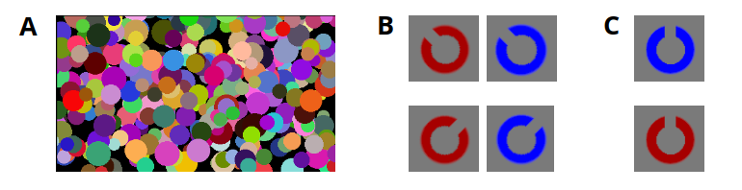
Note. A) An exemplary mask, B) Red and blue annuli cut to the side – used in training and experimental sessions, C) Red and blue annuli cut at the top – used in the conditioning session (as CS+/CS– stimuli) and reacquisition trials.

Figure 2. Schematic depiction of the course of a single training/experimental b-CFS trial.
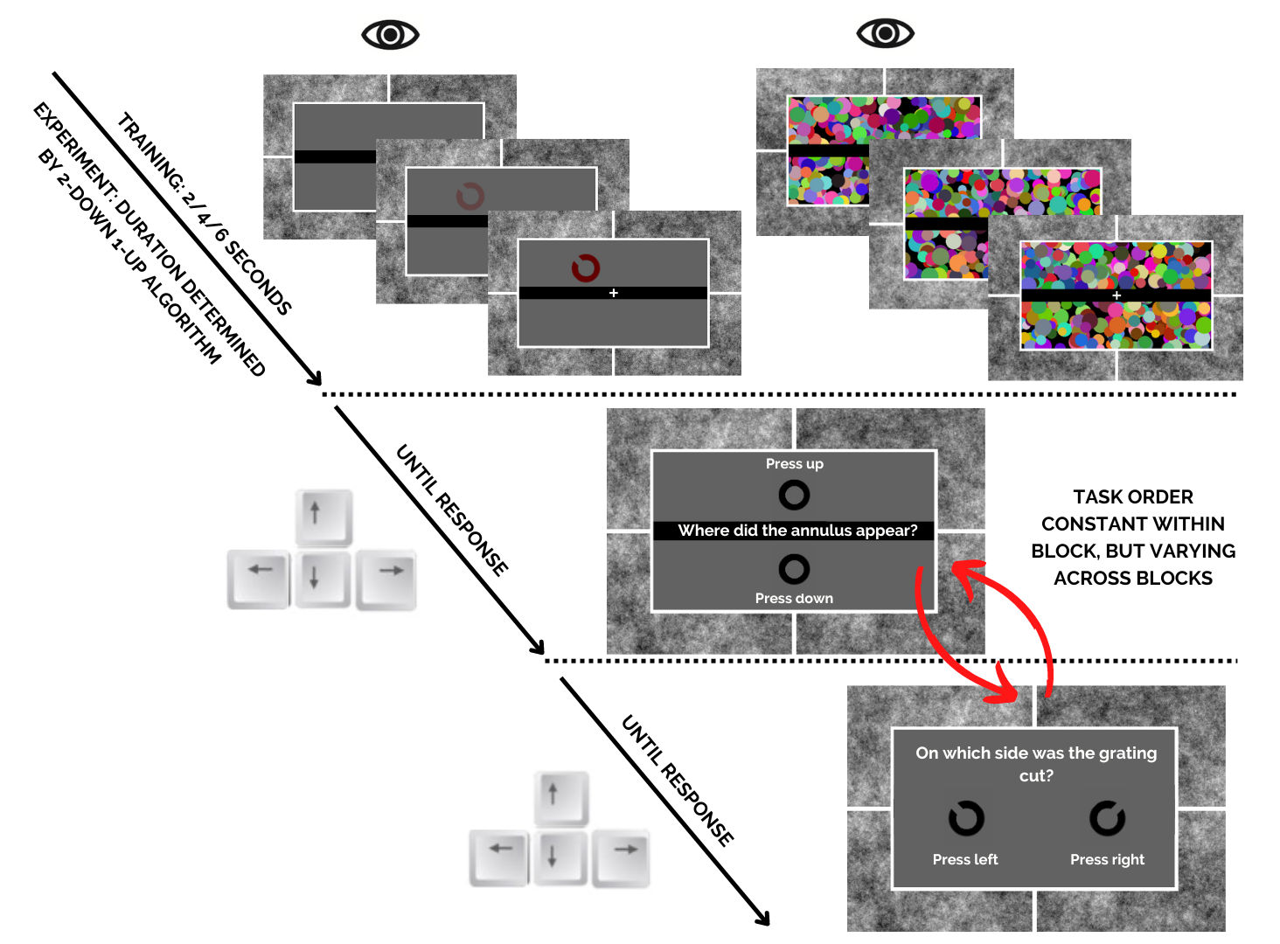
Note. Participants were asked to report the location of the presented annulus (up/down) as well as location of the cut in the annulus (left/right). Both tasks were scaffolded by exemplary black annuli with button-related instructions to minimize the risk of lapse responses. Task order was counterbalanced across blocks, but remained constant within blocks to react against trial-to-trial confusion. In the experimental session, the 2-down/1-up algorithm determining trial durations was driven solely by localization correctness.
Figure 3
Schematic depiction of a reinforced CS+ trial in conditioning session or during reacquisition in Exp. 1 (fear conditioning, 3A) and Exp. 2 (disgust conditioning, 3B).
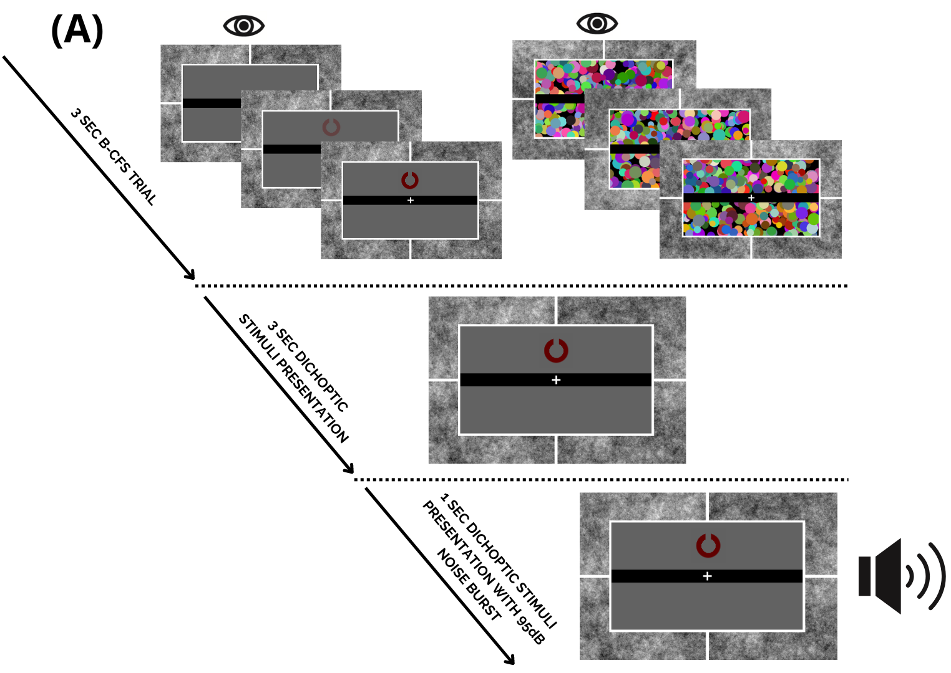
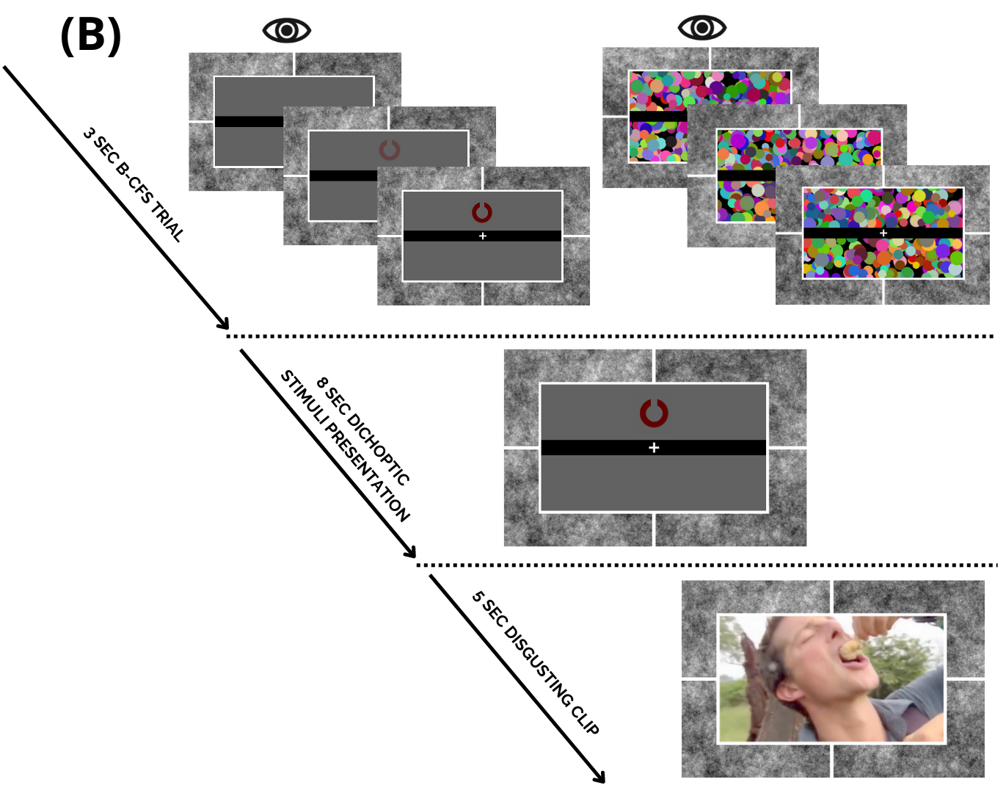

Note. After a 3 second b-CFS presentation, participants dichoptically observed a CS+ annulus cut at 12 o’clock position, followed by US presentation. Exact stimuli presentation times were based on literature recommendations. In the case of CS− or unreinforced CS+ trials in the conditioning session, the trial terminated after annulus presentation.

Figure 4
Localization and discrimination performance for fear-conditioned (CS+; left boxplot, pink color) and neutral (CS-; right boxplot, mauve color) stimuli in the breaking continuous flash suppression tasks.
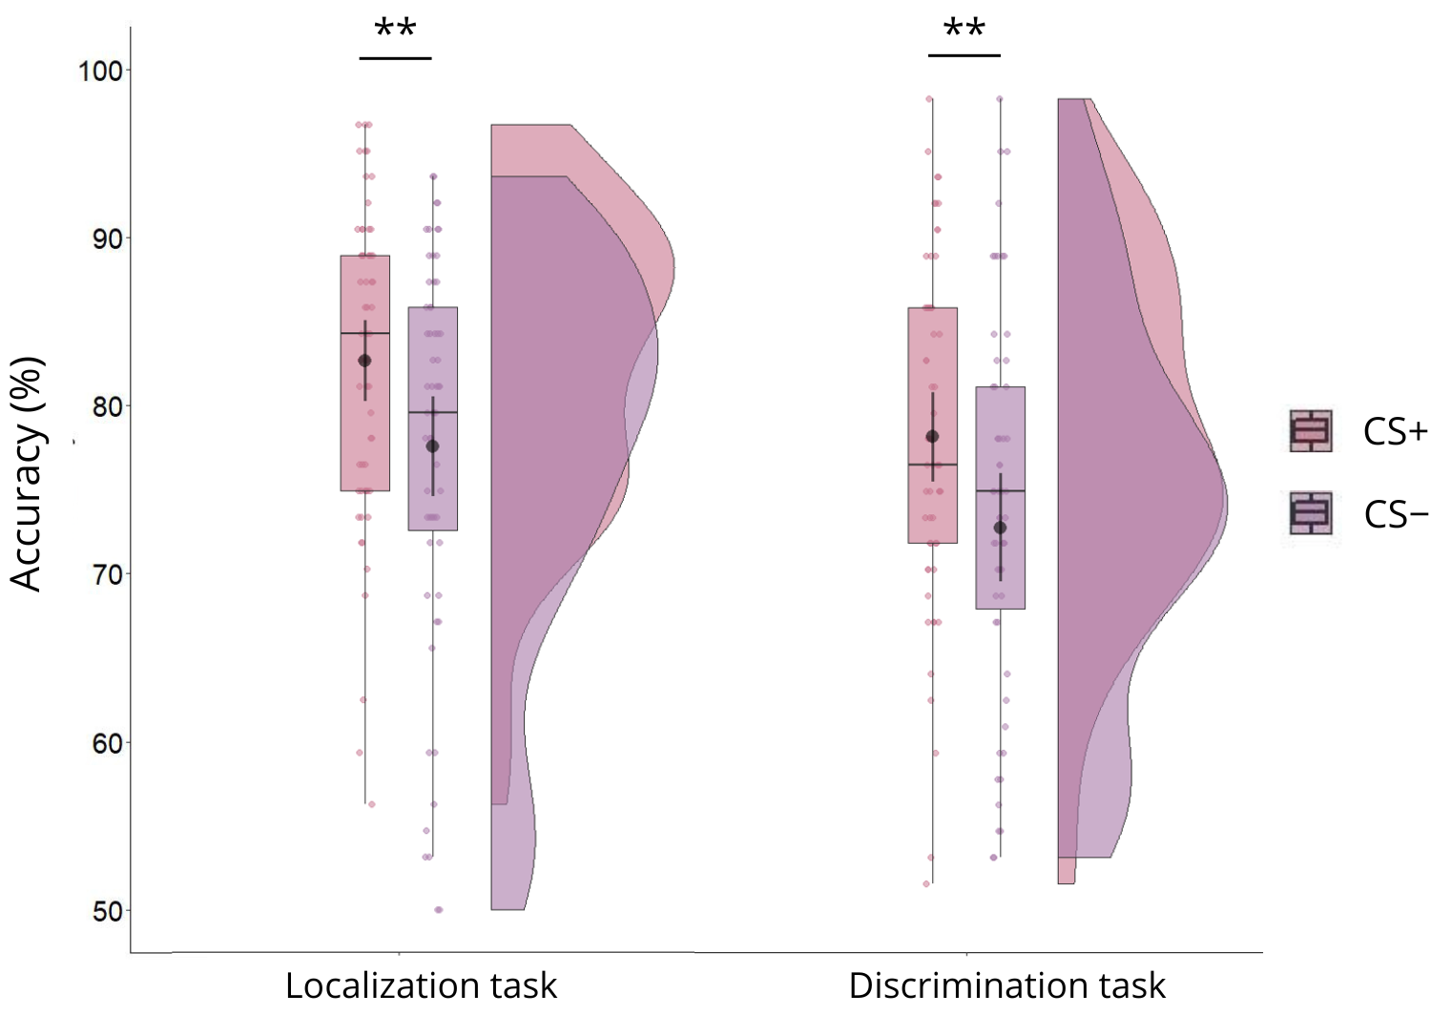
Note. Black dots indicate mean performance across participants and associated 95% confidence intervals, while boxplots present medians ± 1.5 interquartile range. Semi-transparent dots depict performance scores for individual subjects, and kernel density plots visualize probability density distributions of accuracy separately for the CS+ and CS- conditions. ** = p < 0.01.

Figure 5
Positive correlations between mean standardized SCR to US (y axis; μS) and the magnitude of the conditioning effect (x axis, %) in localization (A) and discrimination (B) tasks in the experiment 1. 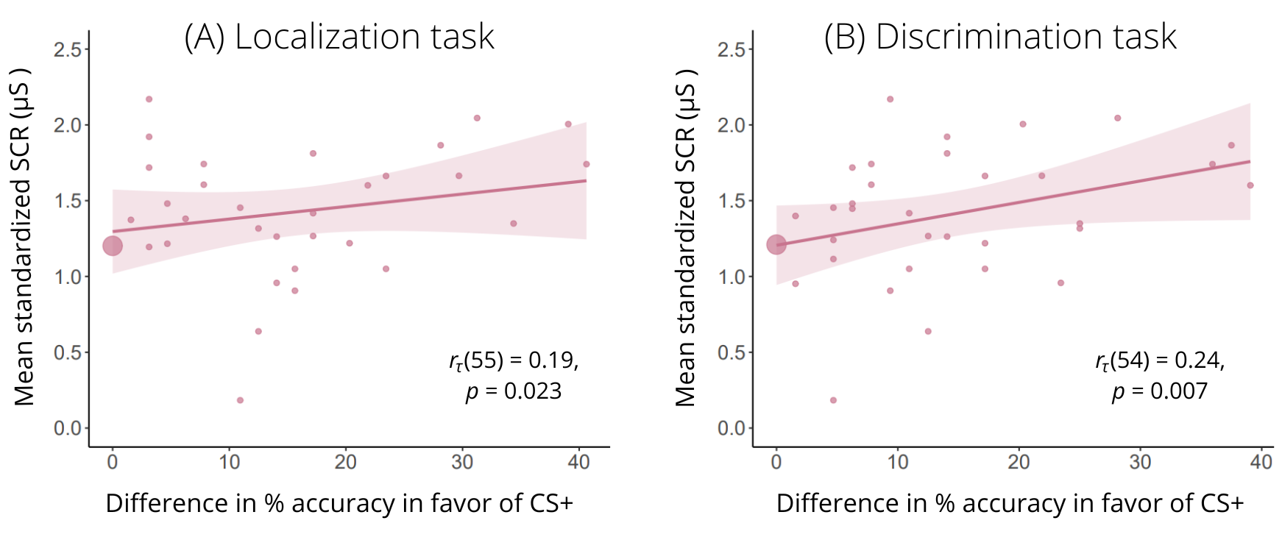
Note. Small dots present individual observations of people who performed better for the fear-conditioned (CS+) stimuli. Participants experiencing no conditioning effect (equal or better performance for CS- stimuli) were recoded to 0 and included in the analyses as separate observations. However, for the purpose of visual transparency of the plot, participants showing no conditioning effect were grouped into a large dot indicating SCR mean for all such observations (26 observations for the localization task and 24 observations for the discrimination task).
Figure 6
Localization and discrimination performance for disgust-conditioned (CS+; left boxplot, pink color) and neutral (CS-; right boxplot, mauve color) stimuli in the breaking continuous flash suppression tasks.
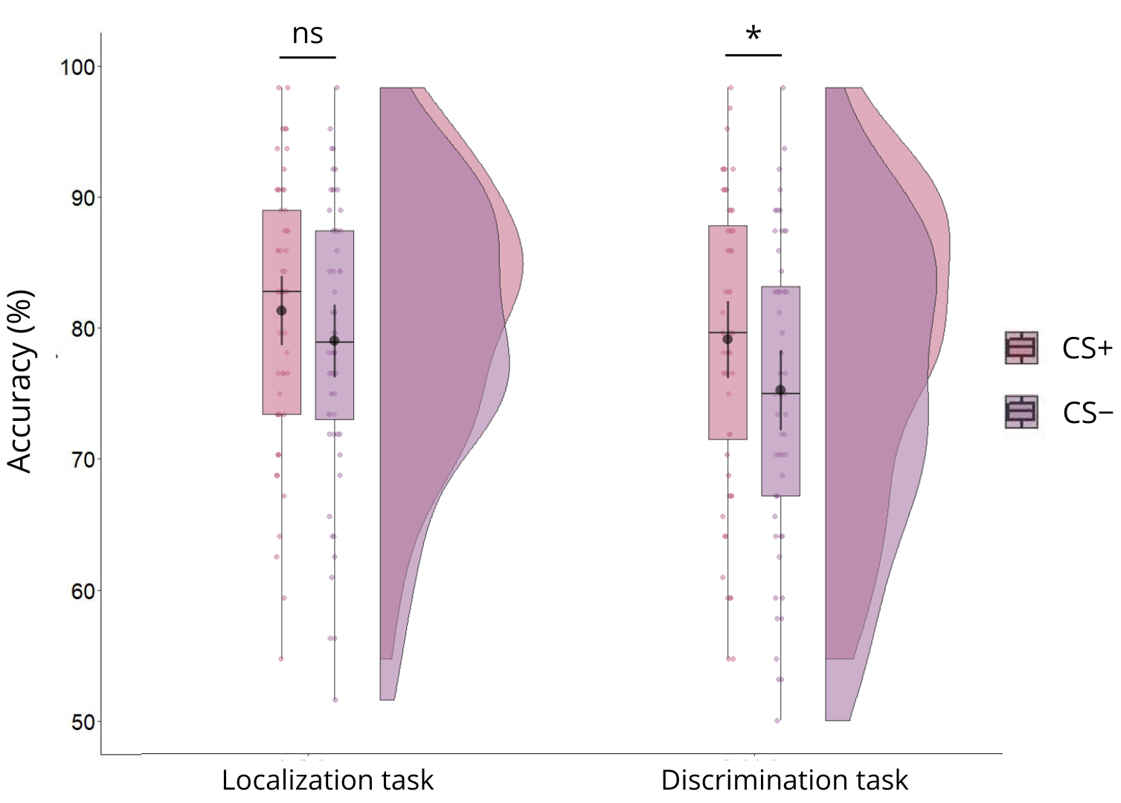
Note. Black dots indicate mean performance with associated 95% confidence intervals, while boxplots present medians ± 1.5 interquartile range. Semi-transparent dots depict performance scores for individual subjects, and kernel density plots visualize probability density distributions of accuracy separately for the CS+ and CS- conditions. * = p < 0.05.
Figure 7
Positive correlations between mean standardized SCR to US (y axis; μS) and the magnitude of the conditioning effect (x axis, %) in localization (A) and discrimination (B) tasks in the experiment 2.
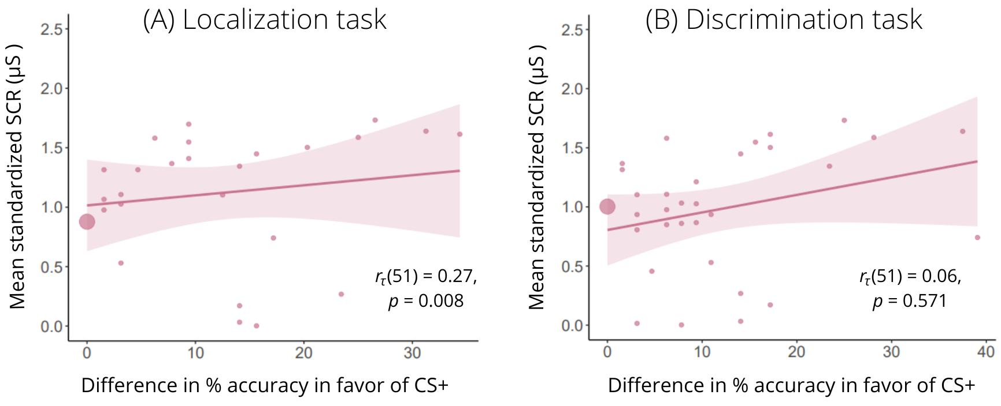
Note. Small dots present individual observations of people who performed better for the conditioned (CS+) stimuli. Participants experiencing no conditioning effect (equal or better performance for CS- stimuli) were recoded to 0 and – for the purpose of visual transparency of the plot – grouped into a large dot indicating SCR mean for all of such observations (27 observations for the localization task and 21 observations for the discrimination task).

