Latent Memory Traces for Prospective Items in Visual Working Memory
Luzi Xu*, Andre Sahakian, Surya Gayet, Chris L.E. Paffen, and Stefan Van der Stigchel
Experimental Psychology, Helmholtz Institute, Utrecht University, Heidelberglaan 1, 3584 CS, Utrecht, The Netherland

Abstract
Visual working memory is a capacity-limited cognitive system that is utilized for enabling goal-directed actions. When sampling items for visual working memory storage, however, observers are often exposed to other items that are not selected for imminent action (hereafter: ‘prospective items’). Here, we asked whether such exposure leads to memory buildup of these prospective items, facilitating subsequent visual working memory encoding for imminent action. In a series of experiments, we addressed this question using a copying task, in which participants attempted to reproduce a model display by placing items in an adjacent empty grid. To investigate whether a memory is formed for prospective items, we swapped the position of unplaced items in the model and compared copying task performance to a condition in which items remained stable. The results show that, when prospective items remained stable, participants took less time inspecting the model when encoding these items later (compared to when they were swapped). This reduced inspection duration was not accompanied by a higher number of inspections or an increase in errors. We conclude that the memory system gradually builds up latent memory traces of items that are not selected for imminent action, thus increasing the efficiency of subsequent visual working memory encoding.
Keywords: visual working memory, action, implicit memory, visual experience, copying task

- Introduction
Visual working memory (VWM) serves goal-directed behavior, as many of our actions require the internal maintenance of task-relevant items. For example, when we go shopping with a shopping list, we need to first encode and store the items on the list, after which the action of placing those items in the shopping basket can be performed. It is often the case, however, that the number of items we need to memorize exceeds the capacity of VWM. In this case, it is difficult, not to say impossible, to remember all items at once, so we may need to select a few items as current targets for imminent action (e.g., pears, pasta, and yogurt) while ignoring prospective targets (e.g., tomatoes and eggs) for the time being. The question we ask here, is whether prior exposure to items that are not selected for imminent action (termed as ‘prospective items’), facilitates VWM encoding of those items when they are selected for action later.
One possibility is that repeated exposure to prospective items benefits subsequent encoding of these items in VWM, through the gradual build-up of memory traces. In support of this, previous studies showed that observers can build up memory traces for task-irrelevant features of a multi-feature item (Boduroglu & Shah, 2014), and for task-irrelevant items surrounding targets (O’Donnell et al., 2018) when actively processing current VWM targets; the latter study showing that changes in irrelevant surrounding items can impair VWM performance of current targets. Based on this evidence, one possible hypothesis is that memory traces build up for prospective items – items that observers are exposed to, but are not selected for imminent action– while observers memorize current items for imminent action. This hypothesis predicts that these memory traces facilitate subsequent VWM encoding of the prospective items.
Another line of evidence supporting such buildup of memory traces comes from studies revealing facilitation effects of prior visual experience on visual perception (e.g., repeated exposure to a particular visual context; Chun & Jiang, 1998; Fiser & Aslin, 2002) and visual working memory (e.g., Blalock, 2015; Calmels et al., 2012; Jackson & Raymond, 2008; Lorenc et al., 2014; Ngiam et al., 2019; Scolari et al., 2008; Yan et al., 2023). From these findings, it can be hypothesized that prior exposure to items that are not selected for imminent action facilitates VWM encoding when these items are selected as targets for action later.
Spending memory resources on items that are not selected for imminent action might also impair memory representations of items that are relevant for the current action. It is therefore also conceivable that repeated exposure to prospective items does not facilitate subsequent VWM encoding of these items. It is indeed known that VWM is gated by top-down attentional control (Gazzaley & Nobre, 2012), and, according to the Selection-for-action hypothesis (Allport, 1989), attentional resources are solely directed to information that is relevant for current action goals. In this framework, current targets for action compete with other items for cognitive resources (including VWM resources), and observers actively employ top-down attentional control to filter out irrelevant information. Consistent with this idea, previous studies showed that irrelevant features of memorized items cannot be retrieved from patterns of delay activity (Serences et al., 2009), and items that are encoded in VWM but are only prospectively relevant are either stored in separate brain regions (Christophel et al., 2018; but see Iamshchinina et al., 2021) or in representational formats distinct from currently relevant items (van Loon et al., 2018; Yu et al., 2020). In fact, some studies have even shown that irrelevant information is actively suppressed in VWM tasks, in order to optimize VWM performance (Feldmann-Wüstefeld & Vogel, 2019; Zanto & Gazzaley, 2009). Based on this, it has been argued that filtering out irrelevant information from VWM reduces encoding errors (Emrich & Ferber, 2012) and decreases forgetting (Lewis-Peacock & Norman, 2014). Another reason to think that latent items will not be encoded is that even the repeated exposure of memory items may not improve VWM performance (Chen et al., 2006). The alternative hypothesis then, is that passive exposure to prospective items does not benefit subsequent VWM encoding of these items when they are selected for action.
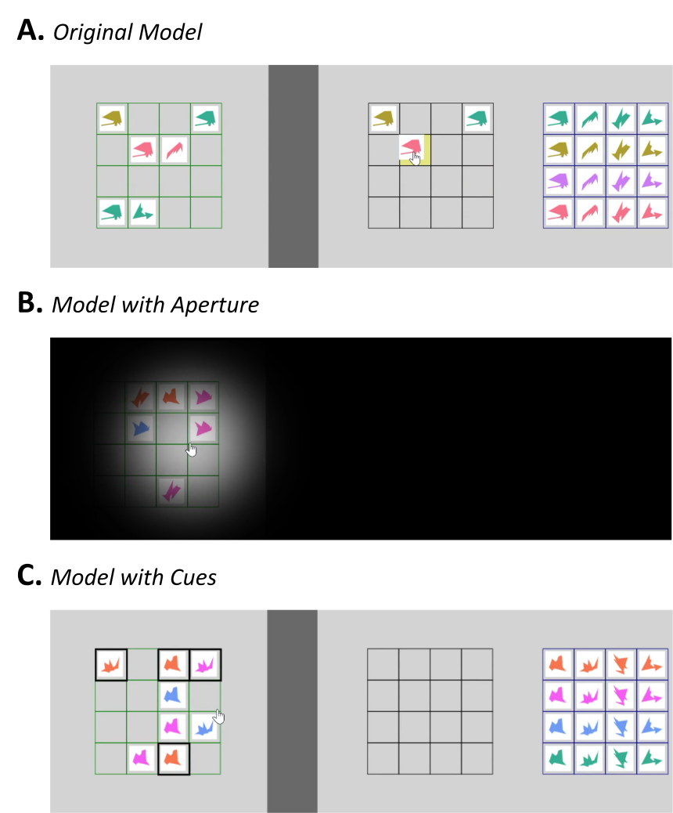
Fig. 1. (A) Overview of the Copying Task display. Participants are required to reproduce the Model grid (left) by dragging items from the Resources grid (right) to the correct position in the Workspace (middle). (B) Experiment display with aperture, as used in Experiments 1 and 2. The aperture ensures that only the area around the cursor was visible to the participant. When the cursor was in the Model grid, the Model was visible; when the cursor was in other grids, the Model grid was invisible. (C) Overview of the cued display, used in Experiment 3. Four items were cued by thick black outlines, and participants were instructed to finish these cued items first. Placing the uncued (i.e., not outlined) items was only allowed after all cued items were placed correctly. When the cursor was in the Model grid, all grids were visible; when the cursor was in other grids, the Model grid was covered by a gray square.
To test the hypotheses described above, we compared memory use in a condition that does allow for the buildup of memory traces for prospective items, with a condition that does not. To do so, we used a so-called Copying Task (Ballard et al., 1995; Sahakian et al., 2023; Somai et al., 2020), in which participants are tasked to reproduce a configuration of items (the Model) in an empty workspace, using building blocks (see Figure 1). To execute this task, observers need to inspect the Model grid and maintain one or more individual items in VWM, select those items from the Resources grid, and move them to the corresponding position in the Workspace grid. This task allowed us to test whether repeated exposure to items in the Model grid that are not selected for imminent action enhances VWM encoding when these items are selected for action later. The key manipulation in this study was that we either kept the positions of the unplaced items unchanged (i.e., the‘Stable’condition, which allows for the buildup of memory traces for these items), or we swapped the unplaced items in the Model while the Model was covered (i.e., the‘Shuffled’condition, hampering the buildup of memory traces for these items). We compared VWM encoding performance in the Stable vs. Shuffled condition when these items were subsequently selected as targets for action, to test whether prior exposure to these unplaced items benefited their later VWM encoding. If prior exposure to unplaced items benefits subsequent VWM encoding of those items, we expect better performance in the Stable condition than in the Shuffled condition, because the Shuffled condition hampers the buildup of memory traces for unplaced items.
We were interested in the efficiency and effectiveness of VWM encoding. As proxies for VWM encoding efficiency, we analyzed the number of Model inspections (i.e., the number of mouse crossings toward the Model grid) per correctly placed items, and inspection duration (i.e., sampling time) per inspection. As a proxy for the effectiveness of VWM encoding, we analyzed the number of incorrect placements (i.e., placement errors) per correctly placed item. We hypothesize that if exposure to prospective targets facilitates VWM encoding, we should observe fewer inspections, shorter inspection duration, and/or fewer errors when the position of prospective items remained constant (i.e., in the Stable condition) compared to when their position changed (i.e., in the Shuffled condition).
- Experiment 1
  - Method
    - Participants
Forty-two participants (21 women and 21 men, mean age = 27.98, SD = 4.54) were recruited via the online platform Prolific (www.prolific.co). The sample size of 40 included participants was based on a previous study that used a similar experimental paradigm and the same stimulus set (Sahakian et al., 2023). We used the same criteria for participant recruitment as this previous study: we only included participants who (1) indicated to have normal or corrected-to-normal vision, (2) indicated to be fluent in English, (3) had an approval rate higher than 95% and (4) had not taken part in earlier pilot versions of this experiment. In addition, we only recruited participants whose age was within the range of 18-35. Note that we included two participants more than planned, because the sample size was inadvertently unbalanced after 40 participants. Participants received monetary compensation for their participation (6.25 GBP).
2.1.2. Apparatus and stimuli
The experiment was programmed in the code editor Visual Studio Code (version 1.75; https://code.visualstudio.com) using the JavaScript libraries jsPsych (version 6.3.0) (de Leeuw, 2015) and Fabric.js (version 4.3.1; www.fabricjs.com), and was hosted online on the web service Gorilla (https://app.gorilla.sc).
Participants completed the experiment using their own devices (laptop or desktop computers) with the use of a computer mouse. To account for the different sizes of the displays in different devices, we used a calibration procedure to equate the stimulus size prior to the formal experiment. In this calibration task, participants were asked to hold up a credit card (or any other standard sized card, commonly 8.56 cm wide) against the screen, and then resize a rectangle on the screen to match the size of the card. This procedure ensured that the light gray rectangle background (see Figure 1) was 25 cm wide and 8.5 cm high, and that each cell of the Copying task grid was 1 cm wide and 1 cm high.
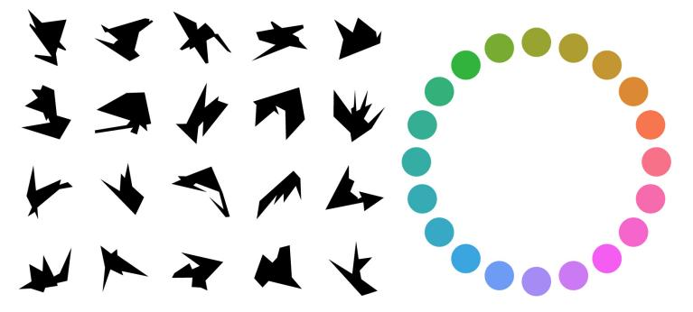
Fig. 2. The twenty shapes and twenty colors that were combined to create the stimuli in the experiment.
For each trial, we selected 16 items (combinations of 4 unique shapes × 4 unique colors) out of 400 possible items (20 shapes × 20 colors). The shapes of the items were randomly selected from a stimulus set (Arnoult, 1956) comprising 20 polygons (Figure 2). The colors of the items were randomly selected from the HSLuv (www.hsluv.org) color space (with 20 equidistant hues on the color wheel, and the saturation and luminance were set to 90% and 65% respectively). Note that, because participants used different devices and performed the task under different lighting conditions, the actual luminance and hue of our stimuli inevitably varied between participants. Finally, to prevent multiple occurrences of identical items in the Model (which would effectively decrease the amount of total information per Model), we allowed for a maximum of two identical items in per Model grid (i.e., per trial).
To track which part of the display participants were looking at, we used a cursor-directed aperture (Anwyl-Irvine et al., 2021); an aperture that followed the location of the cursor. To force participants to actively memorize the items in the Model grid, only the part of the display within the aperture (the area around the cursor) was visible, rendering the rest of the display invisible (i.e., covered by a black overlay). The location of the aperture was recorded continually, and the events (e.g., number or duration of model inspections) were defined by the movements of the aperture across different pre-defined areas (i.e., Model, Workspace, and Resources). The radius of the aperture was set to 9% of the width of the light gray experiment rectangle, and the standard deviation of the Gaussian function (for the transparency) was set to half the size of the aperture’s radius. This aperture size enabled the whole Model to be visible at once when the aperture entered the Model grid, while keeping the Workspace and Resources grids invisible.
2.1.3. Procedure
Before the formal experiment, participants received instructions and completed two practice trials; one without the overlay and aperture (as in Figure 1A) followed by one with the overlay and aperture (Figure 1B). On each trial, participants were required to reproduce the Model grid by dragging items from the Resources grid and dropping them onto the Workspace grid. While an item was hovered over the Workspace, the nearest square of the Workspace was highlighted in yellow. Once participants released an item containing the correct features (shape and color) on the correct grid cell, it was pinned to the center of that cell; if it was released in the wrong place, it would directly fly back to the original location in the Resources grid.
In the Stable condition, the positions of all items in the Model grid remained unchanged throughout the entire trial, which allowed the buildup of memory traces for unplaced items. In the Shuffled condition, the unplaced items (i.e., items that were not placed correctly) were shuffled every time the aperture reentered the Model grid after at least one placement attempt (select or drop items) was made. The positions of items that were placed correctly remained unchanged. Because the unplaced items changed location in the Shuffled condition, a potential buildup of memory traces for these items was hampered.
Participants finished 24 trials (one block) in the Stable and Shuffled blocks (48 trials in total). The order of these two blocks was counterbalanced between participants. Importantly, at the beginning of each block, participants were explicitly informed about the experimental condition of the upcoming trials.
  - Data analysis
We conducted a mixed ANOVA with Model Stability (Stable vs. Shuffled) as within-participant factor, and Block Order (Stable blocks first vs. Shuffled blocks first) as between-participant factor to account for learning effects. The ANOVA was conducted for three major outcome measures: (1) the number of Model inspections (i.e., the number of times the aperture crossed toward the Model grid) per correctly placed item and (2) the inspection duration (i.e., the number of seconds that the aperture stayed in the Model grid) per inspection were used as proxies for VWM encoding efficiency; (3) the number of incorrect placements per correctly placed item was used as proxy for VWM encoding effectiveness.
Notably, since we are interested in comparing Copying task performance between Stable and Shuffled conditions we excluded from analysis: (1) all placements following the first inspection (because items can only be shuffled from the second inspection onwards), and (2) all placements before the inspection in which only one item was left (because a single item cannot be shuffled with itself). By doing so, we only analyzed phases of the experiment where the Stable and Shuffled conditions actually differed.
  - Results
    - Inspections per correctly placed item
The results of the 2 (Model Stability: Stable vs. Shuffled) × 2 (Block Order: Stable blocks first vs. Shuffled blocks first) ANOVA showed no significant main effects of Model Stability (p > .10) and Block Order (p > .10) on the number of inspections, Figure 3. We did find a significant interaction between Model Stability and Block Order, (F(1, 40) = 25.33, p < .001, η_{p}² = 0.39), which shows an improvement of performance (i.e., a reduced number of inspections) in later (vs. early) phases of the experiment. Thus, the stability of items during previous exposure (when they were not yet correctly placed) did not influence the number of inspections for the subsequent placements of these items.
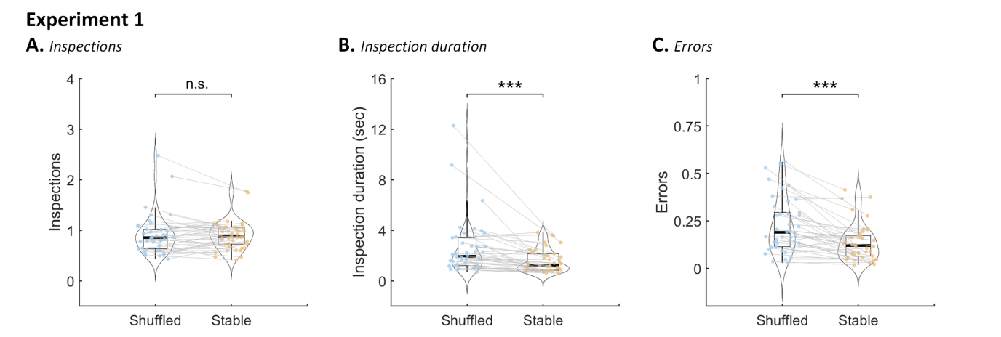
Fig. 3. Results of Experiment 1. (A) Number of Model inspections per correctly placed item. (B) Inspection duration per Model inspection. (C) Number of incorrect placements per correctly placed item. Box plots show the upper/lower quartiles, and the whiskers extend to the most extreme data point within 1.5 inter-quartile ranges above/below the upper/lower quartile. Dots show the mean data of individual participants. Curved contours show the probability density function of participant averages. *p < .05, **p < .01, ***p < .001
    - Inspection duration per inspection
Conducting the same 2×2 ANOVA on inspection duration, shows that the main effect of Model Stability (Stable vs. Shuffled) was significant, with a shorter inspection duration in Stable blocks (1.59 s, SD = 0.90) compared to Shuffled blocks (2.62 s, SD = 2.21), (F(1, 40) = 15.67, p < .001, η_{p}² = 0.28). The main effect of Block Order (p > .10) and the interaction of Model Stability and Block Order (p = .058) were not significant. Taken together, these results show that, given the same number of inspections per correctly placed item, participants spent less time encoding items in VWM when they had remained at the same location throughout a trial (i.e., in the Stable condition) compared to when they were shuffled (i.e., in the Shuffled condition).
    - Errors per correctly placed item
The same 2×2 ANOVA on the error rate shows that the main effect of Model Stability (Stable vs. Shuffled) was significant, with fewer placement errors in Stable blocks (0.14, SD = 0.10) compared to Shuffled blocks (0.22, SD = 0.15), (F(1, 40) = 32.92, p < .001, η_{p}² = 0.45). The main effect of Block Order was not significant (p > .10). The interaction of Model Stability and Block Order was significant (p = .009), which shows an improvement of performance (i.e., reduced number of placement errors) in later (vs. early) phases of the experiment. Taken together, these results show that participants made fewer placement errors for items that were previously stable than for items that were previously shuffled.
  - Interim Discussion
In Experiment 1, we found that when the Model was stable (versus shuffled), participants took less time inspecting the Model, even though the number of inspections was the same. In addition, they made fewer errors when copying the items to the Workspace. These results indicate that repeated exposure to items that had not been correctly placed improved subsequent VWM encoding efficiency and encoding effectiveness.
Given the goal of the study, we hypothesized that these improvements in performance were caused by prior exposure to items that were not selected for imminent action (i.e., prospective items). In this experiment, however, the shuffled items were arguably not all prospective items, but might also include items that were – in fact – selected for action. For example, participants might have attempted to place an item, but placed it incorrectly, and then went back to the Model for further inspection; or, participants might have decided last-minute not to place an item that was initially memorized for action (e.g., because they were unsure about its location or feature), thus going back to the Model. In these two situations, the item that was previously memorized for action already, would have been spatially swapped in the Shuffled condition (along with the other unplaced items). As such, the performance cost in the Shuffled condition of Experiment 1 is either caused by reduced exposure to prospective items (as hypothesized), or because items changed as participants encoded them during consecutive inspections. Since we are specifically interested in the possible effects of the exposure of items that have not been selected for action (i.e., prospective items), we should ensure to only disrupt the buildup of memory traces for items that were not actually acted upon in the Shuffled condition (rather than shuffling all unplaced items). This is what we did in Experiment 2.
- Experiment 2
We conducted Experiment 2 to test whether the benefits in VWM encoding observed in Experiment 1 were solely due to prior exposure to items that were never acted upon (i.e., prospective items), rather than disruption of items that were selected but incorrectly placed. Instead of shuffling the Model before each inspection (what we did in Experiment 1), in Experiment 2, we shuffled the Model after each correct placement. Participants were forced to go back to the Model after each correct placement because they were only allowed to place one item. When participants placed an item incorrectly (or decided not to place an item) and then went back to the Model, the model remained unchanged. This ensured that only those items were shuffled that had not been acted upon, and ensured that items were not shuffled when participants needed multiple glances to place it correctly. By doing so, any difference in performance between the Shuffled condition and the Stable condition can be attributed to the repeated exposure to items that were never acted upon. Again, if the previous exposure to prospective items facilitates VWM encoding, we would observe better VWM performance (i.e., fewer inspections, shorter inspection duration, and/or fewer errors) when prospective items were stable (versus shuffled) compared to when they were shuffled.
  - Methods
    - Participants
A new group of forty participants (21 women and 19 men, mean age = 28.30, SD = 4.50) were recruited via Prolific, following the same recruitment criteria as in Experiment 1.
    - Apparatus and stimuli
The apparatus and stimuli in Experiment 2 were identical to those of Experiment 1.
    - Procedure
The experimental design and procedure of Experiment 2 was similar to that of Experiment 1 except for the following changes: First, participants were allowed to place only one item in the Workspace after each inspection. To achieve this, items could no longer be selected from the Resources grid after a correct placement. As a result, they were forced to go back to the Model before being able to place a new item. Second, in the Shuffled condition, the Model was shuffled after each correct placement of an item.
  - Data analysis
The method of data analysis was identical to that of Experiment 1. As for Experiment 1, we needed to exclude data from those phases of the experiment where the Stable and Shuffled conditions did not differ. In this case, this entailed excluding from analysis all placements following inspection of the first item and following inspection of the last item.
  - Results
    - Inspections per correctly placed item
The results of the 2 (Model Stability: Stable vs. Shuffled) × 2 (Block Order: Stable blocks first vs. Shuffled blocks first) ANOVA revealed no significant main effects of Model Stability (p > .10) and Block Order (p > .10) on the number of inspections (see Figure 4). However, there was a significant interaction between Model Stability and Block Order, (F(1, 38) = 14.79, p < .001, η_{p}² = 0.28), which shows an improvement of performance (i.e., a reduced number of inspections) in later (vs. early) phases of the experiment. Thus, the stability of items during previous exposure (when they were not selected for imminent action) did not influence the number of inspections for the subsequent placements of these items.
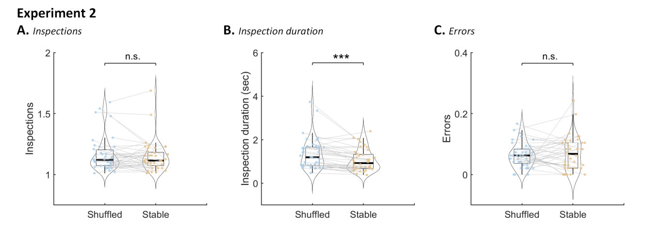
Fig. 4. Results of Experiment 2. (A) Number of inspections of the Model per correctly placed item. (B) Inspection duration of the Model per inspection. (C) Number of placement errors per correctly placed item. Box plots show the upper/lower quartiles, and the whiskers extend to the most extreme data point within 1.5 inter-quartile ranges above/below the upper/lower quartile. Dots show the mean data of individual participants. Curved contours show the probability density function of participant averages. *p < .05, **p < .01, ***p < .001
    - Inspection duration per inspection
The results show that the main effect of Model Stability (Stable vs. Shuffled) on inspection duration was significant, with shorter inspection duration in Stable blocks (1.05 s, SD = 0.50) compared to Shuffled blocks (1.34 s, SD = 0.70), (F(1, 38) = 20.68, p < .001, η_{p}² = 0.35). The main effect of Block Order (p > .10) was not significant. The interaction between Model Stability and Block Order was significant, F(1, 38) = 6.87, p = .013, η_{p}² = 0.15, which shows an improvement of performance (i.e., reduced inspection duration) in later (vs. early) phases of the experiment. Taken together, these results show that, given the same number of inspections per correctly placed item, participants spent less time encoding items in VWM when they had remained at the same location throughout a trial (i.e., in the Stable condition) compared to when they were shuffled (i.e., in the Shuffled condition).
    - Errors per correctly placed item
Results showed that the main effects of Model Stability (p > .10) and Block Order (p > .10), and the interaction between Model Stability and Block Order (p = .064) on the amount of errors were all not significant. These results show that the stability of prospective items during previous exposure (when they were not selected for imminent action) did not influence the number of errors that participants made when subsequently placing these items.
  - Interim Discussion
In Experiment 2, we found that when the unplaced items were stable (versus shuffled), it took participants less inspection time to copy the Model grid, despite similar numbers of inspections and errors. Since we ensured that the unplaced items that were shuffled were items that had not been utilized or even selected for action (i.e., prospective items), the difference between the Stable and Shuffled conditions can be attributed to the stability of prospective items. These results suggest that, through repeated exposure, memory traces were built up for items that were not selected for action. As a result of this, items were more efficiently encoded into VWM later.
Although we found no difference in the number of errors in Experiment 2, we cannot ascertain that the effectiveness of VWM encoding was unaffected by the stability of items when they were not selected for imminent action. This is because we allowed participants to place only one item after each inspection, which inevitably led to floor effects in the number of errors. Therefore, it remains unclear whether the effectiveness of VWM encoding could also be affected by prior exposure to prospective items. We addressed this issue in Experiment 3.
- Experiment 3
In Experiment 3, we used a new approach that incorporated the strengths of the first two experiments into one design while also avoiding their weaknesses: First, in order to optimize the sensitivity for detecting a difference in the number of errors, we allowed participants to place multiple items after each inspection (as in Experiment 1), ensuring a greater sensitivity for detecting difference in VWM encoding effectiveness between the Stable and Shuffled conditions. Second, we ensured that shuffled items were not previously selected for action (as in Experiment 2). To achieve this, we cued four items and instructed participants that these items needed to be placed first. Only after they finished placing these four cued items were they allowed to place the remaining four (uncued) items. Because participants were not allowed to place the uncued items before placing the cued items, we can assume that the uncued items were never selected for action when participants were placing the first four (cued) items. Thus, to manipulate the stability of prospective items, we shuffled the uncued items, while participants were placing the cued items (i.e., in the first phase of the trial). To measure whether exposure to stable prospective items facilitated VWM encoding, we then compared performance for placing uncued items (in the second phase of the trial), depending on whether these items were previously shuffled (Shuffled condition) or not (Stable condition).
  - Methods
    - Participants
A new group of forty participants (19 women and 21 men, mean age = 28.55, SD = 4.76) were recruited via Prolific, following the same recruitment criteria as in Experiments 1 and 2.
    - Apparatus and stimuli
The apparatus and stimuli in Experiment 3 were identical to those of Experiments 1 and 2.
    - Procedure
The experimental design and procedure of Experiment 3 were similar to those of Experiment 1, except for the following changes: First, there were four items cued by thickened black outlines (Figure 1). The cues remained on the screen throughout an entire trial. Participants were instructed to copy these four cued items first. In participants placed an uncued item correctly in this phase of the trial, the item would fly back to the Resources grid as if it was incorrect. Only after participants finished placing all cued items, were they allowed to place the remaining items. Importantly, after having placed all cued items, participants had to reinspect the Model before being allowed to place the uncued items. Second, in the Shuffled condition, we only shuffled the uncued items while participants were placing the cued items (i.e., in the first phase of a trial). Importantly, after having placed all cued items, participants had to reinspect the Model (triggering one more swap in the Shuffled condition) before being allowed to place the uncued items. When participants were placing the uncued items (in the second phase of a trial), the items in the model were always fixed (also in the Shuffled condition). This allowed us to measure the influence of prior exposure on subsequent memory encoding, while keeping the visual stimulation identical between conditions.
Because the items that were shuffled (i.e., the uncued items) were in all likelihood never selected for action during the placements of the cued items, we did not need to incorporate any further restrictions for the swapping to occur (as in Experiment 1). Therefore, in Experiment 3, the uncued items in the Model were shuffled every time participants went back to the Model grid for inspection (in the first phase of a trial).
  - Data analysis
The method of data analysis is similar to that of Experiments 1 and 2. Of note, we are mainly interested in participants’ performance on the uncued items (i.e., the second phase of the trial), as a function of whether these uncued were shuffled or stable in the first phase of the trial (when they were not selected for imminent action). Therefore, we report the data for placing uncued items first. We also report performance for placing cued items (first phase of the experiment), to investigate the influence of swapping (other items) on copying task performance, which might have contributed to the effects observed in Experiments 1 and 2.
  - Results
    - Inspections per correctly placed item: Uncued items (second phase of the trial)
The results of the 2 (Model Stability: Stable vs. Shuffled) × 2 (Block Order: Stable blocks first vs. Shuffled blocks first) ANOVA show no significant main effect of Model Stability (p = .063) and Block Order (p > 0.10) on the number of inspections, Figure 5. The interaction between Model Stability and Block Order is not significant (p = .052). Thus, the stability of items during previous exposure (i.e., uncued items during the placements of cued items) did not influence the number of inspections for subsequent placements of these (uncued) items.
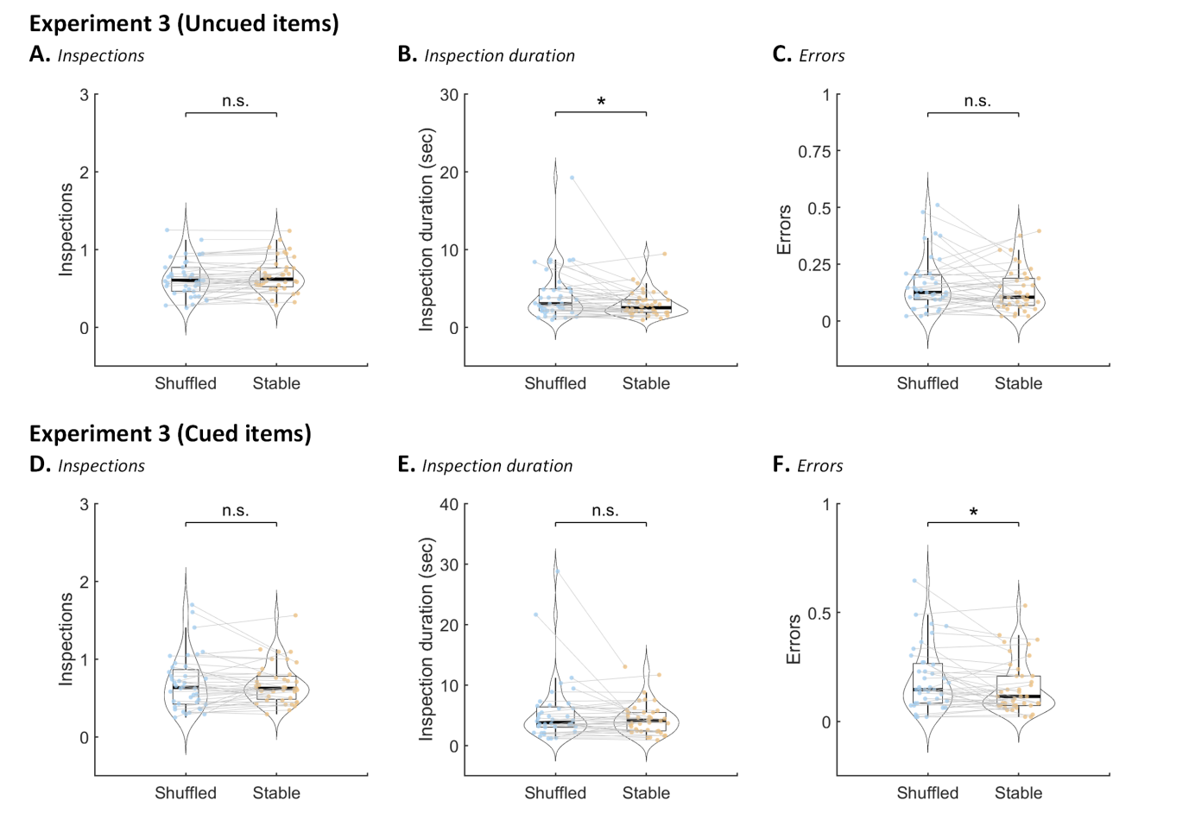
Fig. 5. Results of Experiment 3. (A), (B), & (C) show the data for placing uncued items (second phase of the experiment). (D), (C), & (F) show the data for placing cued items (first phase of the experiment). (A) & (D) Number of inspections of the Model per correctly placed item. (B) & (E) Inspection duration of the Model per inspection. (C) & (F) Number of erroneous placements per correctly placed item. Box plots show the upper/lower quartiles, and the whiskers extend to the most extreme data point within 1.5 inter-quartile ranges above/below the upper/lower quartile. Dots show the mean data of individual participants. Curved contours show the probability density function of participant averages. *p < .05, **p < .01, ***p < .001
    - Inspections per correctly placed item: Cued items (the first phase of the trial)
The results of the 2 (Model Stability: Stable vs. Shuffled) × 2 (Block Order: Stable blocks first vs. Shuffled blocks first) ANOVA show no significant main effect of Model Stability (p > .10) and Block Order (p > .10) on the number of inspections. The interaction between Model Stability and Block Order, however, is significant, F(1, 38) = 4.71, p = .036, η_{p}² = 0.11, which reflects better performance (i.e., a reduced number of inspections) in later (vs. early) phases of the experiment. Thus, the stability of prospective items (i.e., uncued items) did not influence the number of inspections for placing the current targets (i.e., cued items).
    - Inspection duration per inspection: Uncued items (the second phase of the trial)
Results show that the main effect of Model Stability (Stable vs. Shuffled) on inspection duration is significant, with shorter inspection duration in Stable blocks (2.97 s, SD = 1.63) compared to Shuffled blocks (4.14 s, SD = 3.35), (F(1, 38) = 5.72, p = .022, η_{p}² = 0.13). The main effect of Block Order (p > .10) and the interaction of Model Stability and Block Order (p > .10) are not significant. These results show that, given the same number of inspections per correctly placed item, participants spent less time encoding uncued items in VWM when they had remained at the same location throughout a trial (i.e., in the Stable condition) compared to when they were shuffled (i.e., in the Shuffled condition) during previous exposure.
    - Inspection duration per inspection: Cued items (the first phase of the trial)
Results show that the main effects of Model Stability (p = .099) and Block Order (p > .10) on inspection duration were not significant. The interaction between Model Stability and Block Order was also not significant (p > .10). These results suggest that the stability of prospective items (i.e., uncued items) did not influence inspection duration for placing the current targets (i.e., cued items).
    - Errors per correctly placed item: Uncued items (the second phase of the trial)
Results show that the main effects of Model Stability (p > .10) and Block Order (p > .10) on the amount of errors, and the interaction between Model Stability and Block Order (p > .10) are all not significant. These results show that the stability of uncued items in previous exposure did not influence the number of errors that participants made when they subsequently placed these items.
    - Errors per correctly placed item: Cued items (the first phase of the trial)
Results show that the main effect of Model Stability on the amount of errors was significant, with fewer errors in the Stable condition (0.16, SD = 0.12) compared with the Shuffle condition (0.19, SD = 0.14), F(1, 38) = 6.65, p = .014, η_{p}² = 0.15. The main effect of Block Order (p > .10) and the interaction between Model Stability and Block Order (p = .065) were not significant. These results suggest that participants made more errors placing the current (cued) items when the surrounding prospective (uncued) items were being shuffled (i.e., in the Shuffled condition), compared to when they were kept stable (i.e., in the Stable condition).

Table 1. An overview of conditions and behavioral results of Experiments 1-3
Experiment | Shuffled Items | Timing of Shuffling | No. of Placements | Rejections of H₀
1 | Items that are not yet correctly placed | Before each inspection | Unlimited (max. 6) | Inspection duration (efficiency) & Errors (effectiveness):  Stable < Shuffle
2 | Items that were not yet used (either correctly or incorrectly) | After each  correct placement | One placement at most after each inspection | Inspection duration (efficiency):  Stable < Shuffle
3 | Items that were not yet cued for action | Before each inspection | Unlimited (max. 4) | Inspection duration (efficiency):  Stable < Shuffle

  - Interim Discussion
In Experiment 3, we used a cue-based design to ensure that manipulated items were not selected for action, while at the same time optimizing the sensitivity for detecting a difference in the number of placement errors. We replicated the findings of Experiment 2 that when the position of prospective items (i.e., uncued items during the placement of cued items) had been stable, participants took less time inspecting the Model to place these items later. As such, even though participants knew they were not allowed to place the prospective (uncued) items before having placed all cued items, they still built up latent memory traces for those prospective (uncued) items. Also confirming the results of Experiment 2, we found no difference in the number of errors between the Stable and Shuffled conditions. Together, these findings show that prior exposure enhances subsequent VWM encoding by increasing VWM encoding efficiency, while leaving VWM encoding effectiveness unchanged.
- General Discussion
When encoding items into visual working memory (VWM) for imminent action, observers are often simultaneously exposed to other items that are not selected for imminent action. Here, we asked whether observers build up memory traces of these prospective items through prior exposure. More specifically, we investigated whether prior exposure benefits subsequent encoding of items into VWM, when they are selected for action later. In this study, we addressed this question using a so-called Copying Task (Ballard et al., 1995; Sahakian et al., 2023; Somai et al., 2020), in which participants reproduced a six-item Model grid, by placing items in an empty grid. Experiment 1 showed shorter inspection durations and fewer placement errors when the configuration of items that had not been correctly placed was stable rather than shuffled. In Experiments 2 and 3, in which we ensured that the manipulated items were not selected for action, we observed shorter inspection durations when the prospective items were stable (versus shuffled). In these latter two experiments, however, shuffling the non-selected items did not affect the number of erroneous placements. Together, these results show that visual exposure to prospective items increases the efficiency (but not the effectiveness) of encoding these items into VWM when they are selected for action later.
The shorter inspection durations in the Stable (versus Shuffled) condition provide evidence for the buildup of memory traces during visual exposure to prospective items. This memory trace then benefits subsequent encoding of these items into VWM. An alternative account, however, is that inspection durations were not reduced by prior exposure (in the Stable condition), but increased in the Shuffled condition due to interference. That is, the swapping of items might have hampered normal VWM encoding processes. Swapping prospective items might, for instance, cause proactive interference (Makovski et al., 2008), where the memory of previously encoded items interferes with encoding of the current (swapped) items. Such changes in spatial configuration might increase the errors in binding specific features to certain spatial locations (Emrich & Ferber, 2012). Importantly, however, in our Experiment 3, items were no longer shuffled when participants encoded the (formerly prospective) items in VWM for imminent action. Nonetheless, under these circumstances, inspection durations were still shorter in the Stable condition. This demonstrates that prior exposure was beneficial to subsequent VWM encoding, rather than swapping being detrimental to (normal) VWM encoding. Together, these results demonstrate that prior exposure to items that are not selected for imminent action expedites subsequent encoding of these items into VWM.
Our findings support the hypothesis that –through repeated exposure– the visual system builds up memory traces for items that are not yet selected for action. This runs counter to the view that currently irrelevant (i.e., prospectively relevant) items are not processed or even suppressed. Given the capacity limitations of VWM, it is essential to protect VWM content from interference. Since prospective items can potentially compete for cognitive resources with items that are selected for imminent action, it would make sense to inhibit processing of prospective items to benefit VWM processes for items that are encoded for imminent action. Contrary to this idea, analysis of the first phase of Experiment 3 (when prospective items were being shuffled or not) showed that swapping prospective items increased the number of errors for concurrently placed items. This finding shows that the prospective items are not (fully) suppressed, consistent with previous studies showing that processing of task-irrelevant surrounding items does not interfere with VWM performance (Tas et al., 2016) and may instead benefit current VWM processing (O’Donnell et al., 2018). Thus, (prospective) items surrounding the items that are encoded for imminent action may be processed because they can contribute to current VWM processing (e.g., by providing contextual cues). The present findings show another benefit of encoding surrounding items: it benefits subsequent encoding of these items into VWM.
But how could observers build up memory traces for prospective items while concurrently encoding other items for imminent action? One possibility is that prospective items are encoded into VWM (alongside the current items) because they are relevant for the task. In this view, observers might have encoded the display as a whole in VWM (i.e., as a single complex object; Brady & Alvarez, 2015), prioritizing some individual items for imminent action, and other (prospective) items for later use (O'Donnell et al., 2018). Another possibility is that prospective items are encoded by a system that is independent of VWM, thereby bypassing the capacity limit of VWM storage. There are several possible (not mutually exclusive) mechanisms that could operate in parallel with VWM: First, observers may be able to allocate attentional resources to prospective items while concurrently processing current VWM targets (e.g., Einstein & McDaniel, 2005). In this way, the pre-allocation of attention may help facilitate the encoding of these items in VWM later. Second, observers might concurrently build up memory traces of these prospective items through implicit learning processes that are independent of VWM load, such as context learning (Vickery et al., 2010). Third, the repeated exposure of prospective items might draw upon plasticity-based memory systems such as long-term memory (Heinen et al., 2022). All these mechanisms could benefit later VWM encoding of prospective items, while bypassing the capacity limits of the VWM system. Future work is needed to investigate which mechanism is responsible for the memory buildup of prospective items.
The present study has implications for a wide range of VWM studies: while previous studies mainly focused on VWM for items that are selected as targets for imminent goal-directed action (e.g., Zhang & Luck, 2008), our findings imply that, in VWM tasks, more items are processed than only the explicitly targeted items. Second, typical VWM studies require participants to memorize all presented stimuli, and provide a completely new set of stimuli on each trial. Although this approach is useful to investigate specific VWM processes in isolation (e.g., encoding and maintenance of novel visual input), it does not necessarily reflect how VWM operates in the more complex and often stable visual environments that we encounter in daily life. Therefore, the present study contributes to our understanding of how VWM might operate in daily life, where visual information remains externally available, and where the amount of task-relevant information might exceed the capacity limits of VWM (thus requiring multiple consecutive instances of VWM encoding). Third, our results support the idea that prior visual experience can enhance VWM processing of visual stimuli, which is in line with previous work (Blalock, 2015; Calmels et al., 2012; Jackson & Raymond, 2008; Lorenc et al., 2014; Moore et al., 2022; Ngiam et al., 2019; Scolari et al., 2008; Yan et al., 2023). The present work extends this body of literature, by showing that the benefit of prior exposure on VWM processes also occurs when observers are exposed to items that are not selected for imminent action.
The present work can be placed in a conceptual framework that describes the trade-off between sampling information from the external world, and retaining information internally using VWM. That is, because of the limited capacity of VWM (Cowan, 2005, 2010; Miller, 1956), observers sometimes capitalize on the availability of information in the external world (using it as external memory). This strategy decreases the burden on internal VWM storage (Somai et al., 2020; Sahakian et al., 2023), thereby achieving cognitive offloading (Risko & Gilbert, 2016). According to these views, a trade-off is made between the cost of internal VWM storage (e.g., attentional resources) and the costs of (re-)sampling the external world (e.g., the cost of eye movements or locomotion) (Van der Stigchel, 2020). Previous studies revealed that increasing the accessibility (Drasckow et al., 2021; Sahakian et al., 2023) and the stability of information in the external world (e.g., Chota et al., 2023) cause observers to rely less on internal VWM storage, since, in those situations, the cost of external sampling is decreased (e.g., when observers have faster access to re-inspect visual stimuli). Our study reveals how an aspect of the external world - its stability - can reduce the cost of VWM storage; a stable outside world allows repeated exposure to prospective items, thereby rendering internal VWM storage more efficient. Although prior exposure reduced the cost of internal VWM storage (by reducing encoding time), this did not cause participants to rely more on internal VWM storage; that is, participants did not sample the external world (i.e., the Model grid) less frequently when a stable environment allowed for faster VWM encoding. One tentative explanation for this is that observers failed to monitor (subtle) differences in the cost of internal VWM storage, so that the trade-off between internal VWM storage and external sampling depended mainly on the (perceived) cost of external sampling.
- Conclusion
In conclusion, the present study shows that when sampling a subset of items for imminent goal-directed behavior, observers also form latent memory traces for the items that are not selected for imminent action. These memory traces subsequently increase encoding efficiency, by reducing the time needed to encode these items into VWM later. Together, these findings show that the human brain extracts more information from individual glances than what is actively selected for imminent behavior, thereby benefiting prospective VWM-guided behavior.

References
Allport, A. (1989). Visual attention. In M. I. Posner (Ed.), Foundations of cognitive sciences (pp. 631–682).Cambridge, MA: MIT Press.
Anwyl-Irvine, A. L., Armstrong, T., & Dalmaijer, E. S. (2021). MouseView.js: Reliable and valid attention tracking in web-based experiments using a cursor-directed aperture. Behavior Research Methods, 1–25.
Arnoult, M. D. (1956). Familiarity and recognition of nonsense shapes. Journal of Experimental Psychology, 51(4), 269–276.
Ballard, D. H., Hayhoe, M. M., & Pelz, J. B. (1995). Memory representations in natural tasks. Journal of Cognitive Neuroscience, 7, 66–80.
Blalock, L. D. (2015). Stimulus familiarity improves consolidation of visual working memory representations. Attention, Perception, & Psychophysics, 77, 1143–1158.
Boduroglu, A., & Shah, P. (2014). Configural representations in spatial working memory. Visual Cognition, 22(1), 102–124.
Brady, T. F., & Alvarez, G. A. (2015). No evidence for a fixed object limit in working memory: Spatial ensemble representations inflate estimates of working memory capacity for complex objects. Journal of Experimental Psychology: Learning, Memory, and Cognition, 41(3), 921.
Calmels, C., Foutren, M., & Stam, C. J. (2012). Beta functional connectivity modulation during the maintenance of motion information in working memory: importance of the familiarity of the visual context. Neuroscience, 212, 49–58.
Chen, D., Yee Eng, H., & Jiang, Y. (2006). Visual working memory for trained and novel polygons. Visual Cognition, 14(1), 37–54.
Chota, S., Gayet, S., Kenemans, J. L., Olivers, C. N., & Van der Stigchel, S. (2023). A matter of availability: sharper tuning for memorized than for perceived stimulus features. Cerebral Cortex, 33(12), 7608–7618.
Christophel, T. B., Iamshchinina, P., Yan, C., Allefeld, C., & Haynes, J. D. (2018). Cortical specialization for attended versus unattended working memory. Nature Neuroscience, 21(4), 494–496.
Chun, M. M., & Jiang, Y. (1998). Contextual cueing: Implicit learning and memory of visual context guides spatial attention. Cognitive Psychology, 36(1), 28–71.
Cowan N. (2005). Working memory capacity. New York, NY: Psychology Press.
Cowan, N. (2010). The magical mystery four: How is working memory capacity limited, and why?. Current Directions in Psychological Science, 19(1), 51–57.
de Leeuw, J. R. (2015). jsPsych: A JavaScript library for creating behavioral experiments in a web browser. Behavior Research Methods, 47(1), 1–12.
Draschkow, D., Kallmayer, M., & Nobre, A. C. (2021). When natural behavior engages working memory. Current Biology, 31(4), 869–874.
Einstein, G. O., McDaniel, M. A., Thomas, R., Mayfield, S., Shank, H., Morrisette, N., & Breneiser, J. (2005). Multiple processes in prospective memory retrieval: factors determining monitoring versus spontaneous retrieval. Journal of Experimental Psychology: General, 134(3), 327.
Emrich, S. M., & Ferber, S. (2012). Competition increases binding errors in visual working memory. Journal of Vision, 12(4), 12.
Feldmann-Wüstefeld, T., & Vogel, E. K. (2019). Neural evidence for the contribution of active suppression during working memory filtering. Cerebral Cortex, 29(2), 529–543.
Fiser, J., & Aslin, R. N. (2002). Statistical learning of new visual feature combinations by infants. Proceedings of the National Academy of Sciences, 99(24), 15822–15826.
Gazzaley, A., & Nobre, A. C. (2012). Top-down modulation: bridging selective attention and working memory. Trends in Cognitive Sciences, 16(2), 129–135.
Heinen, K. T., Kenemans, J. L., & van der Stigchel, S. (2022). Recruitment of a long-term memory supporting neural network during repeated maintenance of a multi-item abstract visual image in working memory. Scientific Reports, 12(1), 575.
Iamshchinina, P., Christophel, T. B., Gayet, S., & Rademaker, R. L. (2021). Essential considerations for exploring visual working memory storage in the human brain. Visual Cognition, 29(7), 425–436.
Jackson, M. C., & Raymond, J. E. (2008). Familiarity enhances visual working memory for faces. Journal of Experimental Psychology: Human Perception and Performance, 34(3), 556.
Lewis-Peacock, J. A., & Norman, K. A. (2014). Competition between items in working memory leads to forgetting. Nature Communications, 5(1), 5768.
Lorenc, E. S., Pratte, M. S., Angeloni, C. F., & Tong, F. (2014). Expertise for upright faces improves the precision but not the capacity of visual working memory. Attention, Perception, & Psychophysics, 76(7), 1975 – 1984.
Makovski, T., & Jiang, Y. V. (2008). Proactive interference from items previously stored in visual working memory. Memory & Cognition, 36, 43–52.
Miller G. A. (1956). The magical number seven plus or minus two: Some limits on our capacity for processing information. Psychological Review, 63, 81 – 97.
Moore, K. N., Lampinen, J. M., Adams, E. J., Nesmith, B. L., & Burch, P. (2022). Prior experience with target encounter affects attention allocation and prospective memory performance. Cognitive Research: Principles and Implications, 7(1), 37.
Ngiam, W. X., Khaw, K. L., Holcombe, A. O., & Goodbourn, P. T. (2019). Visual working memory for letters varies with familiarity but not complexity. Journal of Experimental Psychology: Learning, Memory, and Cognition, 45(10), 1761.
O'Donnell, R. E., Clement, A., & Brockmole, J. R. (2018). Semantic and functional relationships among objects increase the capacity of visual working memory. Journal of Experimental Psychology: Learning, Memory, and Cognition, 44(7), 1151.
Risko, E. F., & Gilbert, S. J. (2016). Cognitive offloading. Trends in Cognitive Sciences, 20(9), 676–688.
Sahakian, A., Gayet, S., Paffen, C. L., & Van der Stigchel, S. (2023). Mountains of memory in a sea of uncertainty: sampling the external world despite useful information in visual working memory. Cognition, 234, 105381.
Scolari, M., Vogel, E. K., & Awh, E. (2008). Perceptual expertise enhances the resolution but not the number of representations in working memory. Psychonomic Bulletin & Review, 15(1), 215–222.
Serences, J. T., Ester, E. F., Vogel, E. K., & Awh, E. (2009). Stimulus-specific delay activity in human primary visual cortex. Psychological Science, 20(2), 207–214.
Somai, R. S., Schut, M. J., & Van der Stigchel, S. (2020). Evidence for the world as an external memory: A trade-off between internal and external visual memory storage. Cortex, 122, 108–114.
Tas, A. C., Luck, S. J., & Hollingworth, A. (2016). The relationship between visual attention and visual working memory encoding: A dissociation between covert and overt orienting. Journal of Experimental Psychology: Human Perception and Performance, 42(8), 1121–1138.
Van der Stigchel, S. (2020). An embodied account of visual working memory. Visual cognition, 28(5–8), 414–419.
van Loon, A. M., Olmos-Solis, K., Fahrenfort, J. J., & Olivers, C. N. (2018). Current and future goals are represented in opposite patterns in object-selective cortex. ELife, 7:e38677.
Vickery, T. J., Sussman, R. S., & Jiang, Y. V. (2010). Spatial context learning survives interference from working memory load. Journal of Experimental Psychology: Human Perception and Performance, 36(6), 1358.
Yan, N., Grindell, J., & Anderson, B. A. (2023). Encoding history enhances working memory encoding: Evidence from attribute amnesia. Journal of Experimental Psychology: Human Perception and Performance. 49(5), 589–599.
Yu, Q., Teng, C., & Postle, B. R. (2020). Different states of priority recruit different neural representations in visual working memory. PLoS biology, 18(6), e3000769.
Zanto, T. P., & Gazzaley, A. (2009). Neural suppression of irrelevant information underlies optimal working memory performance. Journal of Neuroscience, 29(10), 3059–3066.
Zhang, W., & Luck, S. J. (2008). Discrete fixed-resolution representations in visual working memory. Nature, 453(7192), 233–235.

