Remote photoplethysmography (rPPG) in the wild: Remote heart rate imaging via online webcams.

Daniele Di Lernia^{1,4┼*}, Gianluca Finotti^{2┼}, Manos Tsakiris^{2,3}, Giuseppe Riva^{1,4}, Marnix Naber⁵

¹Humane Technology Lab, Università Cattolica del Sacro Cuore, Largo Gemelli, 1, 20100, Milan, Italy
²Lab of Action and Body, Department of Psychology, Royal Holloway, University of London, Egham Hill, Egham TW20 0EX, United Kingdom
³Centre for the Politics of Feelings, School of Advanced Study, University of London, UK
⁴Applied Technology for Neuro-Psychology Lab, IRCCS Istituto Auxologico Italiano, Via Magnasco, 2 20149 Milan, Italy
⁵ Experimental Psychology, Helmholtz Institute, Utrecht University, Heidelberglaan 1, 3584CS, Utrecht, The Netherlands

┼ These authors contributed equally to this work
Corresponding Author
*Daniele Di Lernia, Department of Psychology, Università Cattolica del Sacro Cuore
Largo Gemelli, 1, 20100, Milan, Italy, Tel.: +39 02 72343863, E-mail address: daniele.dilernia@unicatt.it

Abstract
Remote photoplethysmography is a low-cost technique to measure physiological parameters such as the heartrate by analysing videos of a person. There has been growing attention in this technique due to the increased possibilities and demand for running psychological experiments in online platforms. Many progresses have been made due to technological advancements in commercially available cameras and in the algorithms used to process the videos. Despite these advancements, past research has shown that suboptimal conditions of the video recordings can severely impair the accuracy of the rPPG. Our aim was to test the accuracy of a modified open-source rPPG algorithm on videos collected via an online platform, without control on the hardware of the participants and the contextual variables, such as illumination, distance and motion. Across two experiments, we compared the results of the rPPG extraction algorithm to a validated dataset used for rPPG testing, and then we collected 231 online video recordings and compared the results of the rPPG extraction against a validated mobile heart rate application. Results showed that the rPPG was highly accurate on both datasets thus providing an improved tool for recording and analyzing heartrate in online experiments.

Background

Remote photoplethysmography (rPPG) is a method that utilizes video recordings to collect physiological parameters (such as heart rate, respiration rate, and oxygenation) remotely through light variations on the skin surface (van der Kooij & Naber, 2019). rPPG is based on the concept that heartbeat pulsations produce changes in skin blood perfusion and that such changes can be measured through variations in luminosity (Hertzman, 1937). Using this principle, Verkruysse et al. (2008) demonstrated that heart rate measurements could also be achieved through the remote detection of normal light variations on the skin with consumer cameras. In this case, rPPG works via a process called photo-amplification, able to remotely detect variations in the reflected colours of the skin, which are caused by changes in capillary tissue movement (Kamshilin et al., 2015).
Several open-source implementations of this technology exist and are freely available in code repositories (van der Kooij & Naber, 2019; McDuff & Blackford, 2019; Boccignone et al., 2020). However, rPPG’s accuracy depends on specific setup requirements, including camera specifications, illumination, video encoding, facial movements, and the general setting (e.g., a constant neutral background). Suboptimal conditions may severely impair the possibility to use rPPG techniques in out-of-lab environments, such as during online data collection, where researchers cannot control beforehand the setting, the illumination, or the hardware used by the participants. While several video databases for rPPG benchmarking are openly available (Bobbia et al., 2019; Guillaume Heusch et al., 2017; Soleymani et al., 2012; Stricker et al., 2014), finding a way to include rPPG in online experiments could provide researchers with a tool that can be deployed to collect physiological parameters remotely, fostering large scale psychophysiological data collections outside the lab.
For these reasons, we set out to develop and test an improved algorithm along with a collection and pre-processing pipeline able to extract rPPG data from videos recorded via an online platform. The solution presented can work in suboptimal conditions that usually impair common rPPG algorithms’ ability to extract reliable data when illumination, framing, background, and movements are not controlled for. Moreover, the presented solution can work with basic software requirements, needing only a web-browser, without the necessity to control participants’ hardware (e.g., pc and webcam), and with very short video recordings (starting from 25seconds) if minimum frames per seconds parameters are met. Taken together, these improvements constitute a very flexible and powerful tool that can be easily deployed in online data collections, allow researchers to record and utilize physiological measures in large scale online experiments and psychophysiological paradigms.
In two studies, we will demonstrate rPPG extraction merged with an online experimental platform that allows to record participants’ heart rate despite the limited control over the context and the setup. In study 1, we first compared the results of a modification of an open-source rPPG extraction algorithm (Van der Kooij & Naber, 2019) to a validated dataset (CohFace) used for rPPG testing (Heusch et al., 2017). In the second study we collected 231 online video recordings of 18 participants and we compared the results of the rPPG extraction against a validated mobile heart rate application (Losa-Iglesias et al., 2016).

Methods

Study 1: CohFace Dataset

Stimuli
We tested the rPPG algorithm on the CohFace video dataset (G. Heusch et al., 2017) because the video properties and light conditions most closely match to those of the videos recorded in Study 2. The CohFace dataset includes 164 videos from 40 individuals. The average subject age is 35.6 years old, with a standard deviation of 11.47 years. The gender of the participants was 12 women (30%) and 28 men (70%). Each face is recorded with a Logitech HD Webcam C525, at a resolution of 640 x 480 and a frame rate of 20 FPS, for a duration of 60 seconds. At the same time, Blood-Volume Pulse (BVP) and respiration were also recorded, with a sensor from Thought Technologies (BBVP model SA 9308M) - for more information, see (Heusch et al., 2017). Moreover, each participant was recorded in two different lighting conditions: 1) studio quality (that is, closed blinds, minimizing natural light, with extra light from a spot to keep the face of the subject well illuminated); 2) with natural light (artificial lights were turned off and the blinds were opened).

Analysis
As a first step, we extracted the real number of heartbeats from the BVP trace. To this aim, Heusch and Marcel report using a simple peak-detector available as a free software. However, visual inspection showed that several BVP traces presented slow frequency and/or high frequency noise. For this reason, first, we normalized the data by applying the Matlab normalize function. BVP signals were then detrended and then filtered with the smoothdata function using a moving window (set at 50). Only then, we used the findpeaks function, with a minimum peak distance of 450 ms. Visual inspection showed that this procedure was effective in reliably detect BVP peaks in most cases with the exception of 12 BVP traces. These, and the relative videos, were excluded from further analysis resulting in a final sample of N = 152 videos.

Data Cleaning
All the videos were processed with our rPPG algorithm. As a first step, we removed videos for which the rPPG HR could not be computed because the computer vision toolbox could not recognize a face (10 videos removed). All videos had a frame rate higher than 19.9, therefore no videos were removed due to low frame rate. We removed all videos for which the real HR (0 videos) or the rPPG HR (1 video) was lower than 50 or higher than 120 Beats Per Minute (BPM). Finally, we used the r boxplot function to detect and remove outliers, defined as the values outside the interquartile range, both for the Real HR and the rPPG HR. No outliers were found with this method. This process left us with a total of 141 videos from 39 different participants for the final analysis.

rPPG extraction
Analyses of the videos were conducted in MATLAB. Most analyses steps are described in detail by Van der Kooij and Naber (2018) but some modifications were made to improve the accuracy of the rPPG algorithm. Figure 1 highlights the most relevant analysis steps of the RPPG algorithm. The first step consists of the detection of the face in the first frame using the computer vision toolbox cascade object detector that uses a Viola-Jones algorithm trained on the FrontalFaceLBP dataset (Lienhart et al., 2003). Then we detected unique feature points in the face that consisted of corner points as detected with a minimum eigenvalue algorithm (Shi & Tomasi, 1994). These features were tracked in the following frames using the computer vision toolbox point tracker that uses the Kanade-Lucas-Tomasi algorithm (KLT; (Lucas, 2016; Tomasi, 1991). In contrast to the color-based skin detection method described in Van der Kooij and Naber (2018), we used a rough template of a face to localize skin areas above and below the eyes. The template was adjusted in size and rotated in 2D space depending on the spatial orientation of the tracked features per frame. The average RGB values across all skin pixels was stored per frame, resulting in a 3 (RGB colour channels) by n (number of frames) matrix as input for the rPPG analysis. To roughly equalize data power, which depends on the frame rate and differed across videos, this array was resampled to 60Hz using MATLAB’s pchip interpolation method. Next, each colour channel was band-pass filtered using a Butterworth filter (0.75-2.75Hz; 6th order). We then dimension-reduced the RGB array, initially representing changes in average 3D RGB colour space, to a single array, eventually representing only heart-beat-related fluctuations, using the plane-orthogonal-to-skin algorithm (POS; Wang et al., 2021) with a sliding window size of 1.6secs. This final array was converted to the frequency domain using a time-frequency analysis based on Lomb-Scargle periodogram calculations per sliding window of 10secs with a temporal resolution of 240 points and frequency resolution of 120 points. The resulting power density functions, represented in a 2D (240 by 120) data array, were converted to signal-to-noise ratios (i.e., SNR; also termed coherence) per time point by dividing each power value by the sum of all absolute power values. Only the frequencies with the 5th percentile largest SNR values were selected to calculate heart rate. The final RPPG HR measure was based on the SNR-weighted average of frequencies.
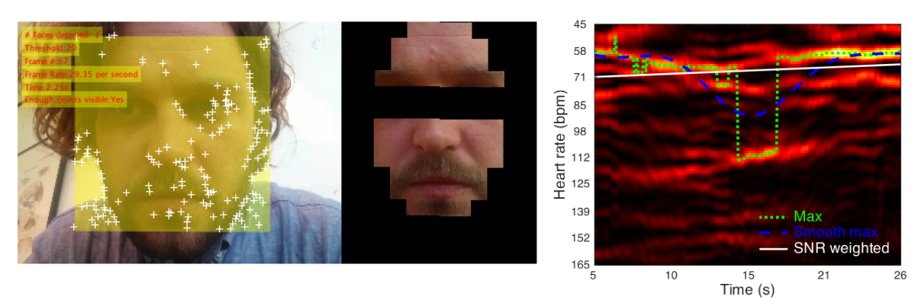
Figure 1 shows, on the left, a snapshot of the RPPG algorithm’s detection of the face location (yellow square), unique features to track head rotations (white crosses), and skin mask placed on top of the face depending on head rotations. It shows, on the right, the results of a time-frequency analysis with time in seconds on the x-axis and heart rate in beats per minute on the y-axis. Brighter colors indicate higher signal power. The overlaid time traces indicate functions representing heart rate based on maximum power values of a raw (green, dotted) or smoothed (blue, dashed) function, or based on SNR-weighted power values (white, solid).

Accuracy
First, we checked whether our variables of interest were normally distributed by visual inspection of Quantile-Quantile Plots (Q-Q plots, which compare two probability distributions by plotting their quantiles against each other), Skewness (that is, the symmetry of the data) and Kurtosis (that is, whether the data are heavy tailed, or light tailed). Furthermore, we performed two separate Shapiro-Wilk tests of normality, one for True HR and one for rPPG HR. Because data were not normally distributed, we used non-parametric tests.
In order to test the accuracy of the HR as measured with the rPPG, we compared the rPPG HR to the ground truth (i.e., BVP-based HR), from now on referred to as True HR. To this end, first, we performed a Spearman correlation between the True HR and rPPG HR.
As a second step, we tested whether the rPPG HR differed from the True HR using estimation statistics (using the median difference to estimate differences across measures). Finally, we averaged the HR across videos per subject. Then, we repeated the previous analysis (bootstrapped Spearman correlation and estimation statistics) on the averaged HR scores.

Study 2: online validation

Participants
Eighteen participants took part in the study. One participant was removed from further analysis due to extremely poor quality of the video recordings, leaving a total of 17 participants and 204 videos in the final dataset (11 females, 6 males, M_{age} = 33.11, SD = 14.34). All participants provided written informed consent before participation. The study was approved by the department of psychology ethics committee at Royal Holloway University of London.

Procedure, video collection and conversion
Participants were invited to perform an online experiment hosted on Gorilla Platform (https://gorilla.sc/). After signing the online consent, participants were instructed to download a validated mobile application to record their heartrate (Losa-Iglesias et al., 2016), to activate the webcam and to i) sit in a well illuminated room with natural light, ii) sit as still as possible during the recordings, iii) face the camera and sit close to the camera iv) avoid any shadows on the face, v) avoid covering any part of the face (e.g., by wearing a mask, by hair or touching the face).
After the instruction, we used Gorilla’s beta video recording zone functionality to activate the webcam of the participants and to record videos of their face. We recorded three videos with different durations (25s, 35s, 45s) for each participant’s session. Participant were informed when the video recording started with an audio cue (i.e., a 200 ms beep). During the recording, they were instructed to look at a fixation cross displayed on a screen. Immediately after each recording interval, participants were instructed to measure their heartrate via the mobile phone application and to manually write in a text field the actual heartrate, which served as control measure for the rPPG HR estimate. Participants were asked to repeat the experiment for approximately seven times on separate days with at least a day in between, resulting in multiple video recordings for each participant. A total of 213 online video recordings were collected. The number of videos varied per participant as some did not completed the total of 8 requested sessions. As such, some participated once (thus contributing with 3 videos), while others participated up to eight times (thus contributing with 24 videos). A total of 71 sessions were concluded and each participant finished 3.9 times (SD = 2.6) on average.
Heartrate measured via mobile application (App HR) immediately after each video recording provided a control measure for the rPPG HR estimate. We selected a mobile application with cross-platform availability, high reliability, high concurrent validity, and high consistency compared to a finger pulsi oximeter (Intra Class Correlation (ICC), used to determine reliability between trials when using each system, pulse oximeter and App; ICC > 0.93; Coefficients of Variation of Method Errors (CVME), calculated for the absolute comparison of parameters; CVME = 1.66−4.06 % (Losa-Iglesias et al., 2016).
We converted the videos (resolution: 640 by 480 pixels) from Gorilla native video settings VP80 or VP90 codec and webm format, to .mp4. For the conversion, we used HandBrake (https://handbrake.fr/) with the following parameters: Production Max, Quality Lossless (Placebo). All other pre-sets parameters were left as they were. These conversion parameters created best quality videos that allowed accurate frame-by-frame processing in MATLAB for the rPPG extraction.

Analysis

Data Cleaning
As a first step, we removed videos for which the App HR control measure was missing. This could happen either because participants didn’t correctly input the App HR values (7 videos removed), or because of a system failure which resulted in the behavioural data not being uploaded to the Gorilla platform (3 videos removed).
Some videos could not be processed because the computer vision toolbox could not detect a face. As a result, for these videos we could not compute the rPPG HR and they were removed from further analysis (5videos removed). Then, we removed all videos with frame rate lower than 20 Frames Per Second (FPS; 24 videos removed). Thirdly, we removed all videos for which the HR as measured either with the phone app or with the rPPG was lower than 50 or higher than 120 Beats Per Minute (BPM), assuming that the parameters extraction failed (6 videos were removed because the App HR was not in this range). Finally, we used the r boxplot function to detect and remove outliers, defined as the values outside the interquartile range, both for the App HR (2 videos removed) and rPPG HR (6 videos removed). This process left us with a total of 151 videos from 15 different participants (9 Females, 6 Males) for the final analysis (See figure 2).
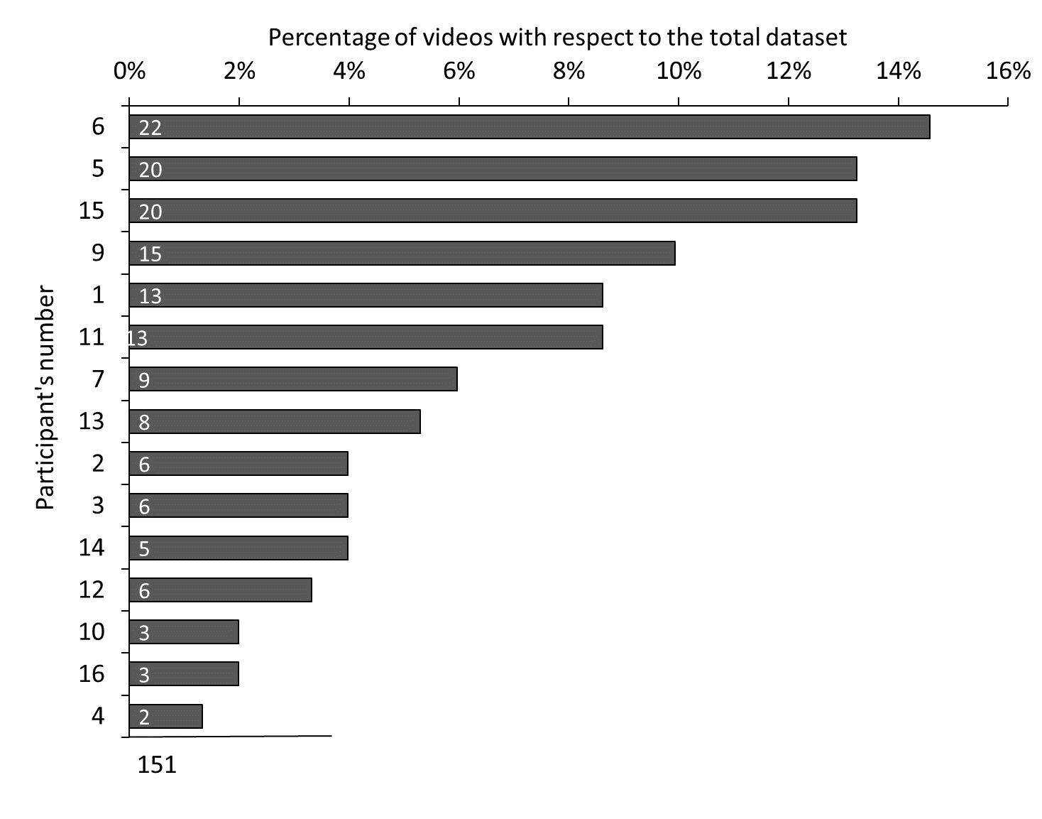
Figure 2 shows, on the x axis, the percentage of videos per participant, y axis, with respect to the total number of videos in the dataset after the data cleaning procedure. The labels inside the bars show the total number of videos per participant (these were collected in different sessions spanning over several days), also show is the sum of all videos.

rPPG extraction
Analyses of the videos were conducted in the same way as for Study 1.

Accuracy
First, we checked whether our variables of interest were normally distributed in the same fashion as for Study 1 and by performing two separate Shapiro-Wilk tests of normality, one for App HR and one for rPPG HR. The analysis showed that data were normally distributed (see results), therefore we used parametric tests.
In order to test the accuracy of rPPG on our wild video dataset, we compared the rPPG HR to the App HR by performing a Pearson correlation.
Second, we calculated to what degree the rPPG HR differed from the App HR. To this end, we used estimation statistics based on confidence intervals (CIs) and represented with Cumming estimation plots (Cumming, 2014; Ho et al., 2019). In particular, we used the mean difference for two comparisons, shown with Cumming estimation plots. These plots show the raw data for each condition and the paired difference with 95% bias corrected accelerated confidence interval based on 5000 bootstrap samples. Paired differences across measures were estimated based on mean (M_{diff}), for normally distributed data, or median (Me_{diff}), for non-normally distributed data. Inference was based on the inspection of the estimated difference across conditions and the precision of such estimate (i.e. length of the CI): in accordance with previous works using this approach (Benassi et al., 2021). CIs fully overlapping with 0 were interpreted as indicative of no evidence of difference between measures; CIs not overlapping with 0 were interpreted as indicative of weak, moderate, or strong evidence of difference between measures based on the size of the estimated difference and its precision, as the longer the CI, the weaker evidence there is (Calin-Jageman & Cumming, 2019; Cumming, 2014).
These statistics were computed using the web application available at: https://www.estimationstats.com/. Previous studies showed that the accuracy of the HR as recorded via rPPG also depends on the duration of the video analysed (van der Kooij & Naber, 2019). In that work, as more frames were added in the rPPG analysis, the more the correlation between the rPPG HR and the ground truth increased. In the present work, each experimental session comprised three video recordings: 25s, 35s, 45s, hence, each video is composed of a different number of frames (the shorter the duration, the less number of frames). Thus, one could speculate that longer videos would provide more reliable estimates. Therefore, to compensate for possible fluctuation in the shorter videos collected, we averaged the HR calculated from the three videos aiming at increasing the correlation between the App HR and the rPPG HR. To test whether this is the case, we averaged the HR per each experimental session. Then, we repeated the previous analysis (bootstrapped Spearman correlation and estimation statistics) on the averaged HR scores.

Results

Study 1: CohFace Dataset

Accuracy
Visual inspection of Q-Q plots and distribution plots showed that the data were not normally distributed. This was further confirmed by the Shapiro-Wilk tests of normality (True HR, P <0.001, rPPG HR, p = 0.09). A bootstrapped Spearman correlation revealed a strong, positive correlation between True HR (IQR = 19.35, SD = 10.67) and rPPG HR (IQR = 10.43, SD = 7.12), which was statistically significant (see Figure 3; r_{s} = 0.752, BCa 95% CI [-0.642, 0.829], p < 0.001, see figure 3).

Figure 3 shows the relation between the True HR and the rPPG HR.
The paired median difference between True HR and rPPG HR is -0.412 [95.0%CI -0.335, 0.917]. This indicates that there was only a small difference between the real heart rate and heart rate scores extracted with the rPPG algorithm (see figure 4).

Figure 4 left shows boxplots for each condition with each paired set of observations connected by a line. The right figure shows the paired median difference between the True HR and rPPG HR.

The bootstrapped Spearman correlation performed on the HR averaged across all videos per participant (N participants = 39, average videos per participant = 3.6, SD = 1.1) revealed a strong, positive correlation between Mean True HR (Mean = 70.59, SD = 11.17) and mean rPPG HR (Mean = 69.56, SD = 6.15), which was statistically significant (See Figure 5); r_{s} = 0.873, BCa 95% CI [0.713, 0.935], p < 0.001). This indicates that recording multiple videos of the same participant substantially improves rPPG’s accuracy (see figure 5).
Figure 5 shows the relation between the True HR averaged per participant and the rPPG HR.

The paired median difference between the average True HR (IQR = 20.63) and average rPPG HR (IQR = 8.70) is 0.429 [95.0%CI -1.23, 1.36] (see figure 6). In this case, averaging the videos did not improve the accuracy of the rPPG as compared to the paired median HR difference of the non-averaged videos. Nonetheless, in both cases the difference between the true HR and the rPPG HR scores was small.

Figure 6 left shows boxplots for each condition with each paired set of observations connected by a line. The right figure shows the paired median difference between the True HR and rPPG HR averaged per participant.

Study 2: online validation

Accuracy
Visual inspection of Q-Q plots and distribution plots showed that the data were normally distributed. This was further confirmed by the Shapiro-Wilk tests of normality (APP HR, P = 0.72, and rPPG HR, p = 0.15).
A bootstrapped Pearson correlation revealed a strong, positive correlation between App HR (across all sessions and conditions, 25, 35 and 45 seconds, mean = 72.83, SD = 8.34) and rPPG HR (mean = 70.27, SD = 6.22), which was statistically significant (r = 0.578, BCa 95% CI [0.386, 0.696], p < 0.001, see Figure 7 top-left plot. For the analyses on the individual conditions, see Supplementary Material).

Figure 7 shows the relation between the HR as measured with the Phone App and the HR calculated with the rPPG across all experimental sessions and all conditions (25, 35 and 45 seconds; for the analyses on the individual conditions see supplementary materials).
The top left plot shows the relation between the two variables in all different timing conditions. In the top right, bottom left and bottom right plots we show the same relationship but for each condition separately (25, 35 and 45 seconds respectively).

When pooling all duration conditions, the paired mean difference between App HR and rPPG HR was -2.56 (Mean Absolute Error (MAE) = 5.50, [95.0%CI -3.56, -1.41], see figure 8). This indicates that there was evidence of a moderate difference between heart rate scores as measured with the App and HR scores extracted with the rPPG algorithm. This difference means that rPPG underestimates HR with respect to the App HR, however this difference is relatively small (5.56 heartbeats).

Figure 8 shows the paired median difference between App HR and rPPG HR with a Gardner-Altman estimation plot. The left figure shows boxplots for each condition and each paired set of observations is connected by a line. The right figure shows the paired mean difference between the two conditions: the median difference is depicted as a dot; the 95% confidence interval is indicated by the ends of the vertical error bar.

Next, we checked whether averaging the HR calculated across the three duration conditions (25, 35, 45 seconds), per session (N = 55), would increase the correlation between the App HR and the rPPG HR. The bootstrapped Pearson correlation revealed a strong, positive correlation between Mean App HR (mean = 72.98, SD = 7.55) and mean rPPG HR (mean = 70.44, SD = 5.85), which was statistically significant (see Figure 9; r_{s} = 0.752, BCa 95% CI [-0.610, 0.838], p < 0.001). Notably, the correlation coefficient is higher than the one for the non-averaged conditions, which seems to support the prediction that combining the rPPG HR for the three conditions would increase the accuracy of the estimated HR.
Figure 9 shows the relation between the HR averaged per condition (25, 35, 45 seconds) and per session, as measured with the Phone App and the rPPG HR.

However, the paired mean difference between the average App HR and average rPPG HR was -2.54, MAE = 4.34, [95.0%CI -3.81, -1.18], indicating no improvement as compared to the – 2.56 mean difference for the non-averaged conditions (see figure 10).

Figure 10 left shows boxplots for each condition with each paired set of observations connected by a line. The right figure shows the paired mean difference between App HR and rPPG HR averaged per session.

Conclusions and future directions
The aim of this study was to demonstrate the functionality of a newly developed rPPG extraction algorithm to measure the heart rate via webcam, with a particular interest to its applicability to online studies.
We have conducted two experiments to demonstrate: 1) how the algorithm performed on an already validated dataset (CohFace) used for rPPG testing (Heusch et al., 2017), and 2) how the algorithm performed on videos recorded via an online platform, with little control over the environmental context and hardware setup of the participants being recorded, compared to a validated mobile heart rate application (Losa-Iglesias et al., 2016).
Results from study 1) show a high correlation between the rPPG heart rate and the true heart rate (r > 0.75), and no evidence of a difference between the two measures.
Results from study 2) show that the HR extracted with our rPPG algorithm correlates (r = 0.58) with the HR recorded via a validated mobile App. However, there was also evidence of a difference between the two measures, with the rPPG underestimating the HR, but the average difference was relatively small (2.56 heartbeats).
It is important to note that, as mentioned, our main goal was to test the applicability of this rPPG algorithm for online studies. In fact, to the best of our knowledge, this is the first study that tested the accuracy of a rPPG algorithm on videos collected in the wild, that is, with no control over several important variables, such as the webcam used by the participants, the luminosity of the room, the distance from the screen and participant motion, to mention a few. Despite this lack of control, the rPPG algorithm showed a high level of accuracy, making it a promising tool for remotely recording physiological measures.
An important aspect that can be observed from our data is that there is some degree of variation in the accuracy of the rPPG. Several factors may account for this variation, and it is reasonable to speculate that the most important is the overall quality of the video (e.g., frame rate, illumination, resolution, image background, distance to camera). For instance it is known that uneven illumination and oversaturation from a light source orthogonal to the participant’s face and the fluctuating light of the monitor reflection increase movement artifacts and reduce the performance of rPPG algorithms (e.g., Moco et al., 2016; Gudi et al., 2020). Another important factor is the level of physiological arousal when starting the experiment. It is likely that the algorithm’s performance is lower with high HR variability (van der Kooij & Naber, 2019), because it is harder to accurately measure an unstable HR. Therefore, if participants had performed an activity that would increase the HR before taking part in the experiment, this could decrease the performance of the rPPG. Hence, the experimenter must take extra attention when using rPPG with online experiments. It is particularly important to give participants clear instructions to minimize such artifacts and increase the quality of the video recordings and, therefore, the performance of the rPPG algorithm. As such, the development of a web-based feedback procedure on the positioning and illumination of the participants’ faces would be a welcome feature in future online experiment.
It must be noted that previous studies showed that rPPG performance drops significantly with darker skin tones (for a review, see Nowara et al., 2020). A limitation of the present study is that we have not tested the algorithm on darker skin tones, which limits the applicability of this tool for online testing. Future studies should particularly aim at testing the accuracy of the algorithm on different skin tones.
To summarize, we have shown that our rPPG algorithm is accurate both when tested on validated videos recorded in a lab and when tested on videos recorded via an online platform, with no control over the recording hardware and the environmental conditions. This is clearly beneficial as it gives researcher another tool that they can use for recording and analysing physiological parameters remotely, with inexpensive and widely available tools.

Author’s notes

Acknowledgments
M.T. was supported by the European Research Council Consolidator Grant (ERC-2016-CoG-724537) under the FP7 for the INtheSELF project, and the NOMIS Foundation for the Centre for the Politics of Feelings.

Author contributions
M.N. developed the rPPG algorithm. G.F. further developed the MATLAB script. D.D.L, M.N., G.R., M.T. and G.F. developed the research plan.
D.D.L. and G.F. implemented the experimental task and collected the data. G.F. analysed the data. D.D.L, M.T. and M.N. provided feedback on the data analysis, G.F and D.D.L. wrote the manuscript with contributions from M.N. D.D.L., M.N., G.R. and M.T. reviewed and edited the manuscript. All authors approved the final version of the manuscript submission. M.T. provided the resources and funding. See figure 11.
Figure 11 Author contributions. Colour code shows the degree of contribution, from high (dark green) to low (light green). White cells are indicative of no contribution in that area.
Declaration of Interests: the authors report no conflict of interests.
Data Sharing: all the videos used in this experiment will be made available upon receiving ethical approval and consent from the participants.

References
Benassi, M., Frattini, D., Id, S. G., Bolzani, R., & Id, T. P. (2021). Visuo-motor integration , vision perception and attention in mTBI patients . Preliminary findings. 1–14. https://doi.org/10.1371/journal.pone.0250598
Bobbia, S., Macwan, R., Benezeth, Y., Mansouri, A., & Dubois, J. (2019). Unsupervised skin tissue segmentation for remote photoplethysmography. Pattern Recognition Letters, 124, 82–90. https://doi.org/10.1016/j.patrec.2017.10.017
Calin-Jageman, R. J., & Cumming, G. (2019). The New Statistics for Better Science: Ask How Much, How Uncertain, and What Else Is Known. American Statistician, 73(sup1), 271–280. https://doi.org/10.1080/00031305.2018.1518266
Cumming, G. (2014a). The New Statistics: Why and How. Psychological Science, 25(1), 7–29. https://doi.org/10.1177/0956797613504966
Gudi, A., Bittner, M., & van Gemert, J. (2020). Real-time webcam heart-rate and variability estimation with clean ground truth for evaluation. Applied Sciences (Switzerland), 10(23), 1–24. https://doi.org/10.3390/app10238630
Hertzman, A. B. (1937). Photoelectric Plethysmography of the Fingers and Toes in Man. Proceedings of the Society for Experimental Biology and Medicine, 37(3), 529–534. https://doi.org/10.3181/00379727-37-9630
Heusch, G., Anjos, A., & Marcel, S. (2017). A Reproducible Study on Remote Heart Rate Measurement. ArXiv.
Heusch, Guillaume, Anjos, A., & Marcel, S. (2017). A Reproducible Study on Remote Heart Rate Measurement.
Ho, J., Tumkaya, T., Aryal, S., Choi, H., & Claridge-Chang, A. (2019). Moving beyond P values: data analysis with estimation graphics. Nature Methods, 16(7), 565–566. https://doi.org/10.1038/s41592-019-0470-3
Kamshilin, A. A., Nippolainen, E., Sidorov, I. S., Vasilev, P. V., Erofeev, N. P., Podolian, N. P., & Romashko, R. V. (2015). A new look at the essence of the imaging photoplethysmography. Scientific Reports, 5, 1–9. https://doi.org/10.1038/srep10494
Lienhart, R., Kuranov, A., & Pisarevsky, V. (2003). Empirical analysis of detection cascades of boosted classifiers for rapid object detection. Lecture Notes in Computer Science (Including Subseries Lecture Notes in Artificial Intelligence and Lecture Notes in Bioinformatics), 2781, 297–304. https://doi.org/10.1007/978-3-540-45243-0_39
Losa-Iglesias, M. E., Becerro-De-Bengoa-Vallejo, R., & Becerro-De-Bengoa-Losa, K. R. (2016). Reliability and concurrent validity of a peripheral pulse oximeter and health-app system for the quantification of heart rate in healthy adults. Health Informatics Journal, 22(2), 151–159. https://doi.org/10.1177/1460458214540909
Lucas, B. D. (2016). An Iterative Image Registration Technique with an Application to Stereo Vision. April 1981.
Moco, A. V., Stuijk, S., & De Haan, G. (2016). Ballistocardiographic Artifacts in PPG Imaging. IEEE Transactions on Biomedical Engineering, 63(9), 1804–1811. https://doi.org/10.1109/TBME.2015.2502398
Nowara, E. M., McDuff, D., & Veeraraghavan, A. (2020). A meta-analysis of the impact of skin type and gender on non-contact photoplethysmography measurements. IEEE Computer Society Conference on Computer Vision and Pattern Recognition Workshops, 2020-June, 1148–1155. https://doi.org/10.1109/CVPRW50498.2020.00150
Shi, J., & Tomasi, C. (1994). Good Features to Track. Proceedings of the IEEE Conference on Computer Vision and Pattern Recognition, June, 593–600. http://ieeexplore.ieee.org/lpdocs/epic03/wrapper.htm?arnumber=6755905%5Cnhttp://www.ncbi.nlm.nih.gov/pubmed/11968495
Soleymani, M., Lichtenauer, J., Pun, T., & Pantic, M. (2012). A multimodal database for affect recognition and implicit tagging. IEEE Transactions on Affective Computing, 3(1), 42–55. https://doi.org/10.1109/T-AFFC.2011.25
Stricker, R., Muller, S., & Gross, H. M. (2014). Non-contact video-based pulse rate measurement on a mobile service robot. IEEE RO-MAN 2014 - 23rd IEEE International Symposium on Robot and Human Interactive Communication: Human-Robot Co-Existence: Adaptive Interfaces and Systems for Daily Life, Therapy, Assistance and Socially Engaging Interactions, 1056–1062. https://doi.org/10.1109/ROMAN.2014.6926392
Tomasi, C. (1991). Detection and Tracking of Point Features Technical Report CMU-CS-91-132. April.
van der Kooij, K. M., & Naber, M. (2019). An open-source remote heart rate imaging method with practical apparatus and algorithms. Behavior Research Methods, 51(5), 2106–2119. https://doi.org/10.3758/s13428-019-01256-8
Verkruysse, W., Svaasand, L. O., & Nelson, J. S. (2008). Remote plethysmographic imaging using ambient light. Optics Express, 16(26), 21434. https://doi.org/10.1364/oe.16.021434
Wang, W., Brinker, B. Den, Stuijk, S., & Haan, G. De. (2021). Algorithmic Principles of Remote-PPG. 64(2017), 1479–1491. https://doi.org/10.1109/TBME.2016.2609282

