A perturbed hydrological cycle during Oceanic Anoxic Event 2
Niels A.G.M. van Helmond¹*, Appy Sluijs¹, Gert-Jan Reichart^{1,2}, Jaap S. Sinninghe Damsté^{1,2}, Caroline P. Slomp¹, and Henk Brinkhuis^{1,2}
¹Department of Earth Sciences, Faculty of Geosciences, Utrecht University, Budapestlaan 4, 3584 CD Utrecht, The Netherlands
²NIOZ, Royal Netherlands Institute for Sea Research, P.O. Box 59, 1790 AB Den Burg, Texel, The Netherlands
*E-mail: n.vanhelmond@uu.nl.

ABSTRACT
The Late Cretaceous Oceanic Anoxic Event 2 (OAE2; ~94 Ma) represents one of the largest global carbon cycle perturbations during the Phanerozoic. OAE2 represents an important, although extreme case study for modern trends because widespread anoxia and enhanced organic carbon burial during OAE2 were linked to exceptionally warm climates and high atmospheric CO₂ concentrations. However, potential consequences of this warmth for the hydrological cycle remain poorly understood, hampering our understanding of its impact on biogeochemical cycles, and climate during this greenhouse episode. Here, we show evidence for changes in the hydrological cycle during OAE2 based on combined geochemical and palynological data for the stratigraphically expanded coastal OAE2 succession at Bass River, located on the New Jersey Shelf (Ocean Drilling Program Leg 174AX), eastern USA. Paleothermometry, based on TEX₈₆, indicates sea surface warming at the onset of OAE2 and a subsequent pronounced cooling event. Palynological data show that these changes in temperature were associated with strong variations in precipitation and runoff. We suggest that an acceleration of the hydrological cycle during OAE2 played a key role in supplying nutrients to coastal waters and enhancing stratification, thus contributing to the development of ocean anoxia.

INTRODUCTION
Throughout the Mesozoic, several episodes of widespread deposition of organic matter occurred, associated with dysoxic or even anoxic bottom waters, termed ‘Oceanic Anoxic Events’ (OAEs; Schlanger and Jenkyns, 1976). The most pronounced is the extensively studied OAE2, which occurred near the Cenomanian/Turonian boundary (~93.9 Ma; Meyers et al., 2012). Excess organic carbon burial during OAE2 resulted in a >2‰ positive carbon isotope excursion (CIE) in both marine and terrestrial carbon reservoirs (e.g., Arthur et al., 1988). Several, not mutually exclusive, hypotheses have been proposed for the widespread ocean dysoxia during OAE2. Many authors have linked high levels of atmospheric CO₂ (Schouten et al., 2003; Bice et al., 2006; Sinninghe Damsté et al., 2008; Barclay et al., 2010), resulting from massive igneous activity (Snow et al., 2005; Kuroda et al., 2007; Turgeon and Creaser, 2008), to exceptional warming of the ocean during the late Cenomanian (Bice et al., 2006; Forster et al., 2007a,b; Sinninghe Damsté et al., 2010), decreasing oxygen solubility. This warmth was likely associated with a more stratified water column, which resulted in poor atmosphere-ocean gas exchange, photic zone euxinia (Sinninghe Damsté and Köster, 1998), and enhanced organic matter preservation at the sediment water interface. Moreover, enhanced recycling of phosphorus (P) from anoxic sediments (Kuypers et al., 2004; Mort et al., 2007; Kraal et al., 2010) likely provided a powerful feedback, whereby abundant N₂-fixing cyanobacteria (Kuypers et al., 2004) added nutrients to boost primary production and export production, leading to further deep water oxygen depletion (Kuypers et al., 2002; Tsandev and Slomp, 2009).
Recent work has suggested elevated productivity resulted from enhanced silicate weathering during OAE2 (Pogge von Strandmann et al., 2013). However, no data exist on a crucial factor fuelling silicate weathering, sea surface stratification and nutrient budgets in the proto-North Atlantic: hydrology, notably precipitation and runoff over evaporation. Typically, in restricted basins, an excess basin-wide fresh water budget results in nutrient trapping, while excess evaporation results in a nutrient desert, as observed, for example, in the present-day Mediterranean Sea (Krom et al., 1991). Moreover, in the modern ocean runoff acts as a nutrient source and, therefore, partly determines sub-thermocline oxygen content (e.g., Middelburg and Levin, 2009). In concert with warm climates and nutrient feedbacks, changes in the intensity of the hydrological cycle may have contributed to the occurrence of OAE2 in the proto-North Atlantic. Since such changes are most obvious in coastal settings, we conducted a high-resolution multidisciplinary geochemical and palynological study on immature New Jersey shallow shelf sediments from the Bass River borehole (Ocean Drilling Program [ODP] Leg 174AX; Fig. 1), which yields remarkably well-preserved palynomorphs and high concentrations of organic molecules, suitable to reconstruct regional climate evolution, with a focus on sea surface temperature (SST), and the hydrological cycle.

MATERIAL AND METHODS
The Bass River borehole (39°36′42”N, 74°26′12”W, New Jersey, USA, ODP Leg 174AX; Miller et al., 1998; Fig. 1) contains ~46 m of upper Cenomanian to lower Turonian strata consisting of dark gray, fossiliferous, micaceous (chloritic), silty clays to clayey silts, deposited in an inner neritic setting (water depth <30 m; Sugarman et al., 1999). OAE2 was previously identified based on ~2.5‰ positive shifts in the stable carbon isotopic composition (δ¹³C) of benthic foraminifera taxa Gavelinella and Epistomina and of bulk organic carbon (δ¹³C_{org}), combined with nannofossil biostratigraphy (Sugarman et al., 1999; Bowman and Bralower, 2005). Weight per cent total organic carbon (TOC) values are low (on average ~1%; Bowman and Bralower, 2005), compared to most other OAE2 sections in the proto-North Atlantic. We expanded (i.e., a broader interval with lower resolution) the data set of Bowman and Bralower (2005) on TOC contents and δ¹³C_{org} (see the GSA Data Repository¹ for detailed methods). Bulk sediment elemental compositions were measured using Inductively Coupled Plasma-Optical Emission Spectrometry (ICP-OES) of sediment extracts upon total digestion, followed by calculation of the ratio of titanium over aluminum (Ti/Al-ratio). We extracted branched and isoprenoid glycerol dialkyl glycerol tetraethers (GDGTs), using organic solvents, and quantified the various GDGTs using high performance liquid chromatography/atmospheric pressure positive ion chemical ionization mass spectrometry (HPLC/APCI-MS). The Branched and Isoprenoid Tetraether (BIT) index, based on the amount of terrestrially derived GDGTs in marine sediments relative to the isoprenoid GDGT crenarchaeol, which is predominantly derived from marine Thaumarchaeota, was calculated to assess the relative abundance of soil organic matter versus marine organic matter (Hopmans et al., 2004). TEX₈₆^{H}, based on the isoprenoid GDGT distribution, was used to estimate absolute SSTs using the modern core top calibration by Kim et al. (2010), which has a calibration error of 2.5°C. The analytical error of TEX₈₆^{H}-based SSTs was 0.07°C (1σ = 0.04°C). Finally, we studied assemblages of organic dinoflagellate cysts (dinocysts) as well as the abundance of the main groups of pollen and spores derived from land plants to assess surface water and continental ecology across OAE2. The ratio of terrestrial (T; pollen and spores) over marine (M; dinocysts) palynomorphs (T/M-ratio) was calculated dividing terrestrial palynomorphs by total encountered palynomorphs (T/T+M). Where possible, data were generated on the same samples to optimize comparability of the signals.

RESULTS AND DISCUSSION

Updated Age Model
The encountered dinocyst taxa support the presence of OAE2 at Bass River but do not provide additional constraints on the existing age model based on calcareous macro- and microfossils and the characteristic positive CIE (Sugarman et al., 1999; Bowman and Bralower, 2005). The combined high-resolution δ¹³C_{org} data set (Bowman and Bralower, 2005; this study; Fig. 2a), however, can be used to correlate confidently to global reference sections the of USGS #1 Portland core, close to the GSSP at Pueblo (Sageman et al., 2006), Eastbourne (Paul et al., 1999) and the Wunstorf core (Voigt et al., 2008; Fig. DR1). Based on a duration of 430–445 k.y. for OAE2 (Voigt et al., 2008), average sedimentation rates were around ~3 cm/kyr for upper Cenomanian to lower Turonian strata, similar to the estimate by Sugarman et al. (1999).

Paleo-Redox Conditions
Sediments for the Bass River borehole are not laminated and signs of bioturbation are present throughout the OAE2-interval. Together with the persistent presence of benthic foraminifera, this indicates that the sediment-water interface remained oxygenated at Bass River to some degree. Presumably, the sea floor at Bass River was above storm base (water depth <30 m; Sugarman et al., 1999) and, therefore, at least seasonally ventilated. This is in accordance with the relatively low TOC/total Phosphorus ratio (TOC/P_{tot} ratios; Algeo and Ingall, 2007; Fig. 2b), which increases from around 70 mol/mol for the pre-OAE2 interval to average values of 100 mol/mol during OAE2. Although this suggests slightly enhanced P-regeneration resulting from low oxygen conditions, TOC/P_{tot} ratios at other sites, predominantly located in the euxinic southern North Atlantic (Sinninghe Damsté and Köster, 1998), are >300 mol/mol (Mort et al., 2007; Kraal et al., 2010), indicating that P-regeneration on the New Jersey shelf during OAE2 was relatively modest.

SST Reconstructions
For the studied interval BIT values are always <0.1, indicative for a predominant marine origin of the GDGTs. A bias from GDGTs derived from soil organic matter on TEX₈₆^{H}-based SSTs is, therefore, unlikely (Weijers et al., 2006). During OAE2 TEX₈₆^{H}-based SST reconstructions indicate 36–37°C (Fig. 2c), generally somewhat higher than the reconstructed values prior to and after OAE2. Immediately after the onset of the CIE, SSTs drop by ~2.5°C to minima around 33–34ºC (Fig. 2c). A t-test confirms that this cooling is significant in our dataset (p<0.0005). Although independent age constraints are limited, the stratigraphic position of the cooling seems to be consistent with the Plenus Cold Event, previously recorded throughout the North Atlantic (Jefferies, 1962, Gale and Christensen, 1996, Forster et al., 2007b; Sinninghe Damsté et al., 2010; Fig. DR1). Indeed, both the trends in, and absolute values of reconstructed SSTs at Bass River are similar to previous TEX₈₆-based SST reconstructions for the OAE2 interval in the Equatorial Atlantic (DSDP 367 and ODP 1260; Forster et al., 2007b) and mid-latitudinal NW Atlantic (ODP 1276; Sinninghe Damsté et al., 2010; Fig. 1), although the cooling was stronger at Site 1276. This cooling has been attributed to decreased atmospheric CO₂ levels as a result of enhanced global organic carbon burial (Sinninghe Damsté et al., 2010; Jarvis et al., 2011).
Within this cooler interval we observed the influx of the typically boreal dinocyst species-‘complex’ (morphologically closely related species) Cyclonephelium compactum- C. membraniphorum (Fig. 2d; Marshall and Batten, 1988), indicating that this cooling resulted in plankton species to migrate from high to low latitudes.

Hydrology
The recorded variations in SST, dinocyst assemblages and geochemistry provide insight in the relation between temperature and hydrology across OAE2. The dinocyst assemblages are characteristic of shallow shelf settings. Assemblages up to ~590 mbs are mainly composed of cosmopolitan species (e.g., Spiniferites ramosus, Circulodinium distinctum and Canningia spp.; Tocher and Jarvis, 1995). From 590 mbs onwards Palaeohystrichophora infusorioides increase in absolute abundance per gram of sediment and start dominating dinocyst assemblages (Fig. 2e). This species is part of a group of morphologically closely-related dinocysts produced by dinoflagellates that were tolerant to low sea surface salinities (SSS), following previous Cretaceous and early Paleogene work also on the Bass River core, based on empirical relations (e.g., Harland, 1973; Brinkhuis et al. 2006; Sluijs and Brinkhuis, 2009). We, therefore, interpret the increase in Palaeohystrichophora infusorioides (Fig. 2e) to result from decreased SSS during OAE2 due to fresh water forcing by precipitation, resulting in increased stratification along the continental margin, contributing to water column deoxygenation.
Pollen and spore assemblages for the Bass River borehole are dominated by saccate gymnosperm pollen (Fig. 2f) of which modern relatives, Pinus and Picea (pine and spruce), are initially dispersed by wind (e.g., Mudie and McCarthy, 1994). Despite exceptions, modern trees producing saccate pollen, e.g. pines, are generally associated with relatively dry conditions. (Willis et al., 1998). High values of the T/M-ratio during the cold event (Fig. 2f) may therefore in this case reflect relatively dry conditions. This is consistent with trends in the Ti/Al-ratio (Fig. 2g), which shows a statistically significant (P<0.05) rise during the cold event with a slight stratigraphic offset with the drop in TEX₈₆ and peak in T/M ratios, despite the scatter in individual Ti/Al data points. Increasing Ti/Al-ratios of marine sediments may be interpreted as increased input of wind transported dust, as titanium concentrates in heavy minerals that are mainly transported by wind (Shimmield and Mowbray, 1991; Beckmann et al., 2005). We interpret the combination of increased saccate pollen and Ti/Al values to reflect relatively dry conditions for the cold event. Collectively, both palynology and inorganic geochemical proxies show that prior to OAE2 and during the large cooling event conditions were relatively dry. Within OAE2, conditions shifted to a more humid climate, with enhanced runoff. Post-OAE2 climate generally shifted back to drier conditions again. This general pattern is consistent with an intensified hydrological cycle during warmer climates (e.g., Pierrehumbert, 2002).
Our results show that temperature and hydrology changed consistently across OAE2. These coupled changes seem to be the result of enhanced evaporation that lead to increased precipitation and runoff at times of peak warmth, perhaps enforced by decreased plant transpiration feedbacks (e.g., Betts et al., 2007). Consequently, during relatively cooler episodes evaporation was less and precipitation and runoff decreased. Particularly because some sections in the proto-North Atlantic show relatively low TOC contents during the large cooling phase (Forster et al., 2007b; Sinninghe Damsté et al., 2010), hydrology was likely an important factor determining nutrient budgets, stratification and sea floor oxygenation on at least a regional scale and therefore was potentially a critical player in the carbon cycle. Future studies combining high-resolution hydrology and weathering proxy records combined with better resolved age models and site-to-site correlations will allow better quantification and determination of the sequence of events on a larger geographic scale.

SUMMARY AND IMPLICATIONS
Toward OAE2 SST rapidly increased and both palynological and inorganic geochemical records suggest enhanced runoff. During the ‘Plenus Cold Event’ climate temporarily became drier and equatorward migration of plankton species occurred. For the remainder of OAE2 SSTs were high and humid conditions prevailed. After OAE2, SSTs gradually returned to pre-OAE values and climate became drier. Our results provide evidence for changes in the hydrological cycle during OAE2, coupled to temperature changes, which impacted on nutrient supply and stratification, thereby contributing to basin wide oxygen depletion and associated enhanced burial of organic matter.

ACKNOWLEDGMENTS
This research used samples provided by the Integrated Ocean Drilling Program (IODP). We thank J. Browning and the Rutgers core repository for supplying the samples used in this study, N. Welters, J. van Tongeren, J. Ossebaar, A. van Dijk and T. Zalm for analytical assistance and S. Voigt for discussion. We gratefully acknowledge two anonymous reviewers, M.L. Quijano, P. Pogge von Strandmann, H. Tsikos and the editor for constructive comments. This research was supported by the ‘Focus & Massa project’ of Utrecht University granted to H. Brinkhuis and C. Slomp and additional financial support by Statoil. The European Research Council under the European Community’s Seventh Framework Program provided funding for this work by ERC Starting Grant #259627 to A. Sluijs and #278364 to C.P. Slomp and ERC Advanced Grant #226600 to J.S. Sinninghe Damsté.

REFERENCES CITED
Algeo, T.J., and Ingall, E., 2007, Sedimentary Corg:P ratios, paleocean ventilation, and Phanerozoic atmospheric pO2: Palaeogeography, Palaeoclimatology, Palaeoecology, v. 256, p. 130–155, doi:10.1016/j.palaeo.2007.02.029.
Arthur, M.A., Dean, W.E., and Pratt, L.M., 1988, Geochemical and climatic effects of increased marine organic carbon burial at the Cenomanian/Turonian boundary: Nature, v. 335, p. 714–717, doi:10.1038/335714a0.
Barclay, R.S., McElwain, J.C., and Sageman, B.B., 2010, Carbon sequestration activated by a volcanic CO₂ pulse during Ocean Anoxic Event 2: Nature Geoscience, v. 3, p. 205–208, doi:10.1038/ngeo757.
Beckmann, B., Flögel, S., Hofmann, P., Schulz, M., and Wagner, T., 2005, Orbital forcing of Cretaceous river discharge in tropical Africa and ocean response: Nature, v. 437, p. 241–244, doi:10.1038/nature03976.
Betts, R.A., Boucher, O., Collins,M., Cox, P.M., Falloon, P.D., Gedney, N., Hemming, D.L.,
Huntingford, C., Jones, C.D., Sexton, D.M.H., and Webb, M.J., 2007, Projected increase
in continental runoff due to plant responses to increasing carbon dioxide. Nature
v. 448, p. 1037–1041.
Bice, K.L., Birgel, D., Meyers, P.A., Dahl, K.A., Hinrichs, K.-U., and Norris, R.D., 2006, A multiple proxy and model study of the Cretaceous upper ocean temperatures and atmospheric CO₂ concentrations: Paleoceanography, v. 21, PA2002, doi:10.1029/2005PA001203.
Bowman, A.R., and Bralower, T.J., 2005, Paleoceanographic significance of high-resolution carbon isotope records across the Cenomanian–Turonian boundary in the western interior and New Jersey coastal plain, USA: Marine Geology, v. 217, p. 305–321, doi:10.1016/j.margeo.2005.02.010.
Brinkhuis, H., and 22 others, 2006, Episodic fresh surface waters in the Eocene Arctic Ocean: Nature, v. 441, p. 606–609, doi:10.1038/nature04692.
Forster, A., Schouten, S., Baas, M., and Sinninghe Damsté, J.S., 2007a, Mid-Cretaceous (Albian–Santonian) sea-surface temperature record of the tropical Atlantic Ocean: Geology, v. 35, p. 919–922, doi:10.1130/G23874A.1.
Forster, A., Schouten, S., Moriya, K., Wilson, P.A., and Sinninghe Damsté, J.S., 2007b, Tropical warming and intermittent cooling during the Cenomanian/Turonian Oceanic Anoxic Event (OAE 2): Sea surface temperature records from the equatorial Atlantic: Paleoceanography, v. 22, PA1219, doi:10.1029/2006PA001349.
Gale, A.S., and Christensen, W.K., 1996, Occurrence of the belemnite Actinocamax plenus in the Cenomanian of SE France and its significance: Bulletin of the Geological Society of Denmark, v. 43, p. 68–77.
Harland, R., 1973, Dinoflagellate cysts and acritarchs from the Bear-paw Formation (Upper Campanian) of southern Alberta, Canada: Palaeontology, v. 16, p. 665–703.
Hopmans, E.C., Weijers, J.W.H., Schefuß, E., Herfort, L., Sinninghe Damsté, J.S., and Schouten, S., 2004, A novel proxy for terrestrial organic matter in sediments based on branched and isoprenoid tetraether lipids: Earth and Planetary Science Letters, v. 224, p. 107–116, doi:10.1016/j.epsl.2004.05.012.
Jarvis, I., Lignum, J.S., Gröcke, D.R., Jenkyns, H.C., and Pearce, M.A., 2011, Black shale deposition, atmospheric CO₂ drawdown, and cooling during the Cenomanian-Turonian Oceanic Anoxic Event: Paleoceanography v.26, PA3201, doi:10.1029/2010PA002081.
Jefferies, R.P.S., 1962, The palaeoecology of the Actinocamax plenus subzone (lowest Turonian) in the Anglo-Paris Basin: Palaeontology, v. 4, p. 609–647.
Kim, J.-H., van der Meer, J., Schouten, S., Helmke, P., Willmott, V., Sangiorgi, F., Koç, N., Hopmans, E.C., and Sinninghe Damsté, J.S., 2010, New indices and calibrations derived from the distribution of crenarchaeal isoprenoid tetraether lipids: Implications for past sea surface temperature reconstructions: Geochimica et Cosmochimica Acta, v. 74, p. 4639–4654, doi:10.1016/j.gca.2010.05.027.
Kraal, P., Slomp, C.P., Forster, A., and Kuypers, M.M.M., 2010, Phosphorus cycling from the margin to abyssal depths in the proto-Atlantic during oceanic anoxic event 2: Palaeogeography, Palaeoclimatology, Palaeoecology, v. 295, p. 42–54, doi:10.1016/j.palaeo.2010.05.014.
Krom, M.D., Kress, N., Brenner, S., and Gordon, L.I., 1991, Phosphorus limitation of primary productivity in the Eastern Mediterranean-Sea. Limnology and Oceanography, v. 36, p.424–432.
Kuroda, J., Ogawa, N.O., Tanimizu, M., Coffin, M.F., Tokuyama, H., Kitazato, H., and Ohkouchi, N., 2007, Contemporaneous massive subaerial volcanism and Late Cretaceous oceanic anoxic event 2: Earth and Planetary Science Letters, v. 256, p. 211–223, doi:10.1016/j.epsl.2007.01.027.
Kuypers, M.M.M., Pancost, R.D., Nijenhuis, I.A., and Sinninghe Damsté, J.S., 2002, Enhanced productivity led to increased organic carbon burial in the euxinic North Atlantic basin during the late Cenomanian oceanic anoxic event: Paleoceanography, v. 17, PA1051, doi:10.1029/2000PA000569.
Kuypers, M.M.M., van Breugel, Y., Schouten, S., Erba, E., and Sinninghe Damsté, J.S., 2004, N₂-fixing cyanobacteria supplied nutrient N for Cretaceous oceanic anoxic events: Geology, v. 32, p. 853–856, doi:10.1130/G20458.1.
Marshall, K.L., and Batten, D.J., 1988, Dinoflagellate cyst associations in Cenomanian–Turonian “black shale” sequences of northern Europe: Review of Palaeobotany and: Palynology, v. 54, p. 85–103.
Meyers, S. R., Siewert, S.E., Singer, B.S., Sageman, B.B., Condon, D.J., Obradovich, J.D., Jicha, B.R., and Sawyer, D.A., (2012), Intercalibration of radioisotopic and astrochronologic time scales for the Cenomanian/Turonian Boundary Interval, Western Interior Basin, U.S.A: Geology, v. 40, p. 7–10, doi:10.1130/G32261.1.
Middelburg, J.J., and Levin, L.A., 2009, Coastal hypoxia and sediment biogeochemistry: Biogeosciences, v. 6, p. 1273–1293, doi:10.5194/bg-6-1273-2009.
Miller, K.G., and 18 others, 1998, Bass River site report: Proceedings of the Ocean Drilling Program, Initial Reports, Volume 174AX, p. 5–43.
Mort, H.P., Adatte, T., Föllmi, K.B., Keller, G., Steinmann, P., Matera, V., Berner, Z., and Stuben, D., 2007, Phosphorus and the roles of productivity and nutrient recycling during oceanic anoxic event 2: Geology, v. 35, p. 483–486, doi:10.1130/G23475A.1.
Mudie, P.J., and McCarthy, F.M.G., 1994, Late Quaternary pollen transport processes, western north Atlantic: Data from box models, cross-margin and N–S transects: Marine Geology, v. 118, p. 79–105, doi:10.1016/0025-3227(94)90114-7.
Paul, C.R.C., Lamolda, M.A., Mitchell, S.F., Vaziri, M.R., Gorostidi, A., and Marshall, J.D., 1999, The Cenomanian/Turonian boundary at Eastbourne (Sussex, UK): A proposed European reference section: Palaeogeography, Palaeoclimatology, Palaeoecology, v. 150, p. 83–121, doi:10.1016/S0031-0182(99)00009-7.
Pierrehumbert, R.T., 2002, The hydrologic cycle in deep-time climate problems: Nature, v. 419, p. 191–198, doi:10.1038/nature01088.
Pogge von Strandmann, P.A.E., Jenkyns, H.C., and Woodfine, R.G., 2013, Lithium isotope evidence for enhanced weathering during Oceanic Anoxic Event 2: Nature Geoscience, v. 6, p. 668–672, doi:10.1038/ngeo1875.
Sageman, B.B., Meyers, S.R., and Arthur, M.A., 2006, Orbital time scale and new C-isotope record for Cenomanian–Turonian stratotype: Geology, v. 34, p. 125–128, doi:10.1130/G22074.1.
Schlanger, S.O., and Jenkyns, H.C., 1976, Cretaceous oceanic anoxic events: Causes and consequences: Geologie & Mijnbouw, v. 55, p. 179–184.
Schouten, S., Hopmans, E.C., Forster, A., van Breugel, Y., Kuypers, M.M.M., and Sinninghe Damsté, J.S., 2003, Extremely high sea-surface temperatures at low latitudes during the middle Cretaceous as revealed by archaeal membrane lipids: Geology, v. 31, p. 1069–1072, doi:10.1130/G19876.1.
Shimmield, G.B., and Mowbray, S.R., 1991, The inorganic geochemical record of the northwest arabian sea: a history of productivity variations over the last 400 k.y. from sites 722 and 724: Proceedings of the Ocean Drilling Program, Scientific Results, v. 117, p. 409–443.
Sinninghe Damsté, J.S., and Köster, J., 1998, A euxinic southern North Atlantic Ocean during the Cenomanian/Turonian oceanic anoxic event: Earth and Planetary Science Letters, v. 158, p. 165–173, doi:10.1016/S0012-821X(98)00052-1.
Sinninghe Damsté, J.S., Kuypers, M.M.M., Pancost, R.D., and Schouten, S., 2008, The carbon isotopic response of algae, (cyano)bacteria, archaea and higher plants to the late Cenomanian perturbation of the global carbon cycle: Insights from biomarkers in black shales from the Cape Verde Basin (DSDP Site 367): Organic Geochemistry, v. 39, p. 1703–1718, doi:10.1016/j.orggeochem.2008.01.012.
Sinninghe Damsté, J.S., van Bentum, E.C., Reichart, G.-J., Pross, J., and Schouten, S., 2010, A CO₂ decrease-driven cooling and increased latitudinal temperature gradient during the mid-Cretaceous Oceanic Anoxic Event 2: Earth and Planetary Science Letters, v. 293, p. 97–103, doi:10.1016/j.epsl.2010.02.027.
Sluijs, A., and Brinkhuis, H., 2009, A dynamic climate and ecosystem state during the Paleocene–Eocene Thermal Maximum: Inferences from dino⟩agellate cyst assemblages on the New Jersey Shelf: Biogeosciences, v. 6, p. 1755–1781, doi:10.5194/bg-6-1755-2009.
Sluijs, A., Brinkhuis, H., Schouten, S., Zachos, J.C., Bohaty, S., John, C., Deltrap, R., Reichart, G.J., Sinninghe Damsté, J.S., Crouch, E., and Dickens, G.R., 2007, Environmental precursors to rapid light carbon injection at the Palaeocene/Eocene boundary: Nature, v. 450, p. 1218–1221, doi:10.1038/nature06400.
Snow, L.J., Duncan, R.A., and Bralower, T.J., 2005, Trace element abundances in the Rock Canyon Anticline, Pueblo, Colorado, marine sedimentary section and their relationship to Caribbean plateau construction and oxygen anoxic event 2: Paleoceanography, v. 20, PA3005, doi:10.1029/2004PA001093.
Sugarman, P.J., Miller, K.G., Olsson, R.K., Browning, J.V., Wright, J.D., De Romero, L.M., White, T.S., Muller, F.L., and Uptegrove, J., 1999, The Cenomanian/Turonian carbon burial event, Bass River, NJ, USA: Geochemical, paleoecological, and sea-level changes: Journal of Foraminiferal Research, v. 29, p. 438–452.
Tocher, B.A., and Jarvis, I., 1995, Dinocyst distributions and stratigraphy of two Cenomanian-Turonian boundary (Upper Cretaceous) sections from the western Anglo-Paris Basin: Journal of Micropalaeontology, v. 14, p. 97–105, doi:10.1144/jm.14.2.97.
Tsandev, I., and Slomp, C.P., 2009, Modeling phosphorus cycling and carbon burial during Cretaceous Oceanic Anoxic Events: Earth and Planetary Science Letters, v. 286, p. 71–79, doi:10.1016/j.epsl.2009.06.016.
Turgeon, S.C., and Creaser, R.A., 2008, Cretaceous oceanic anoxic event 2 triggered by a massive magmatic episode: Nature, v. 454, p. 323–326, doi:10.1038/nature07076.
Voigt, S., Erbacher, J., Mutterlose, J., Weiss, W., Westerhold, T., Wiese, F., Wilmsen, M., and Wonik, T., 2008, The Cenomanian–Turonian of the Wunstorf section– (north Germany): Global stratigraphic reference section and new orbital time scale for oceanic anoxic event 2: Newsletters on Stratigraphy, v. 43, p. 65–89, doi:10.1127/0078-0421/2008/0043-0065.
Weijers, J.W.H., Schouten, S., Spaargaren, O.C., and Sinninghe Damsté, J.S., 2006, Occurrence and distribution of tetraether membrane lipids in soils: Implications for the use of the TEX₈₆ proxy and the BIT index: Organic Geochemistry, v. 37, p. 1680–1693, doi:10.1016/j.orggeochem.2006.07.018.
Willis, K.J., Bennett, K.D. and Birks, H.J.B., 1998, The late Quaternary dynamics of pines in Europe, in: Richardson, D.M., Ecology and Biogeography of Pinus, Cambridge University Press, Cambridge, p. 107-121.

FIGURE CAPTIONS

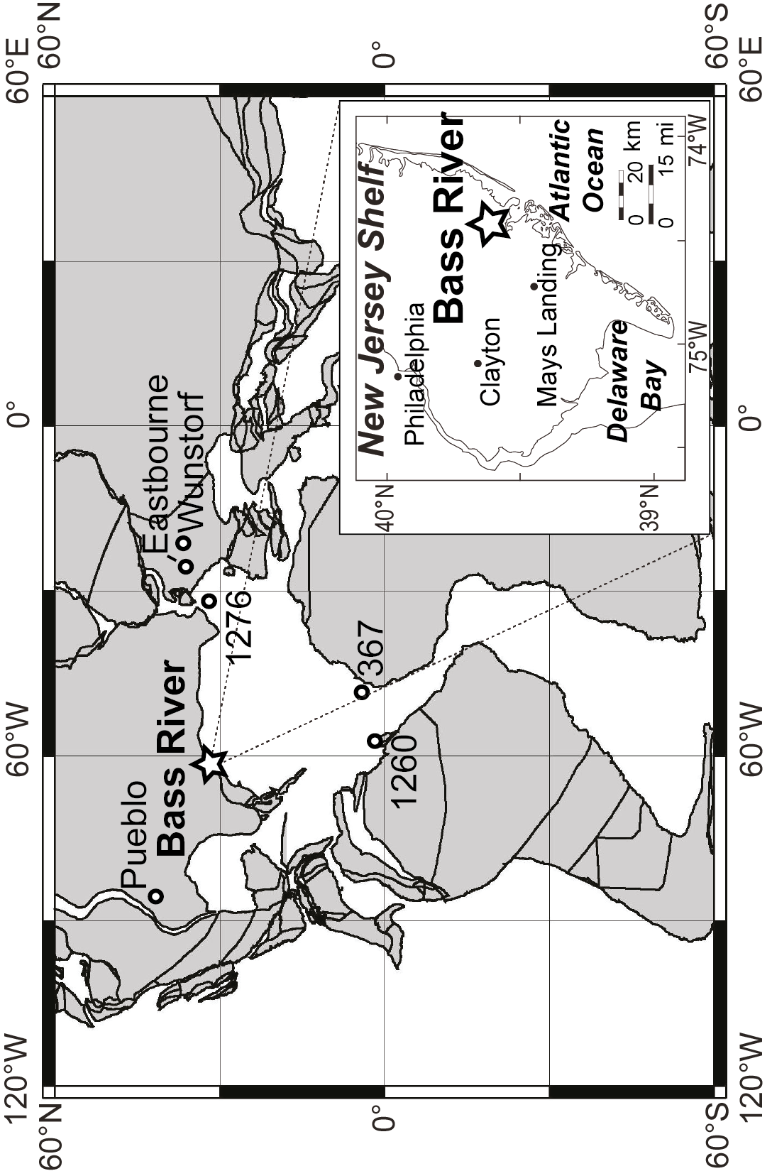
Figure 1. Paleogeographic map for the Cenomanian/Turonian boundary time interval indicating locations of the Bass River borehole and sections mentioned in discussion (Pueblo, Eastbourne, Wunstorf, DSDP Site 367 and ODP Sites 1260 and 1276) in a plate tectonic reconstruction (Map generated at http://www.odsn.de/odsn/services/paleomap/paleomap.html.). Insert map (modified from Sluijs et al., 2007) indicates the present day drill location of the Bass River borehole.

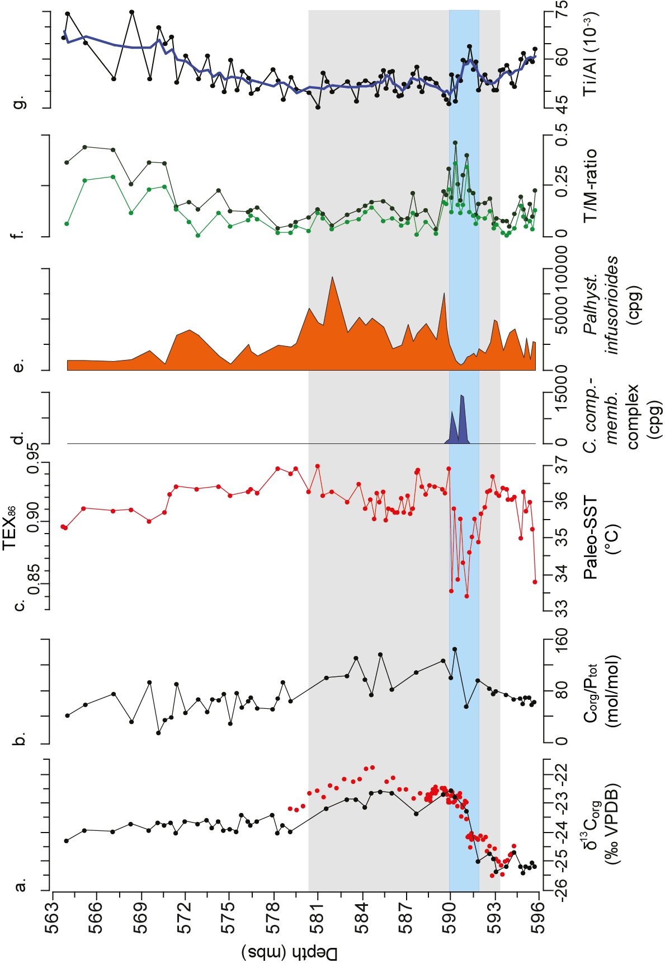Figure 2. Palynological and geochemical results across Oceanic Anoxic Event 2 (OAE2) at Bass River. (A) δ¹³C_{org}, this study (black) and data adopted from Bowman and Bralower (2005; red). (B) total organic carbon/total phosphorus ratio (TOC/P_{tot} ratio). (C) TEX₈₆ and sea surface temperature (SST) reconstruction based on TEX₈₆^{H} (Kim et al., 2010), the blue bar depicts the cold event. (D) dinocyst species Cyclonephelium compactum- C. membraniphorum complex in cysts per dry gram of sediment (cpg). (E) dinocyst species Paleohystrichophora infusorioides (cpg). (F) dark green data depict the ratio of terrestrial versus marine palynomorphs (T/M-ratio), the data in light green depict saccate gymnosperm pollen versus marine palynomorps. (G) titanium over aluminum ratio (Ti/Al-ratio; black) and five point moving average (blue). The gray zone indicates the OAE2 interval, based on correlation to global reference sections (see text). mbs = meters below surface.
¹GSA Data Repository item 2014xxx, methods, Figure DR1 and Tables DR1-DR2, is available online at www.geosociety.org/pubs/ft2013.htm, or on request from editing@geosociety.org or Documents Secretary, GSA, P.O. Box 9140, Boulder, CO 80301, USA.

